GOVERNOR’S SECRETARIAT
ARUNACHAL PRADESH
ITANAGAR

Press Communiqué
Dated Jan 31, 2026

Anini Gets Mini Secretariat as First Cabinet Meeting Held at New Facility
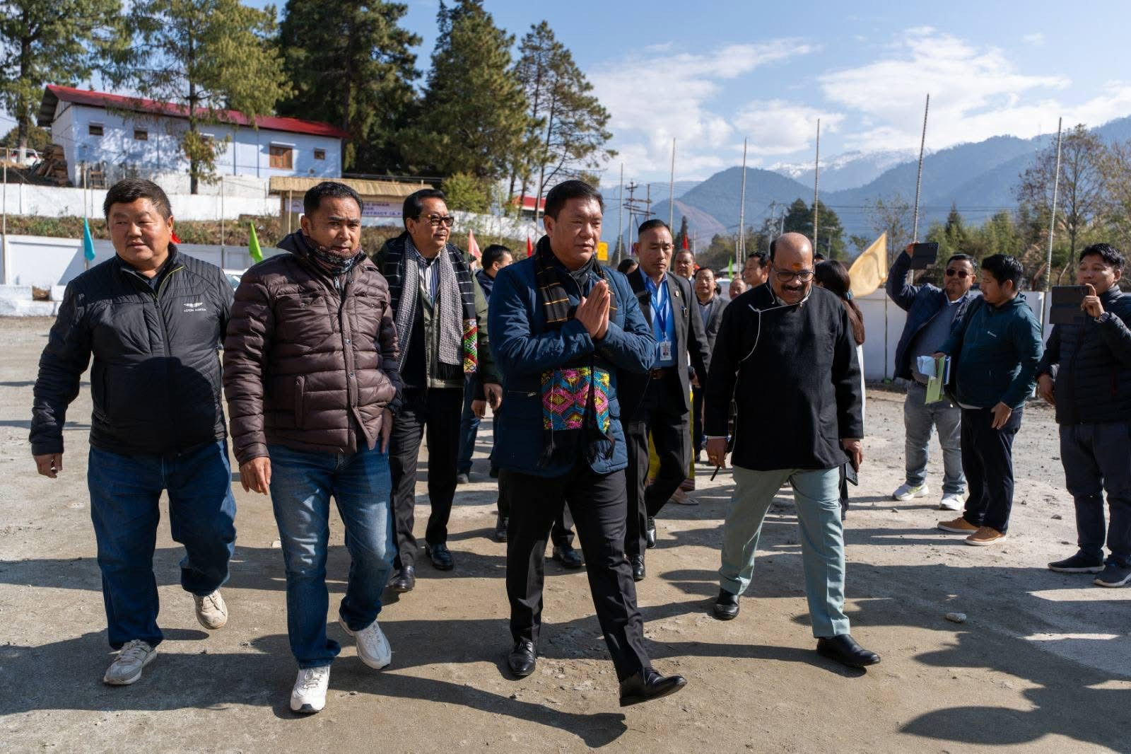
Anini, 31st Jan’2026: Mini Secretariat at Anini was formally inaugurated in the august presence of the Hon’ble Chief Minister of Arunachal Pradesh, Shri Pema Khandu; Hon’ble Deputy Chief Minister, Shri Chowna Mein; Hon’ble Ministers Shri Wangki Lowang, Shri Biyuram Wahge, Shri Nyato Dukam, Shri Gabriel D. Wangsu, Shri Ojing Tasing, and Smti Dasanglu Pul; and the Hon’ble Chief Secretary, Shri Manish Kumar Gupta. The programme was attended by Commissioners, Secretaries, Directors, and Heads of Departments. Following the inauguration, the first Cabinet Meeting was also held at the Mini Secretariat.
The inauguration of the Mini Secretariat and the holding of the first Cabinet Meeting at Anini mark a historic milestone in strengthening the administrative infrastructure of Dibang Valley. The facility is expected to enhance governance efficiency, improve inter-departmental coordination, and ensure effective delivery of public services at the grassroots level. The event underscores the State Government’s firm commitment to decentralised, transparent, and people-centric governance, bringing decision-making closer to the people in the remotest regions of the State.
