GOVERNOR’S SECRETARIAT
ARUNACHAL PRADESH
ITANAGAR

Press Communiqué
Dated Jan 29th, 2026

CM Pema Khandu Calls for Stronger Grassroots Democracy Through Empowered Panchayats

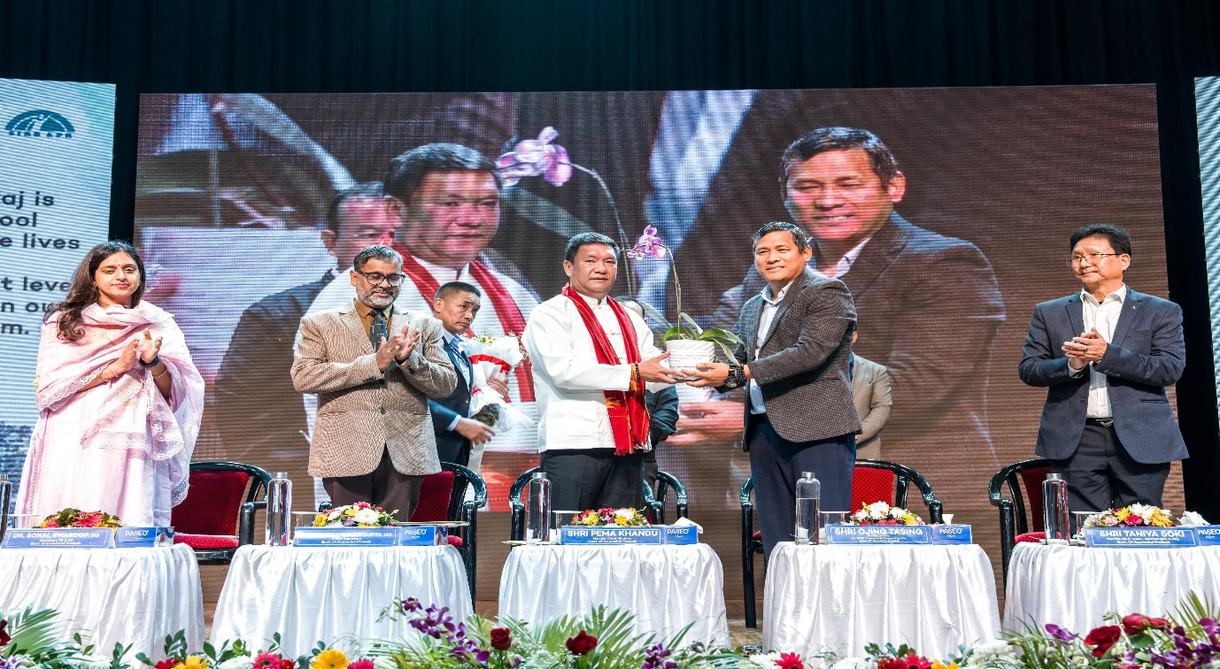

Chief Minister Pema Khandu on Thursday called upon elected Panchayati Raj Institution (PRI) representatives to strengthen grassroots democracy through inclusive planning, effective implementation of schemes, and close coordination with government machinery.
Inaugurating the extended four-day State Level Interaction-cum-Orientation Programme for elected PRI representatives (2026–2030), organised by the Department of Panchayati Raj, the Chief Minister congratulated newly elected Zilla Parishad Chairpersons (ZPCs), Zilla Parishad Members (ZPMs), and Gram Panchayat Chairpersons (GPCs) for securing a public mandate in the recent Panchayat elections.
Explaining the structure of the programme, the Chief Minister said the first two days would involve joint training sessions for all ZPCs, ZPMs, and GPCs, followed by two additional days of extended training for ZPMs and GPCs. He said the technical sessions were designed to make the Panchayati Raj system more robust by covering government schemes, latest technologies, and administrative processes.
Highlighting Arunachal Pradesh’s two-tier Panchayati Raj system, the Chief Minister said the model was adopted to ensure efficiency and clarity of roles, given the state’s unique demographic and geographical conditions. He described Panchayati Raj as the foundation of grassroots democracy and stressed that elected representatives carry significant responsibility in reflecting public opinion and democratic values in village development planning.
Sharing data on PRI representation, Khandu informed that the state has 27 ZPCs, 245 ZPMs, and 2,108 GPCs, along with over 8,000 Gram Panchayat Members. He said that due to space constraints, only 50 per cent of GPCs were invited for the present training, adding that district-wise and zonal-level programmes would be organised in the future for wider outreach.
The Chief Minister said the government would undertake delimitation during the next Panchayat election cycle, following the upcoming census, to make Panchayati institutions more effective. He stated that the State Election Commission has already been empowered to carry out the exercise.
Referring to national development goals, the Chief Minister said India has emerged as the fourth-largest economy globally and is expected to soon become the third-largest. He said the vision of Viksit Bharat 2047 can only be realised when villages are developed, underlining the central role of Panchayati Raj institutions in rural transformation.
He highlighted key governance initiatives such as Seva Aapke Dwar and Cabinet Aapke Dwar, stating that these programmes have enabled direct delivery of services and benefits to over 15 lakh people while helping the government understand ground-level challenges.
Reaffirming the autonomy of Panchayati Raj institutions, Khandu assured that there would be no interference by MLAs in Panchayat functioning. He said Panchayats are independent bodies empowered to execute their roles and responsibilities fully, adding that complaints of interference had been taken seriously.
The Chief Minister said Arunachal Pradesh is among the first states in the country to allocate 10 per cent of its state-owned resources directly to the Panchayati Raj system over the last five years, leading to increased grants as the state’s economy grows. He also highlighted the integration of digital platforms, e-governance tools, online audits, PFMS, and gender inclusion frameworks to enhance transparency and efficiency.
Welcoming the replacement of MGNREGA with the Viksit Bharat Gramin Rozgar aur Aajeevika Guarantee Mission (VBGRAM), the Chief Minister said the new scheme guarantees 125 days of employment and makes timely employment a constitutional right, with penalties for delays. He said the scheme focuses on four priority areas—water security, rural infrastructure, livelihood enhancement, and disaster mitigation—requiring need-based village planning.
He urged PRI representatives to adopt participatory and inclusive planning practices, involving all households in village meetings and prioritising the upliftment of weaker and economically vulnerable sections. He stressed the importance of convergence among schemes of various departments to maximise development outcomes.
The Chief Minister said the government has constructed 1,182 Panchayat Bhawan-cum-Common Service Centres across the state and completed District Panchayat Resource Centres in five districts, with three more nearing completion. He also highlighted the growing participation of women in Panchayati Raj, noting that women’s representation has reached nearly 48–50 per cent, well above the mandated reservation.
Emphasising the role of women and Self-Help Groups (SHGs) in strengthening the rural economy, the Chief Minister said over 1.4 lakh women in Arunachal Pradesh are now engaged in SHG activities. He said the state government has consistently promoted SHGs through initiatives such as the annual Saras Mela and encouraged PRI representatives to integrate SHGs into local development planning.
He also informed that the state government has signed an MoU with the Institute of Rural Management, Gujarat, to provide specialised training for Panchayati representatives and officials. Training on platforms such as e-Gram Swaraj and Audit Online would be intensified in the coming days.
Calling the five-year tenure a rare opportunity for public service, the Chief Minister urged elected representatives to work with urgency, vision, and accountability from day one. He encouraged healthy competition among Panchayats, innovation in governance, and close coordination with district officials to ensure tangible outcomes.
Khandu said strong teamwork between Panchayats, the district administration, and the state government would be essential to transform villages and position Arunachal Pradesh as a model of grassroots governance.
PRI Minister Ojing Tasing, Advisor to the PRI Minister Taniya Soki, Chief Secretary Manish Kumar Gupta, and PR Secretary Sonal Swaroop were also present, among others.
