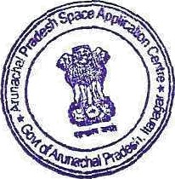
Arunachal Pradesh Space Application Centre

(Department of Science & Technology) Government of Arunachal Pradesh
Civil Secretariat, Block-1, Room No.106, Itanagar

NO. SRSAC/731/2023-24 (Vol.I) Dated, Itanagar, the 2•‘ January, 2026

Lim ited Tender Notice
Sealed tenders in prescribed format are invited from the APSAC empaneled firms/ companies for execution of the work on ‘Natural Resources Inventory fot Micro Level Agricultural Planning (NRIMAP) in Leparada District’. Tender documents can be obtained from the address mentioned below:
Or. Liagi Tajo
Joint Director cum Nodal Officer (State Plan), Arunachal Pradesh Space Application Centre,
Dept. of Science & Technology, Govt. of Arunachal Pradesh,
Civil Secretariat, Itanagar.
Alternatively, tender documents can be obtained by request through email to apsac.nrimap@gmai1.com.The completed applications, as per instructions in the tender document should reach the above-mentioned address on or before 16* January 2026 upto 1600 hrs.






Arunachal Pradesh SpaceApplication Centre (APSAC) reserves the sole right to accept or reject any or all proposals without assigning any reason whatsoever.

Dr. Liagi Tajo
Joint Director cum Nodal Oflicer (State Plan) Arunachal Pradesh Space Application Centre, Dept. of Science & Technology,
Govt. ofArunachal Pradesh, Itanagar

