GOVERNOR’S SECRETARIAT
ARUNACHAL PRADESH
ITANAGAR

Press Communiqué
Dated December 2, 2025

Dy CM Chowna Mein Attends 20th International Tipitaka Chanting Ceremony at Bodhgaya

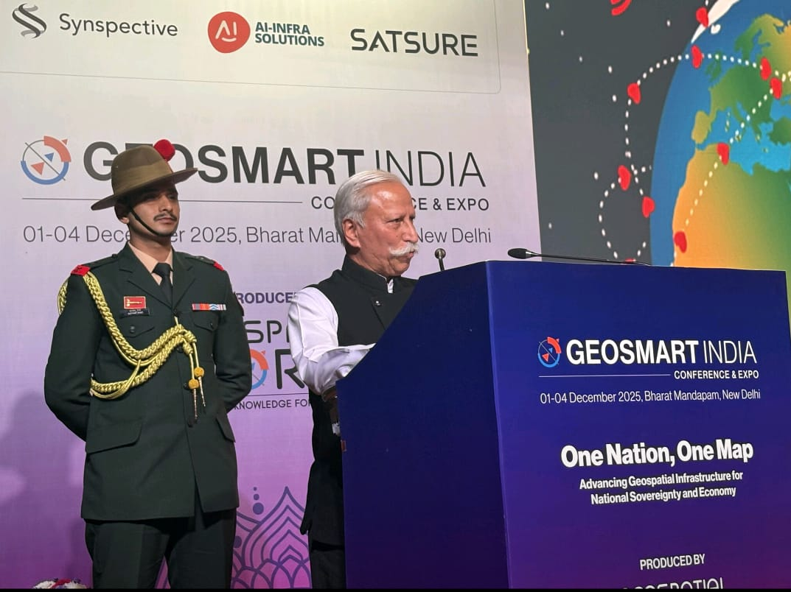

Governor participates in GeoSmart India 2025
Geospatial technology will be a transformative force for Arunachal Pradesh, helping the State plan and grow wisely: Governor
Governor underscores the urgency of developing a State-specific application
Geospatial tools make monitoring more transparent and efficient, enabling real-time tracking of land use, forests, water bodies, crop patterns, and project progress
GIS dashboards will bring greater transparency to government projects and guide long-term sustainability through mapping of natural resources and renewable energy potential
The Governor of Arunachal Pradesh, Lt. General KT Parnaik, PVSM, UYSM, YSM (Retd.) participated in the GeoSmart India 2025 at Bharat Mandapam, New Delhi on 2nd December 2025. The 4-day Conference-cum-Expo, themed “One Nation, One Map: Advancing Geospatial Infrastructure for National Sovereignty and Economy,” is being organized by Geospatial Media and Communications.
Participating in the North East Conclave section of the event, the Governor said that geospatial technology—ranging from GIS and GPS to drones, satellite imagery, and digital maps—has become an essential tool for smart, evidence-based governance. He said that it strengthens the developmental process by mapping terrain, resources, and infrastructure gaps with precision, enabling planners to choose the best locations for roads, bridges, and public services while reducing guesswork and ensuring alignment with community needs and environmental realities.
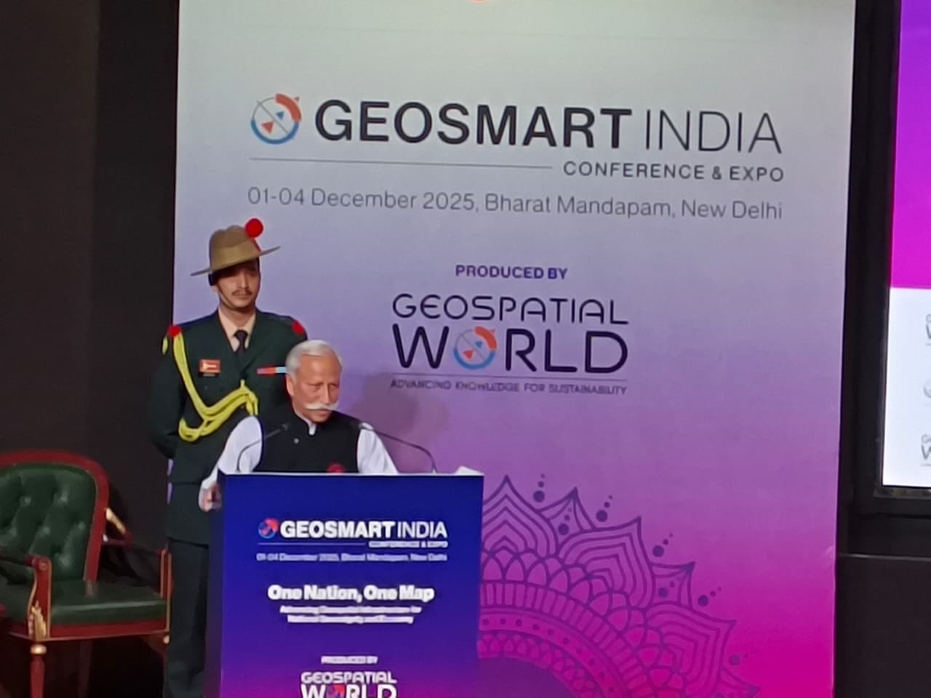
The Governor stated that geospatial tools make monitoring more transparent and efficient by tracking land use, forests, water bodies, crop patterns, and project progress in real time, allowing timely corrective action. These technologies, he added, support scientific assessment of natural resources, climate patterns, biodiversity, and socio-economic trends, helping policymakers make informed, future-ready decisions.
He further noted that before major projects begin, geospatial analysis helps evaluate feasibility, risks, and environmental sensitivity, reducing disputes and cost overruns. He suggested developing a State-level geospatial policy, building a central data repository, training government teams in GIS, integrating drone-based mapping, using dashboards for public projects, and fostering collaboration among departments to create unified geospatial datasets for better decision-making. The Governor reiterated that geospatial technology will be a transformative force for Arunachal Pradesh, helping the State plan and grow wisely.
The Governor said that geospatial technology tools are vital for disaster preparedness, allowing early identification of landslide zones, flood paths, and vulnerable settlements, and supporting quicker, more targeted response. Geospatial monitoring, he said, will also strengthen environmental protection by tracking forests, wildlife corridors, and river systems. It will boost agriculture by identifying suitable zones for key crops such as kiwi, orange, and apple, and support precision farming. He added that it will improve both urban and rural development through better land records, drainage planning, and asset management; assist border management along remote frontiers; and help promote sustainable tourism through accurate mapping of trekking routes, cultural sites, and eco-tourism zones.
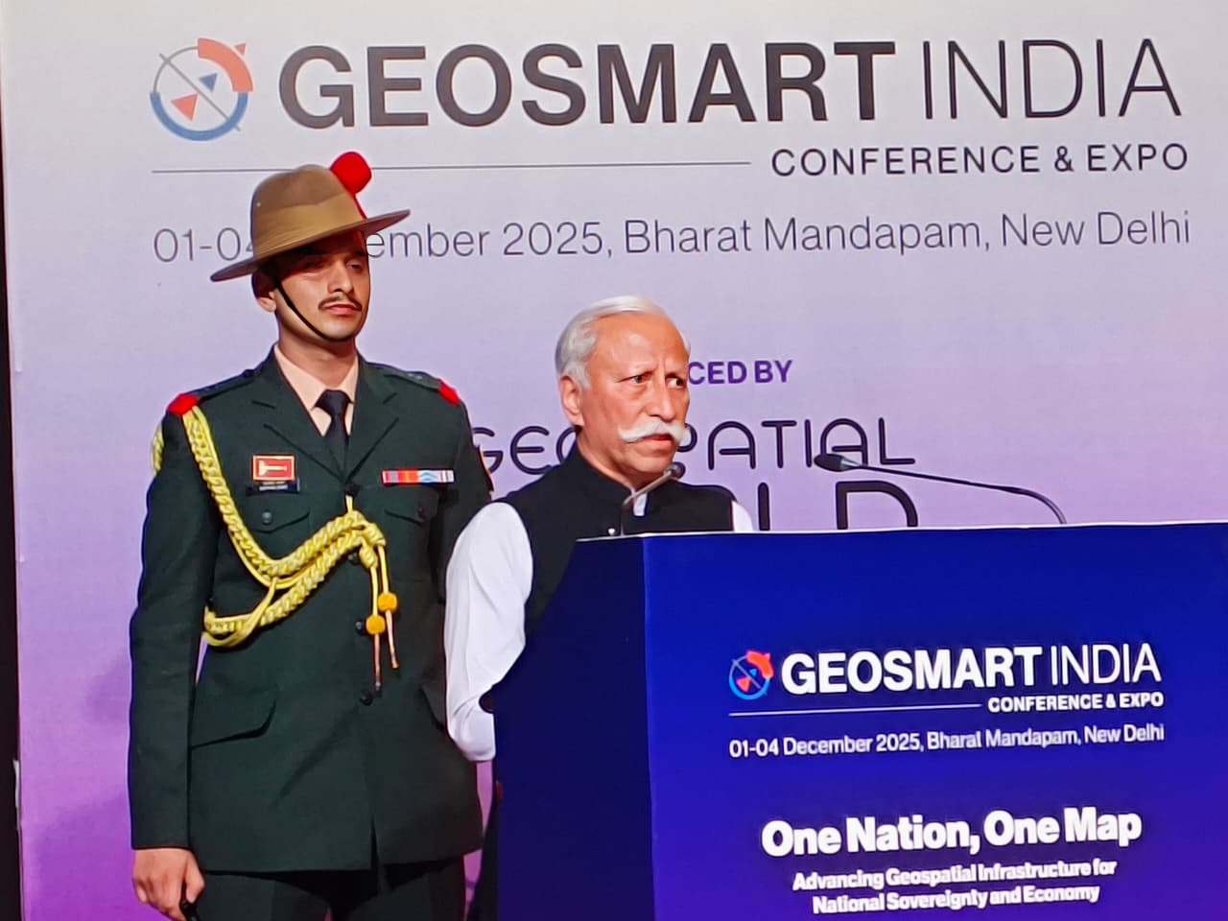
The Governor emphasized that GIS dashboards will bring greater transparency to government projects, while mapping natural resources and renewable energy potential will guide long-term sustainability—making geospatial technology a critical foundation for the State’s future growth and good governance.
Referring to his recent review of the PM GatiShakti implementation in the State, the Governor said that while the GatiShakti platform is invaluable for tracking welfare schemes and infrastructure projects, Arunachal Pradesh must now take a step further. He emphasized that with a State-specific AI-driven application tailored to local needs and geographical realities, the government can develop an integrated, user-friendly dashboard accessible to all departments. Such a unified platform, he said, would streamline coordination, eliminate duplication of efforts, ensure faster decision-making, and foster greater transparency and responsive governance for the people of Arunachal Pradesh.
Underscoring the urgency of developing a State-specific application, the Governor said that such an advanced platform would greatly strengthen Arunachal Pradesh’s security architecture. He explained that it could map and analyze drug-trafficking routes with greater precision, support continuous border monitoring and surveillance in remote areas, and enable real-time fusion of intelligence from different agencies. By creating a common space for interagency collaboration, the system would enable quicker, more reliable information-sharing, improve airspace monitoring, enhance cross-border intelligence coordination, and facilitate tracking of suspicious movements.
The Governor added that it would also assist in asset tracking and seizure operations, empowering law-enforcement agencies to act swiftly and decisively, ultimately helping protect the State’s youth, communities, and long borders with greater efficiency and confidence.
PRO to Governor
Arunachal Pradesh
NEW DELHI, December 2, 2025

