GOVERNOR’S SECRETARIAT
ARUNACHAL PRADESH
ITANAGAR

Press Communiqué
Dated December 3, 2025

International Day of Persons with Disabilities Observed in Namsai District

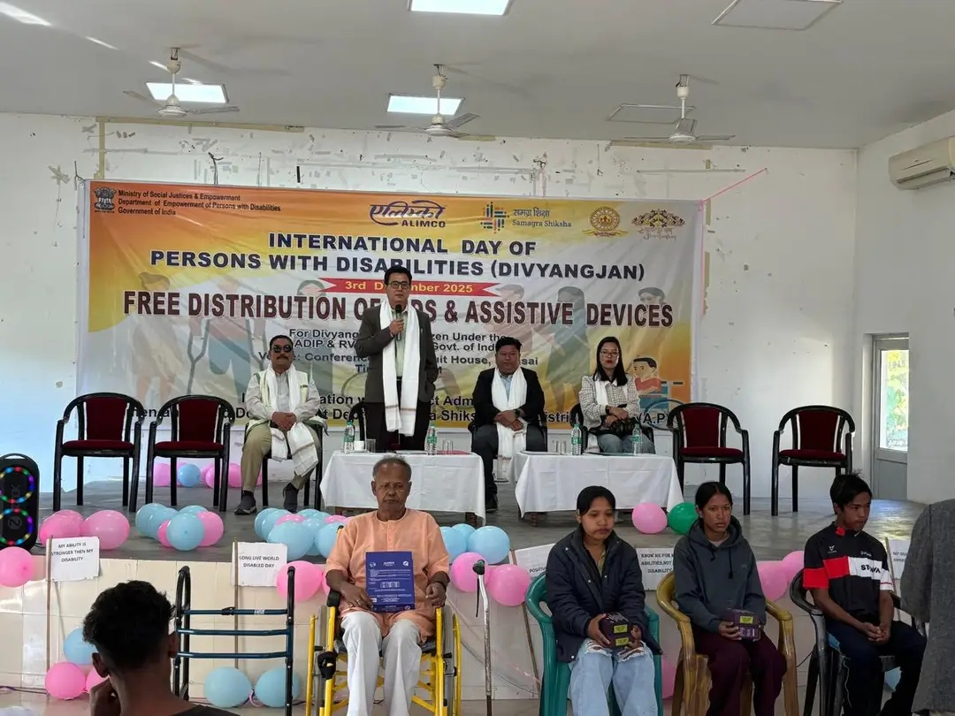

The International Day of Persons with Disabilities was observed in Namsai District, organised by ALIMCO in collaboration with the District Administration, Women & Child Development Department, and Samagra Shiksha/ISSE, Namsai.

The programme commenced with a welcome address by Dr. Miti Siboh, District Nodal Officer, SJETA, Namsai. This was followed by a presentation from Mr. Sanjeev Kumar of ALIMCO, who briefed the gathering on the organisation and its role in supporting persons with disabilities.

DDSE Pokdey Yomgam also addressed the event and shared words of encouragement for the persons with disabilities.

The Deputy Commissioner, Namsai, concluded the programme with an encouraging message and distributed the aids and appliances provided by ALIMCO to the beneficiaries. He urged them to remain confident and assured them that they are not lesser in any way, but capable and equal members of society.

The formal programme concluded with a vote of thanks delivered by Ms. Nabam Yayek.
