GOVERNOR’S SECRETARIAT
ARUNACHAL PRADESH
ITANAGAR

Press Communiqué
Dated December 2, 2025

Dy CM Chowna Mein Attends 20th International Tipitaka Chanting Ceremony at Bodhgaya

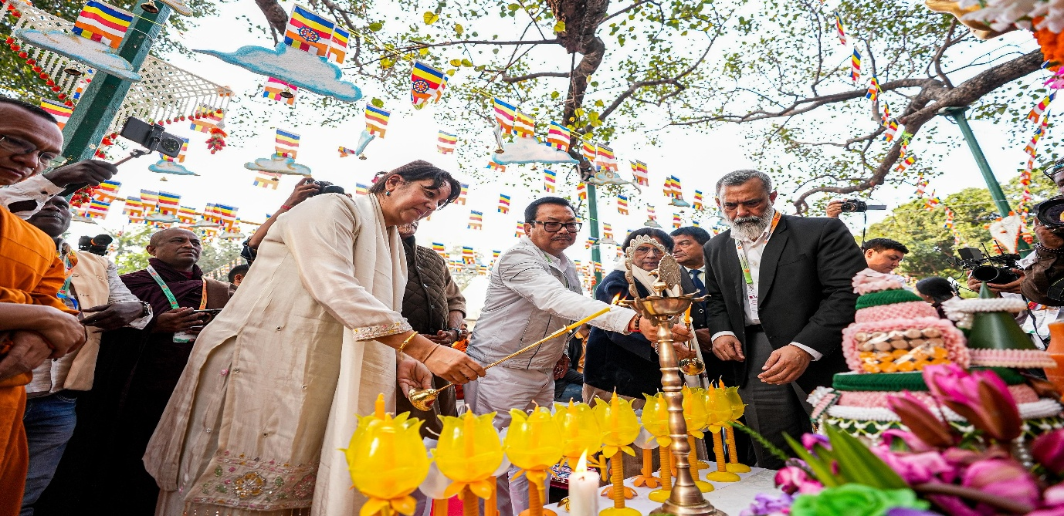

Dy CM Chowna Mein Attends the inaugural session of 20th International Tipitaka Chanting
Ceremony at Bodhgaya
BODHGAYA, December 02: Deputy Chief Minister of Arunachal Pradesh Chowna Mein
attended the 20th International Tipitaka Chanting Ceremony at Bodhgaya, the sacred land of
enlightenment. Standing beneath the revered Bodhi Tree, where the Compassionate One
attained supreme awakening in presence of Union Minister for Culture &amp; Tourism, Gajendra
Singh Shekhawat, Venerable Sanghas, Monks, Nuns and delegates from more than 22
countries and also witnessed the unified chanting of the Tipitaka.
He stated that the collective recitation served as a powerful reminder of the Buddha’s
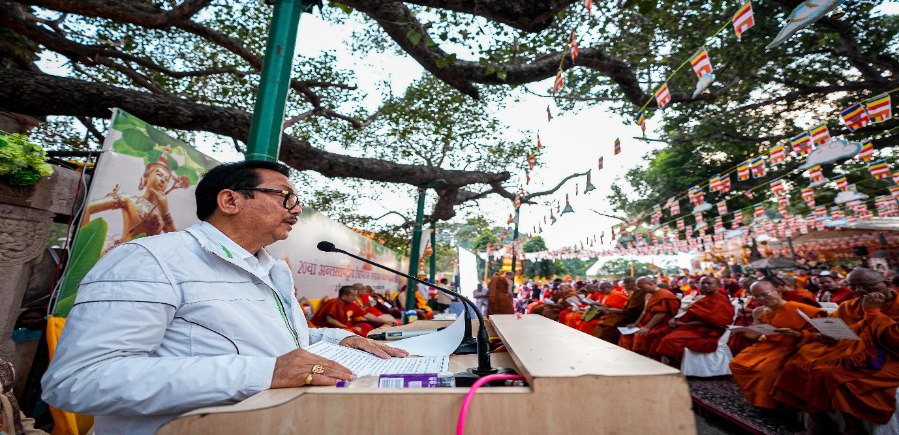
universal message of compassion, peace and harmony and described the experience as a
profound spiritual blessing.
He said that this chanting of Tipitaka will not only spread Lord Buddha’s teaching of love and
compassion but will also foster peace, unity and harmony across a global community
fulfilling the spirit of ‘Vasudeva Qutumbakam’ – ‘one earth, one family, one future’ as envisaged by Prime Minister, Narendra Modi.
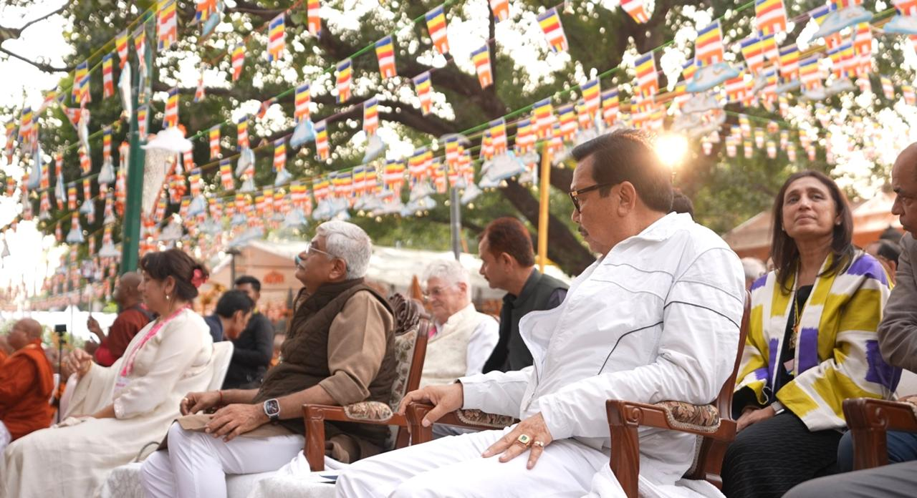
Quoting Prime Minister Narendra Modi, Mein said, “Buddhism is India’s gift to the world”, and
we rekindle that torch here today as the event continues to embody India’s commitment to
preserving and promoting its timeless Buddhist heritage before the world.
Mein also conveyed his sincere thanks to Prime Minister Narendra Modi for recognising Pali
as a Classical Language, and for the repatriation of sacred Buddha relics to India from
Thailand, Mongolia and Bhutan, which he said has strengthened spiritual bonds and
reinforced India’s cultural diplomacy rooted in its Buddhist legacy.
He highlighted Arunachal Pradesh as the Himalayan Cusp of Dhamma, where both
Mahayana and Theravada Buddhism continue to flourish. Recalling the State’s rich Buddhist
heritage from the ancient monasteries of Tawang to the Golden Pagoda in Namsai and the
majestic 180-foot Buddha statue at Dhamma Hill, he noted that Arunachal Pradesh remains
deeply committed to preserving and promoting the teachings of the Buddha with devotion
and vibrancy.

Mein expressed profound gratitude to the International Tipitaka Chanting Council of
India(ITCC), International Buddhist Confederation(IBC), Life of Buddhadharma Foundation
International(LBDFI), the Mahabodhi Society and all partner organisations for successfully
organising this global spiritual congregation.
He appreciated the delegation from Arunachal Pradesh especially the Tai Khamti community
for presenting the Maha Sangha Dana to monastic delegates from across the world,
honouring them with traditional Tai Khamti delicacies.
He said that the enduring echoes of the Tipitaka will continue to guide humanity towards
peace, and that the compassion of the Buddha will inspire unity across borders

