GOVERNOR’S SECRETARIAT
ARUNACHAL PRADESH
ITANAGAR

Press Communiqué
Dated November 22, 2025

ALF 2025: A Melting Pot of diverse voices conclude as a resounding success

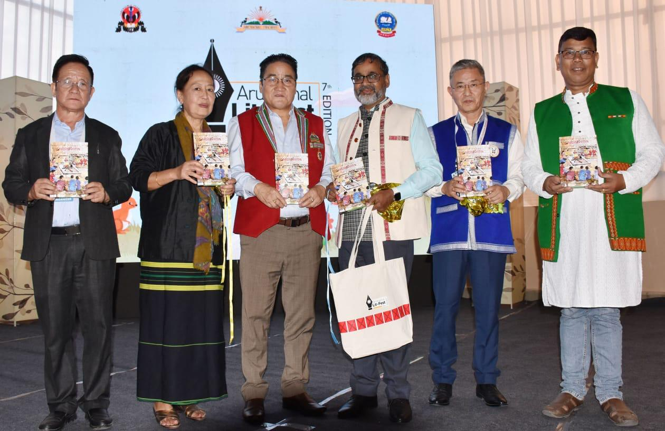

ITANAGAR, November 22:
The Arunachal Literary Festival (ALF) 2025 wrapped up its three-day run, celebrating the power of narrative across food, culture, technology and, most notably, the Children’s Corner—which was unanimously hailed as the “Most Happening Section of the Fest.”

The final day at the Namdapha Hall began with an insightful session on “Gastronomy: Books and Bites.” Panelist Sona Bahadur, speaking about her new book Invitation to Feast, highlighted that India’s rich culinary heritage is endangered due to inadequate documentation. The session delved into the sociological and political dimensions of food, shedding light on the unfortunate “otherization” of Northeast India’s unique cuisine. The discussion underscored that the kitchen, when viewed through a literary lens, is a powerful space filled with stories of memory, heritage, and resilience.

The Children’s Corner, the festival’s most popular space, engaged young minds from the start. Renowned artist Deepa Kiran, founder of the Story Arts Foundation, mesmerized children with a unique musical storytelling performance, while acclaimed author Pankaj Saikia conducted an imaginative workshop on wordless stories, encouraging children to explore and embrace the “visual medium.”

At the Pakke Hall, the intellectual core of the festival unfolded. The important session on “Narrating the Native,” moderated by Bompi Riba, brought forth compelling perspectives. Miranda Pertin emphasized the urgent need to document the rapidly evolving ‘native’ identity, while picture-book creator Ogin Nayam highlighted the significance of visual storytelling in connecting with young readers. Attendees were also treated to a special poetry reading by 14 poets—both seasoned and emerging—led by Padma Shri awardee Sheen Kaaf Nizam, a revered contemporary Urdu poet and scholar.

The deeply human final session at Pakke Hall, titled “What Makes World Literature?” and moderated by Tashi Chophel, began with a personal question: Which book would you claim as your own? The discussion reaffirmed that “reading will never die,” as panelists reflected on books tied to personal history and trauma, including Aanchal Malhotra’s work on Partition. The conversation also celebrated the enduring importance of bookshop culture. Just prior to this, the debate on “Literature in the Age of AI” concluded that while Artificial Intelligence presents challenges, it can never replicate the emotional depth and human sensitivity that define great literature. Together, these sessions reinforced ALF 2025’s commitment to exploring identity, connection, and the universal stories shared across the world and even around the dinner table.

International academic engagement was also spotlighted at the festival. In Namdapha Hall, Maria Gil Burman, Director of the Institute of Cervantes, presented on the institute’s role in promoting Spanish language and Hispanic culture. She encouraged participants to explore global educational opportunities and enroll in their vibrant cultural and linguistic programs.

The festival drew to a powerful and poignant close with a deeply engaging final session at Namdapha Hall. The concluding event, “In Conversation with Aanchal Malhotra,” offered a fitting culmination to the festival’s themes. The renowned oral historian and author, celebrated for her seminal work on Partition, guided attendees through profound reflections on memory, material culture, and the enduring human narratives that shape history.

This memorable session underscored the festival’s commitment to meaningful dialogue and diverse perspectives, ensuring that ALF 2025 concluded on a note of intellectual richness and emotional resonance.

