GOVERNOR’S SECRETARIAT
ARUNACHAL PRADESH
ITANAGAR

Press Communiqué
Dated November 20, 2025

7th Arunachal Literature Festival begins
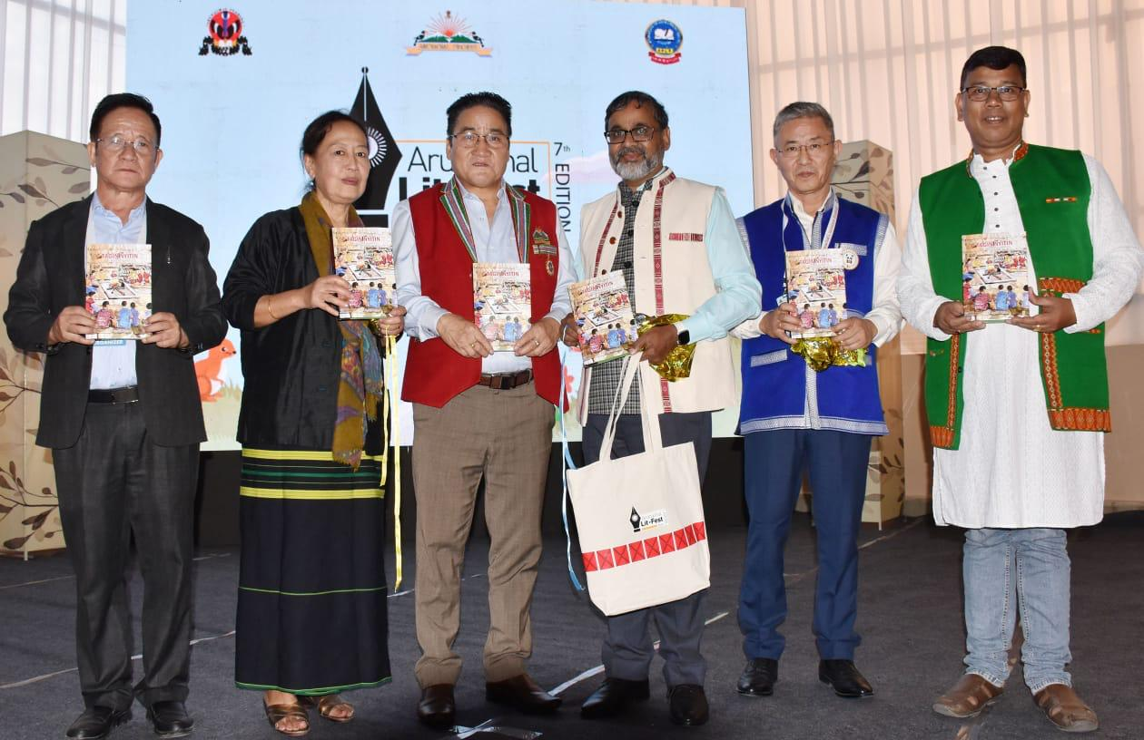
ITANAGAR, November 20:
The 7th edition of the much-anticipated Arunachal Literature Festival (ALF), themed “Building Bridges through Literature,” officially kicked off with a spectacular inaugural session at the Dorjee Khandu Convention Centre this evening. The three-day event promises to be a vibrant confluence of regional, national, and international literary voices.

Organized by the Department of Information & Public Relations in collaboration with the Arunachal Pradesh Literary Society (APLS), this premier annual literary event brings together renowned authors, writers, poets, translators, storytellers, scholars, artists, and readers from across the country and abroad. The festival also welcomes the state’s budding aspiring writers, offering a platform for participants from diverse literary traditions and reflecting ALF’s commitment to promoting the rich literary landscape of Arunachal Pradesh while fostering dialogue between cultures and disciplines.

Inaugurating the festival, Chief Secretary Manish Kumar Gupta underscored the timeless significance of literature in shaping society, preserving identity, and nurturing cultural memory. Calling the festival “a celebration of imagination, creativity, and the enduring power of words,” he thanked the Department of IPR and APLS for uniting the literary community. He also praised the rise of young and first-time writers—especially students and women—for bringing fresh perspectives.

Reflecting on the deeper value of literature, Gupta noted that a society’s identity is shaped not only by economic or infrastructural progress but also by “the strength of its ideas and the stories it tells about itself.” He emphasized that literature mirrors collective consciousness—preserving the past, interpreting the present, and inspiring the future.

Speaking about the state’s rich cultural tapestry, he highlighted its ancient oral traditions, folk songs, myths, and legends that predate the written word. He expressed optimism about the emergence of young writers and poets across the state who bring new energy while carrying forward ancestral narratives. Gupta also acknowledged the evolving mediums of expression—from traditional print to digital platforms—and stressed the need to embrace both continuity and innovation.

Reiterating the government’s commitment to preserving linguistic and cultural diversity, he highlighted ongoing efforts to document indigenous oral traditions, support local authors, and strengthen reading habits among students. He further stressed the importance of transforming school and university libraries into vibrant hubs of literary exchange and creative exploration.

Festival Advisor and acclaimed author Padmashree Mamang Dai, in her insightful introductory remarks, reflected on the festival’s growth and its increasing stature over the years. She emphasized the solace and perspective literature provides, stating, “In the time of crisis, literature comes to the rescue.”

Earlier, in her welcome address, Festival Nodal Officer Higio Zarngam highlighted the festival’s renewed digital commitment after a six-year hiatus, noting that this outreach is crucial to taking literary exchange “beyond these four walls,” and reaffirming that “Literature belongs to everyone.”

The inaugural event was attended by several literary luminaries, along with Commissioner to HCM Sonam Chombay, Commissioner Planning Ankur Garg, Secretary Industry & Skill Development Bullo Mamu, Secretary IPR Nyali Ete, and members of the Arunachal Pradesh Literary Society.

Other highlights of the session included the lighting of the ceremonial lamp, screening of the ALF promo video, release of two books—Tagin Proverbs by Er. Lardik Kare, and Himbitach: Tale of a Transcended Beauty written by Lopa Rebi Kojum and illustrated by Tomar Tomsai Nayam—presentation of a folk dance by IPR staff, and a special ‘In Conversation with the Author’ session where Commissioner to HCM Sonam Chombay discussed his book In Between the Blurry Lines, moderated by senior journalist Ranju Dodum.

The three-day event will feature multiple sessions across three halls—Namdapha, Pakke, and Children’s Corner. The programme includes author conversations, poetry readings, prose sessions, panel discussions, workshops, storytelling sessions, children’s activities, and theme-based talks.

This year’s international guests include Mami Yamada, a renowned Japanese author of over 20 books including several bestsellers; Kunzang Choden from Bhutan, the 2023 SAARC Literature Award recipient and author of several works including children’s books; and Ms. Maria Gil Burman, Director of Instituto Cervantes, Embassy of Spain, who will present on “The Role of Instituto Cervantes in promoting Hispanic Literature in India.”
Sd/- PR Cell
DIPR

