GOVERNOR’S SECRETARIAT
ARUNACHAL PRADESH
ITANAGAR

Press Communiqué
Dated Sept 7, 2025

CM Pema Khandu launches Arunachal Kiwi Mission, lays foundation stones at Ziro Valley ahead of Cabinet Aapke Dwar
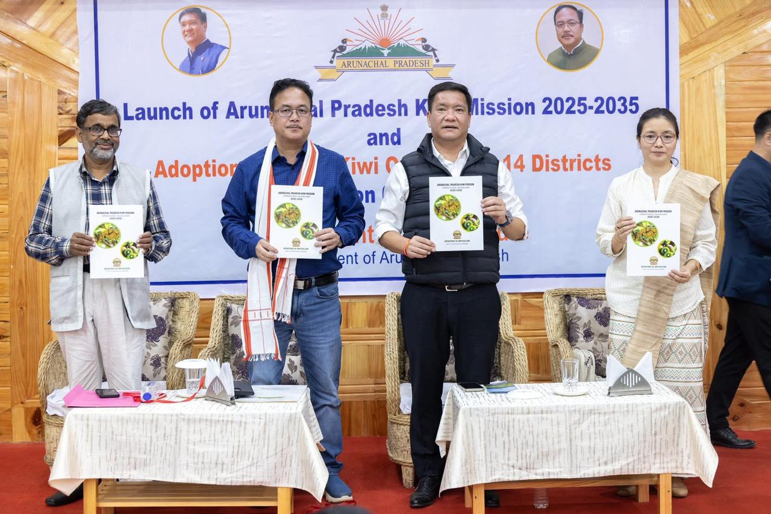
Ziro, September 7, 2025: The Hon’ble Chief Minister of Arunachal Pradesh, Shri Pema Khandu, along with Cabinet Ministers and senior officials, arrived at Ziro Valley on September 7, 2025, ahead of the Cabinet Aapke Dwar programme.
On September 7, the Chief Minister laid the foundation stone for two major projects — the Centre of Excellence for Kiwi Fruits at Kardo and the Wholesale and Retail Fish Market at Hapoli. These projects are aimed at boosting horticulture and fisheries while creating sustainable livelihood opportunities for farmers and entrepreneurs.
In a solemn function at Ziro Valley Resort, the Hon’ble Chief Minister handed over an ex-gratia amount of ₹50 lakhs to Smti. Charo Kamhua Tage, wife of Late Corporal Tage Hailyang, who was martyred in the Pahalgam terrorist attack on 22 April 2025.
Marking a significant milestone in the horticulture sector, the Chief Minister also launched the Arunachal Kiwi Mission. Under this initiative, 31 model kiwi farms across 14 kiwi-growing districts of Arunachal Pradesh have been adopted to promote commercial-scale kiwi farming with scientific interventions. Kiwi farmers interacted with the Hon’ble CM and shared their experiences and challenges they are facing.
The event was graced by Hon’ble Minister for Agriculture and Allied Sectors Shri Gabriel D. Wangsu, other Cabinet Ministers, Ld. Chief Secretary Shri Manish Kumar Gupta, Ld. Secretaries and commissioners of various departments, Hon’ble MLA of Ziro Er. Hage Appa, Deputy Commissioner Smti Oli Perme, Superintendent of Police Shri Keni Bagra, dignitaries, kiwi farmers from all 14 districts and other officials.
The Cabinet Aapke Dwar programme is scheduled to be held on September 8, 2025, at the Civil Secretariat Building, Ziro. Further, a Mega Seva Aapke Dwar camp will be conducted on September 9, 2025, at Government Secondary School, Hari, where multiple departments will deliver citizen-centric services under one roof.
The Cabinet’s visit to Ziro reflects the government’s commitment towards grassroots governance, farmer welfare, and inclusive development of the state.

