GOVERNOR’S SECRETARIAT
ARUNACHAL PRADESH
ITANAGAR

Press Communiqué
Dated Sept 8, 2025

Agriculture Department Conducts Natural Farming Training for Over 100 Farmers at Lungla
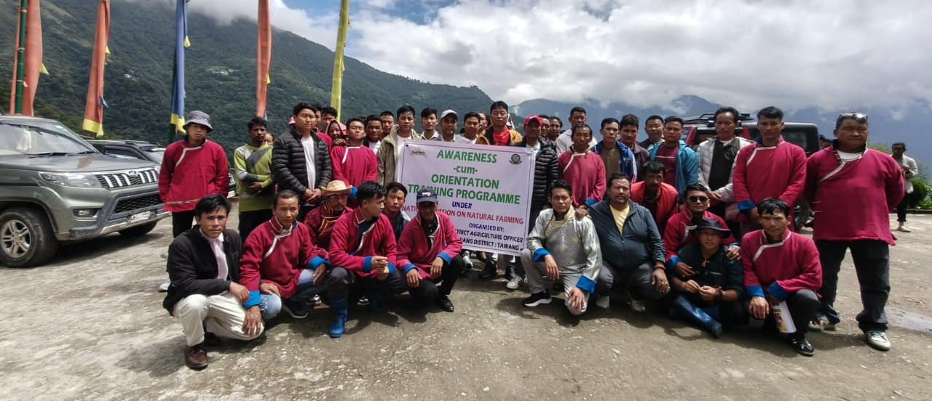
Lungla, September 8, 2025 – The Department of Agriculture conducted an Awareness-cum-Orientation Training Programme on Natural Farming for the Mangnam and Sakyur Clusters at Lungla yesterday under the Centrally Sponsored Scheme National Mission on Natural Farming.
The programme witnessed enthusiastic participation from over 100 farmers, along with Zilla Panchayat Member Lungla, Gram Chairpersons, other Panchayati Raj Institution members, Gaonburhas, Self Help Group members, and Community Resource Persons.
Expert Guidance on Sustainable Practices
Entomologist K.B. Kayastha from Tawang served as the resource person and elaborated on the mission's key objectives. He highlighted the critical importance of nature-based sustainable farming systems and emphasized the utilization of on-farm natural farming bio-inputs to reduce dependence on externally purchased inputs, thereby significantly lowering production costs for farmers.
The expert further explained various natural farming practices that improve soil structure and nutrition, promote crop diversification, and enhance the soil's water-holding capacity, contributing to overall agricultural sustainability.
Local Leadership Support
In his address to the gathering, ZPM Lungla Thutan Gombu encouraged farmers to adopt natural farming methods with scientifically backed approaches. He stressed the importance of ensuring sustainability, climate resilience, and safe food production through these innovative farming techniques.
Interactive Learning Session
The programme featured an interactive session where farmers actively participated by clarifying their queries on different aspects of agricultural practices with the resource person. This engagement made the training both informative and practical, addressing specific concerns and challenges faced by local farmers.
The training programme is part of the broader initiative to promote sustainable agricultural practices and reduce the environmental impact of farming while ensuring food security and farmer welfare in the region.
