GOVERNOR’S SECRETARIAT
ARUNACHAL PRADESH
ITANAGAR

Press Communiqué
Dated Sept 8, 2025

Cabinet Aapke Dwar held at Mini Secretariat, Ziro, Important Cabinet Decisions Taken
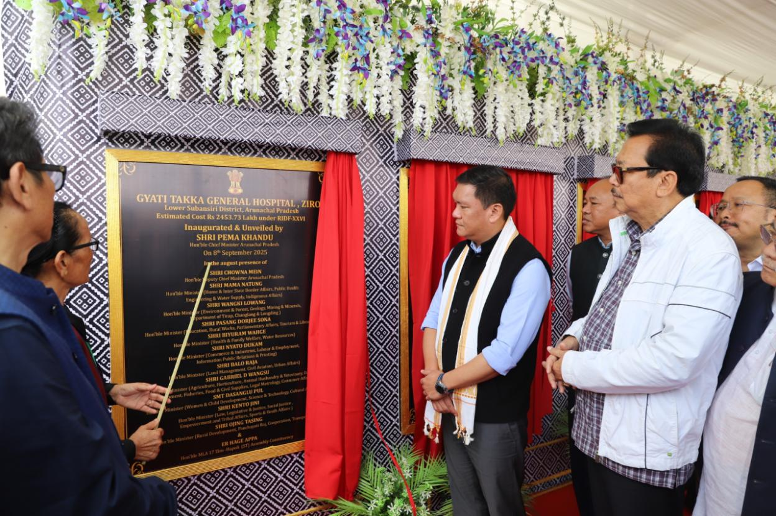
Mini Secretariat Building, Ziro, September 8, 2025: The historic Cabinet Aapke Dwar programme was held today at the Mini Secretariat Building, Ziro, under the chairmanship of Hon’ble Chief Minister Shri Pema Khandu in the august presence of Deputy Chief Minister Shri Chowna Mein, Cabinet Ministers, Chief Secretary, Secretaries, Commissioners, Hon’ble MLA of Ziro Shri Er. Hage Appa, Deputy Commissioner Smti Oli Perme, Superintendent of Police Shri Keni Bagra, Admin officrs, HoDs and other dignitaries.
On the occasion, the Hon’ble Chief Minister inaugurated the Gyati Takka General Hospital, Ziro and the Office building of the Superintending Engineer, Subansiri Basin, Department of Hydropower Development, Ziro.
Further, the Chief Minister laid the foundation stones for several landmark projects including:
• Accommodation facilities for Government officers and staff in all districts
• Multi-layer Parking Zone at Hapoli Township
• Multipurpose Convention Hall at Abotani Club, Hapoli
• Artificial Grass Turf at Padi Yubbe Outdoor Stadium, Ziro
• Circuit House at Ziro
• Improvement of District Headquarters Township Road at Ziro

A paperless Cabinet meeting was also conducted using the e-Cabinet app at the Mini Secretariat Building, Ziro where several key policy decisions were taken. Some of the major decisions include:
1. Approval of the Arunachal Pradesh Municipal Control on Advertisement Regulation, 2025 to regulate haphazard hoardings and advertisements in urban areas.
2. Imposition of Property Tax in notified urban areas including areas of Itanagar Municipal Corporation and Pasighat Municipal Council.
3. Proposal for amendment of Recruitment Rules of the Department of IPR.
4. Rationalisation of Finance and Accounts Officer and Treasury Officer Recruitment Rules.
5. Creation of a new Nyapin PWD Sub-division under Sangram Division.
6. Amendment of Recruitment Rules of the Department of Labour and Employment.
7. Supersession of 1999 Recruitment Rules of the Department of Agriculture.
8. Amendment of Arunachal Pradesh Land Settlement and Record Rules, 2012 – increasing land allotment duration from 33 years to 50 years, with renewal for another 49 years, extending allotment of Government land up to 99 years.
9. Approval for the establishment of new Fire Stations at Mebo, Kimin, Deomali and Lumla.
10. Approval of the Arunachal Pradesh Urban and Country Amendment Bill, 2025 for planned urban expansion.
11. Establishment of Government Science and Commerce College at Ziro.

The day marked a significant step in bringing governance closer to the people under the visionary leadership of the Hon’ble Chief Minister.

