GOVERNOR’S SECRETARIAT
ARUNACHAL PRADESH
ITANAGAR

Press Communiqué
Dated Sept 8, 2025

Cabinet Aapke Dwar Meeting Goes Paperless at Ziro; Key Development Decisions Announced
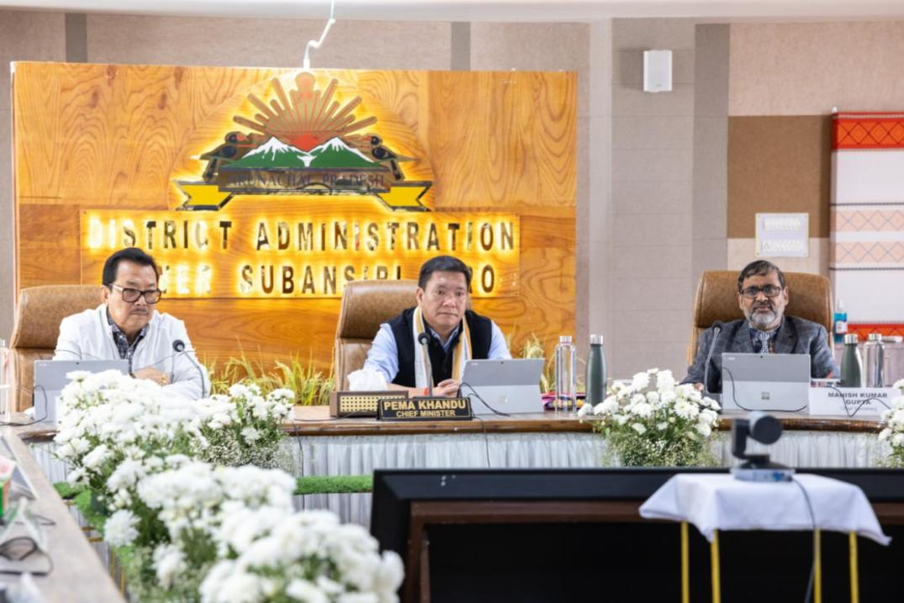
ZIRO, September 8, 2025 : In a significant step towards digital governance and environmental responsibility, the Government of Arunachal Pradesh, led by Chief Minister Pema Khandu, convened a fully paperless cabinet meeting, “Cabinet Aapke Dwar”, at Ziro in Lower Subansiridistrict today. The session was conducted using the eCabinet Application, marking a progressive shift in governance practices, first outside the State Capital.

The Cabinet approved the introduction of the Draft Arunachal Pradesh Urban and Country Planning (Amendment) Bill, 2025 in the forthcoming Legislative Assembly session.In recent years, Arunachal Pradesh has been experiencing rapid urbanization with 47 notified urban centers. Planning interventions are of the outmost importance to regulate haphazard growth and development through the planning process and after considering the vastness of the geographical area and accessibility of the urban towns of the State and to achieve and attain the objective and vision of the State Government. This bill is aimed to address these challenges.
The scheme guidelines for reform-based Part-X (Urban Planning Reforms) of the “Scheme for Special Assistance to the States for Capital Investment 2025-26”, at A.1 (Implementation of Town Planning Scheme (TPS)/Land Pooling Scheme), recommends for the States under “Category A: States without legal framework”, to achieve the formulation of an act, rules and implementing authority with clear roles & responsibilities and to obtain capital incentives of ₹ 100 Crore during the current financial year 2025-26. This amendment Bill will enable the State to access this resource.
Further, amendments of town and country planning acts help to facilitate organized urban growth by allowing for new planning schemes, transferring development rights, transferring administrative authority, empowering local bodies, and ensuring compliance with national and state-level master plans and constitutional provisions like the 74th Amendment Act. These changes also help to control unauthorized development and create better, healthier, and sound environments for people to live in.
Recognising the urgent requirement for enhanced fire safety infrastructure, the Cabinet sanctioned the establishment of four new Fire Stations at Mebo (East Siang), Kimin (PapumPare), Deomali (Tirap), and Lungla (Tawang). Along with these, 68 new posts were created to provide adequate manpower support. The move aims to bridge critical gaps in emergency response and ensure improved safety for residents.

The Cabinet has approved “Arunachal Pradesh Municipal Property Tax Management Rule’ 2025” prepared by Directorate of Town Planning, Department of Urban Affairs. The Property Tax shall be implemented initially in all the Municipal areas of the state.
The State Governments shall attain its goal to strengthen the Urban Local Bodies by implementing decentralized measures on urban governance and empowering them to have sustainable urban growth, improve urban infrastructure and enhance fiscal autonomy of ULBs.
Thus, the implementation of Property Tax in Urban Areas especially in the constituted municipalities of Arunachal Pradesh will enable municipality to generate revenue and make municipality independent and self-reliant in other word AtmanirbharMunicipality.
The Cabinet also approved the Arunachal Pradesh Municipal (Control on Advertisement) Regulations, 2025, which will regulate outdoor advertising in themunicipalities. The regulation seeks to balance commercial interests with urban aesthetics and orderly development.
Further, approval was granted for amendments to the Arunachal Pradesh (Land Settlement and Records) Rules, 2012, enabling the allotment of Government land on lease for agricultural, residential, and commercial purposes, as well as for industries, estates, parks, and public utilities. Lease periods will extend up to 50 years, renewable for an additional 49 years.
The Cabinet approved the amendments to the Recruitment Rules for the posts of Art Expert, Finance and Accounts Officers / Treasury Officers, Labour Inspectors, Statistical Inspectors, and Marketing Inspectors pertaining to the Departments of Information & Public Relations, Finance, Labour & Employment, and Agriculture.

These amendments are aimed at streamlining the recruitment process, updating eligibility criteria in line with present requirements, and ensuring transparency in appointments across the departments.
The Commissioner (Finance), Gvoernment of Arunachal Pradesh on 8th September, 2025 has presented a comprehensive update on State finances, digital receipts, and fund-release mechanisms, underscoring sustained revenue growth and faster, more transparent public financial management before the Hon’ble Cabinet at Ziro, Lower Subansiri District, Arunachal Pradesh.
Strong year-on-year gains in State’s Own Revenue
State’s Own Revenue (SOR) has recorded healthy, broad-based growth over the last three completed years. Total SOR (achieved) rose to Rs.4,030.02 crore in 2024-25 from Rs.2,414.46 crore in 2021-22, an increase of Rs.1,615.56 crore (≈66.9%). Within this, Own Tax Revenue increased to Rs.2,819.70 crore from Rs.1,639.78 crore (+Rs.1,179.92 crore; ≈71.9%), while Own Non-Tax Revenue rose to Rs.1,210.32 crore from Rs.774.67 crore (+Rs.435.65 crore; ≈56.2%).
State’s Own Revenue (SOR) has recorded healthy, broad-based growth over the last nine completed years. Total SOR (achieved) rose to Rs.4,030.02 crore in 2024-25 from Rs.927.19 crore in 2015-16, an increase of Rs.3,102.83 crore (≈334.65%). Within this, Own Tax Revenue increased to Rs.2,819.70 crore from Rs.535.07 crore (+Rs.2,284.63 crore; ≈426.98%), while Own Non-Tax Revenue rose to Rs.1,210.32 crore from Rs.392.12 crore (+Rs.818.20 crore; ≈208.66%).
Arunachal Pradesh's GST collection increased from Rs.227.94 crore in 2017–18 to Rs.1,894.42 crore in 2023–24, reflecting a remarkable growth of 731%.
The Annual Budget has increased to Rs.39,842.23 crore in 2025–26 from Rs.12,533.63 crore in 2015–16 — an increase of Rs.27,308.60 crore, representing a growth of 217.88% over the decade.
Benefits of e-GRAS and e-GSK
To make citizen and business payments simpler and fully auditable, the State implemented the Electronic Government Receipt Accounting System (e-GRAS). First notified on 10.02.2021, e-GRAS was piloted with 14 Departments and progressively extended across the Government through 2024; it is mandated for all credit receipts from 01.01.2025. Key benefits include: a single, 24×7 digital window for Government receipts; automated challan generation and PFMS-ready accounting; faster reconciliation; and significant reduction in manual handling and delays.
To complement e-GRAS at the last-mile, the State has supported e-GSK (GST Suvidha Kendra) facilitation so small traders and remote-area taxpayers can access assisted services for registration and return filing. This handholding improves compliance, widens the base, and brings more small businesses onto digital rails, reinforcing the gains from e-GRAS.
SNA-SPARSH and Treasury Route: release & utilization status
The State also reviewed fund flows under the Single Nodal Agency (SNA) framework using the SPARSH platform, alongside the Treasury Route. Under SNA-SPARSH, Government of India releases total Rs.1,584.87 crore. Of this, Rs.1,098.46 crore has been electronically acknowledged (EA) by the Finance, Planning & Investment Department.

The way forward
The Government will continue to (i) expand and deepen e-GRAS usage across all credit heads, (ii) strengthen e-GSK facilitation to improve voluntary compliance, and (iii) tighten acknowledgement and draw-down cycles on both SNA-SPARSH and Treasury Route funds so that project execution timelines are not impacted. These steps, together with the sustained growth in the State’s own tax and non-tax revenues, will further improve the pace, transparency, and efficiency of public spending.
