GOVERNOR’S SECRETARIAT
ARUNACHAL PRADESH
ITANAGAR

Press Communiqué
Dated Sept 8, 2025

DC West Siang Awards Winners of Jumge Ete Memorial Essay Competition 2025
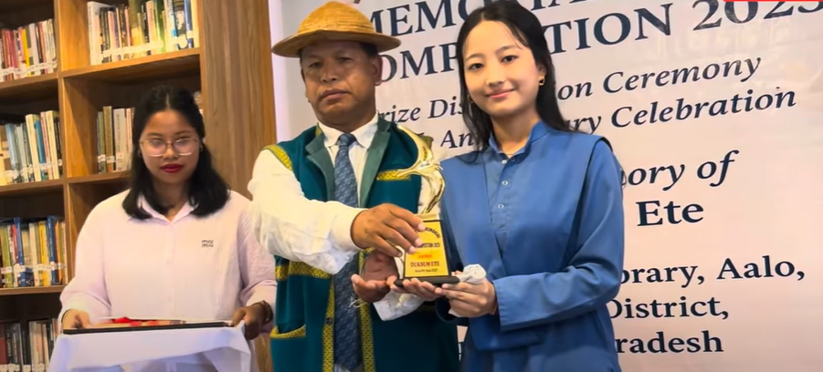
Aalo, September 8, 2025 – Sri Liyi Bagra, APCS, Deputy Commissioner West Siang, graced the prize distribution ceremony of the Jumge Ete Memorial Essay Competition 2025 as Chief Guest at Aalo yesterday. Shri Kardak Riba, Superintendent of Police West Siang, attended the function as Guest of Honour.
The Deputy Commissioner awarded prizes to the winners of the competition. Miss Ina Angu of Class XII (Science) secured the first position, followed by Miss Birdak Mili of Class XII in second place, and Miss Duksum Ete in third place.
Ms. Jumi Ete, Circle Officer Bagra and Chief Coordinator of the event, welcomed the gathering and congratulated the prize winners while encouraging young students for their bright future endeavors.
Speaking on the occasion, SP West Siang Shri Kardak Riba described the event as the best platform for bright students and advised participants to focus on their studies with dedication.
Sri Huzar Lollen (Retired IAS), while delivering the keynote address, emphasized the importance of developing writing and reading skills for a bright future. He encouraged students to participate in competitive examinations and compete at both national and state levels to broaden their horizons.
As Chief Guest, DC Liyi Bagra appealed to students to excel in their academic fields. "Knowledge has no limit for students who are eager to learn," he said, while encouraging active participation in literary activities to enhance understanding and learning.
The Jumge Ete Memorial Essay Writing Competition was conducted on August 25, 2025, for students from Class VI to Class XII, witnessing participation from hundreds of students across the district. The Chief Coordinator announced that similar events would be organized in 2026 as well.
The program was attended by Heads of Departments, parents, students, and teachers from various educational institutions.
