GOVERNOR’S SECRETARIAT
ARUNACHAL PRADESH
ITANAGAR

Press Communiqué
Dated Sept 4, 2025

Union Civil Aviation Minister Inaugurates New Terminal Building at Donyi Polo Airport, Boosting Northeast Connectivity
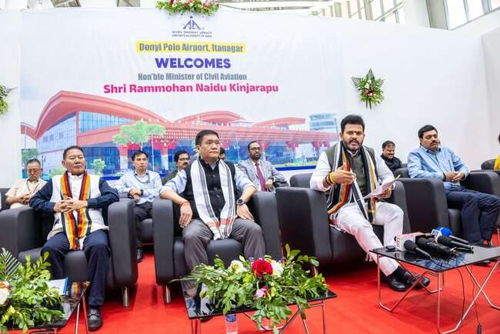
ITANAGAR, September 4 – The Union Minister of Civil Aviation, Shri Kinjarapu Rammohan Naidu, today made the new terminal building at Donyi Polo Airport in Hollongi operational, marking a new era for civil aviation in the Northeast and the State of Arunachal Pradesh. Chief Minister Pema Khandu, Civil Aviation Minister Balo Raja, Chief Secretary Shri Manish Kumar Gupta, and Chairman of the Airports Authority of India (AAI) Shri Vipin Kumar were also present at the event. They were joined by a number of other dignitaries, including Civil Aviation Secretary Mamta Riba, Secretary GA & Protocol Komkar Dolum, Dr. Sharad Kumar, Member (Operations) AAI; Dr. H. Srinivas, Member (Human Resources) AAI; Pankaj Malhotra, Member (Finance) AAI; Suresh Muthiah, Member (Air Navigation Services) AAI; Anil Kumar Gupta, Member (Planning) AAI; Dr. Nikhil Kumar Kanodia, IPS, Chief Vigilance Officer (CVO) AAI; Shri M. Rajakishore, Regional Executive Director (North Eastern Region) AAI, Joint Secretary Ministry of Civil Aviation Shobit Gupta and Rubina Ali, and Director-General (DG) of the Directorate General of Civil Aviation (DGCA) Faiz Ahmed Kidwai.
In a press conference, the Minister hailed the inauguration as a "happy day for civilization and also the State of Arunachal Pradesh," as the new terminal building begins operations. The Minister noted that the project, which had been pending for some time, was completed under the guidance of Chief Minister Pema Khandu, with support from both the Arunachal Pradesh government and the Government of India. The Minister added that civil aviation has been a very important sector for the NDA government under the leadership of Prime Minister Narendra Modi, with the number of airports, aircraft, and passengers doubling in the last 11 years.
A special focus has been placed on improving connectivity in the Northeast. Holongi Airport, which started operations in 2022, is one of several airports in the state to be developed, along with Pasighat, Tezu, and Ziro. The new terminal building at Donyi Polo Airport has a pre-cover capacity of 800 passengers, allowing it to handle up to 15 lakh people per year. This is a significant increase from the previous temporary building, which had a capacity of 150 passengers.
To further boost connectivity, the frequency of flights to Delhi will increase from four days a week to seven days a week, starting September 17. The daily flights, operated by Indigo, will connect Itanagar to a major hub. The airport also currently connects to Guwahati, Kolkata, and Tezu.
The Minister also mentioned discussions are underway to increase connectivity even further, with plans to strengthen regional links, including the development of heliports within the state. This is part of the extended UDAN scheme, which has been renewed for another 10 years to improve domestic and regional connectivity by supporting airlines on routes that were previously considered unviable. The modified scheme will place a special emphasis on extending air connectivity to all northeastern states, hilly regions, and aspirational districts.
Several new passenger-centric initiatives were also launched at the airport. These include the UDAN Yatri Cafe, which provides passengers with food and beverages at reasonable prices; a library initiative that allows passengers to pick up and drop off books at different airports; the AVASAR initiative, which provides a platform for self-help and women's groups in Arunachal Pradesh to sell their products at the airport; and a new kids' store to cater to families traveling through the airport.
These initiatives are part of a broader plan to improve the overall passenger experience. The Minister also stated that the government is looking at providing free Wi-Fi to both domestic and international passengers, as well as installing more charging stations and workstations. The inauguration and the Northeastern Ministerial Conference, held today in Itanagar, are seen as important steps toward strengthening coordination between the central government and the northeastern states to address key development issues.
