GOVERNOR’S SECRETARIAT
ARUNACHAL PRADESH
ITANAGAR

Press Communiqué
Dated September 21, 2025

CM Pema Khandu Honoured with ‘Outstanding Public Service Award’ by Hindu College Alumni Association
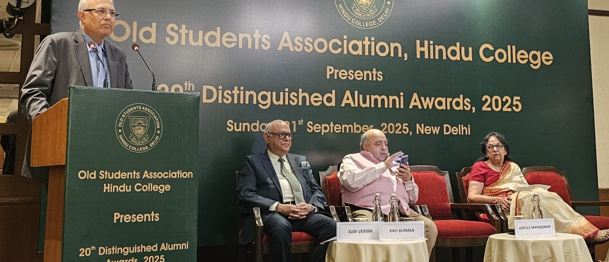

Arunachal Pradesh Chief Minister Pema Khandu has been conferred with the prestigious ‘Outstanding Public Service Award’ by the Old Boys Association of Hindu College (OBAHC), New Delhi. The award, instituted to recognize exceptional contributions to society and governance by alumni of Hindu College, was presented during the 20th Distinguished Alumni Awards 2025 ceremony in New Delhi on Sunday.
On behalf of the Chief Minister, the award was graciously received by Nalong Mize, Chairman of the Arunachal Pradesh Forest Corporation Limited, himself an alumnus of Hindu College.
Expressing his deep gratitude, the Chief Minister dedicated the honour to the people of Arunachal Pradesh, whose trust, cooperation, and collective spirit of progress have guided his journey in public service.
In his message, Khandu said:
“It is truly humbling to be recognised by my alma mater for the work we are doing in Arunachal Pradesh. This honour belongs not to me alone but to the people of my state, who inspire me every day to work harder for a brighter future. I extend my heartfelt thanks to the Old Boys Association of Hindu College for this recognition, and to my fellow Hinduites whose camaraderie continues to enrich my life and service.”
The Old Boys Association of Hindu College, one of India’s most prominent alumni networks, celebrates the accomplishments of its members who have made significant contributions across diverse fields. This year’s recognition of Khandu highlights his transformative leadership in Arunachal Pradesh, marked by major strides in infrastructure development, education, healthcare, good governance, women’s empowerment, and environmental sustainability.
Under his stewardship, Arunachal Pradesh has emerged as a model of balanced progress—blending tradition with modern aspirations—while staying true to the vision of Viksit Arunachal, Viksit Bharat.
The OBAHC members applauded the Chief Minister’s achievements and reaffirmed their pride in his leadership as a shining example of Hindu College’s enduring legacy of nurturing leaders who serve the nation with integrity and dedication.
Other distinguished awardees at the ceremony included Filmmaker Imtiaz Ali, India’s Foreign Secretary Vikram Misri, Supreme Court Judge Justice Manmohan, and Rajiv Nayyar (Lifetime Achievement Award).
