GOVERNOR’S SECRETARIAT
ARUNACHAL PRADESH
ITANAGAR

Press Communiqué
Dated July 18, 2025

Papum Pare DC Vishakha Yadav took stock of the progress of the construction works at Government Engineering college

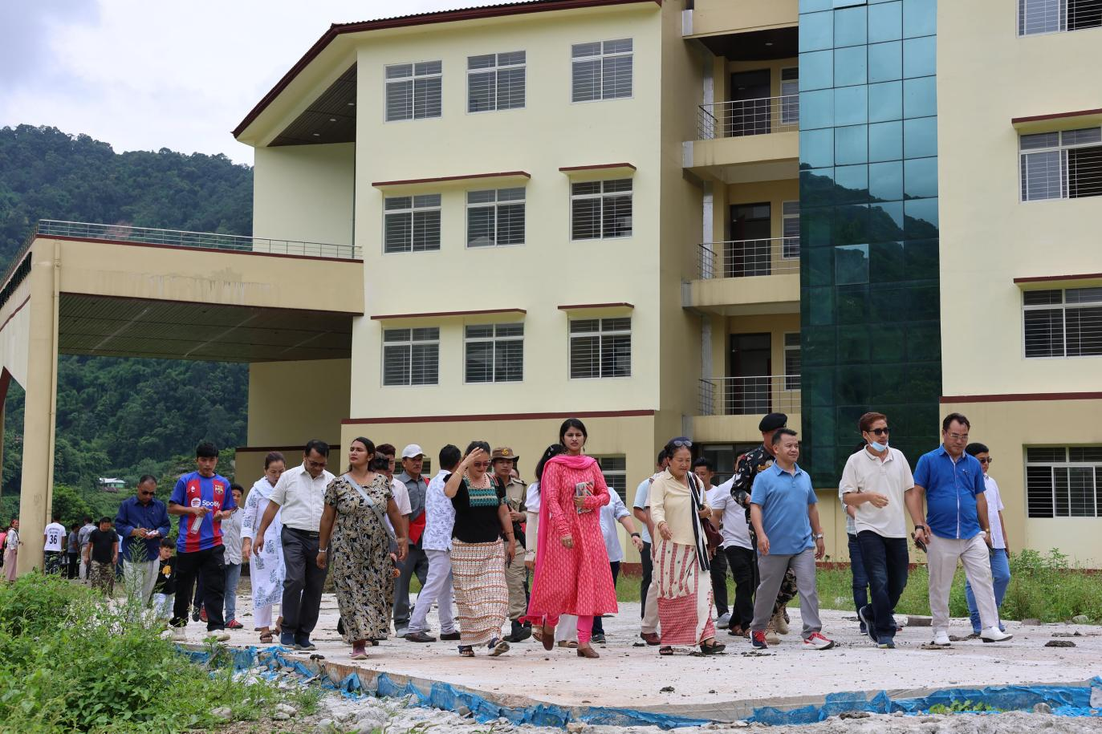

On 18th July the Government of Arunachal Pradesh announced the creation of 34 posts of teaching and non teaching posts for the Government Engineering College at Toru , Papum Pare district.
The news was received with much jubilation specially by the people of 15 Sagalee assembly constituency and particularly the land donors of the engineering college whose 10yrs of long wait was finally seeing the day .
The Foundation of the first engineering college of the state , whose foundation stone was laid by the then Chief Minister of Arunachal Pradesh and the legislature of 15-Sagalee on 15th April, 2025.
The ten year long wait, though frustrating for the people of the area, specially the land doners; who had scarificed their fruit bearing orchards for the construction of the engineering college is finally in the final phases of its completion.
On Thursday 31st July Papum Pare DC Vishakha Yadav inspected the ongoing works at Government Engineering college and held a review meeting with all the stakeholders including the Education department, PWD, PHED, Electrical and the land donors.
During the review taken by the DC Vishakha Yadav at the premises of the college on 31st July a unanimous decision was taken by all the stakeholders to work in a war footing manner to ensure the college starts functioning from the next academic session. i.e 2026-2027.
During the meeting AE, PWD and incharge of the construction works for the engineering college informed that the academic /administrative building, boys and girls hostel have been completed and handed over to the education department.
She further informed that the crucial bridge over the river Pare that connects the college with the other bank will be completed by December, 2025
The Deputy Director, Higher and Technical Education Minto Ete also informed that residential quarters including the Dean’s residence,6 units of Type-IV quarters, 4 units of Type-III, boundary walls, internal roads and playground have been completed.
The construction of the main gate, CC drain and RCC culvert in the approach are going on in full swing and assured completion by the April,2026 before the new academic session starts.
The water and electric supply for the college was also discussed in detail.
The required transformers have been already installed for the college and with assistance from the government the power cables can be laid for the campus soon.

