GOVERNOR’S SECRETARIAT
ARUNACHAL PRADESH
ITANAGAR

Press Communiqué
Dated July 30, 2025

Governor lauds the exemplary service rendered Deepak Nabam Living Home and Mother’s Home
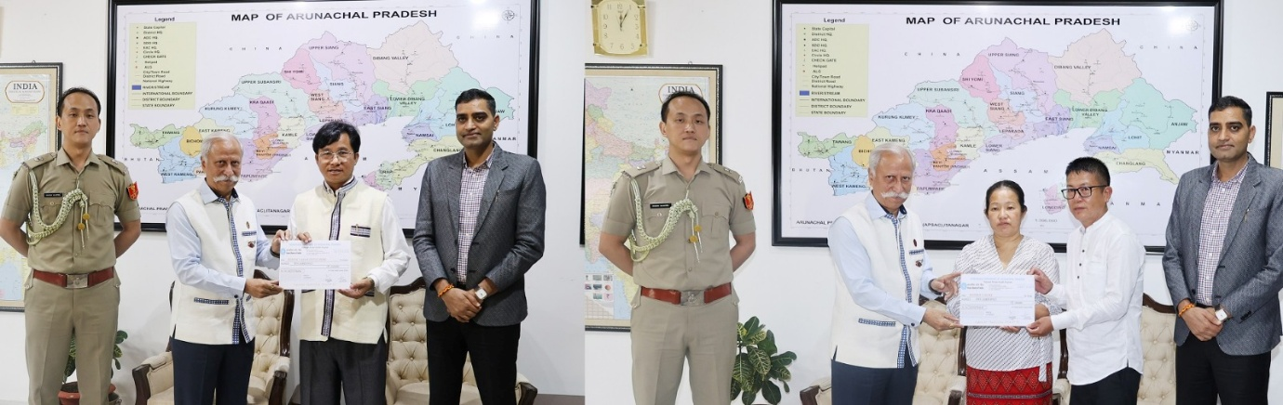
ITANAGAR, July 30:
The Governor of Arunachal Pradesh, Lt. General KT Parnaik, PVSM, UYSM, YSM (Retd.) handed over Grant-in-Aid cheque of Rs. 10 Lakh to Deepak Nabam Living Home, Senki Park, Itanagar and another cheque of Rs. 5 Lakh to Mother’s Home, Lekhi Village. Deepak Nabam, Chairman, Deepak Nabam Living Home and Taillang Puming and Taillang Lodor, Secretary, Mother’s Home, received their cheques.
The Governor, who has consistently advocated for the welfare and dignity of persons battling mental health challenges, called upon all NGOs to redouble their efforts in the rehabilitation and reintegration of such individuals into society. Acknowledging the growing need for compassionate care and structured support systems, he emphasized that mental health should no longer be a silent struggle or social taboo, but a shared responsibility.
The Governor lauded the exemplary service rendered by organizations like Deepak Nabam Living Home and Mother’s Home, recognizing them as shining examples of humanity in action. He deeply appreciated the selfless dedication of their teams, noting that such efforts not only heal lives but also restore hope, dignity, and a sense of belonging to those who need it the most.
The Governor said that their unwavering commitment to supporting some of the most vulnerable and neglected members of our society, especially those grappling with mental illness and abandonment, reflects true social service. He said that the State and Central Governments are always with them to take up their benevolent mission ahead through various programmes.
Commissioner to Governor and Commissioner Health, Shri Pawan Kumar Sain, State Programme officer, National Mental Health Programme (NMHP), Dr. Haniya Payee, in-charge Tele MANAS, NMHP, Dr. Hatobin Mai, and Director, Finance, NMHP Habung Youngbow, were also present during the function.

