GOVERNOR’S SECRETARIAT
ARUNACHAL PRADESH
ITANAGAR

Press Communiqué
Dated August 5, 2025
Governor Congratulates Ms Yano
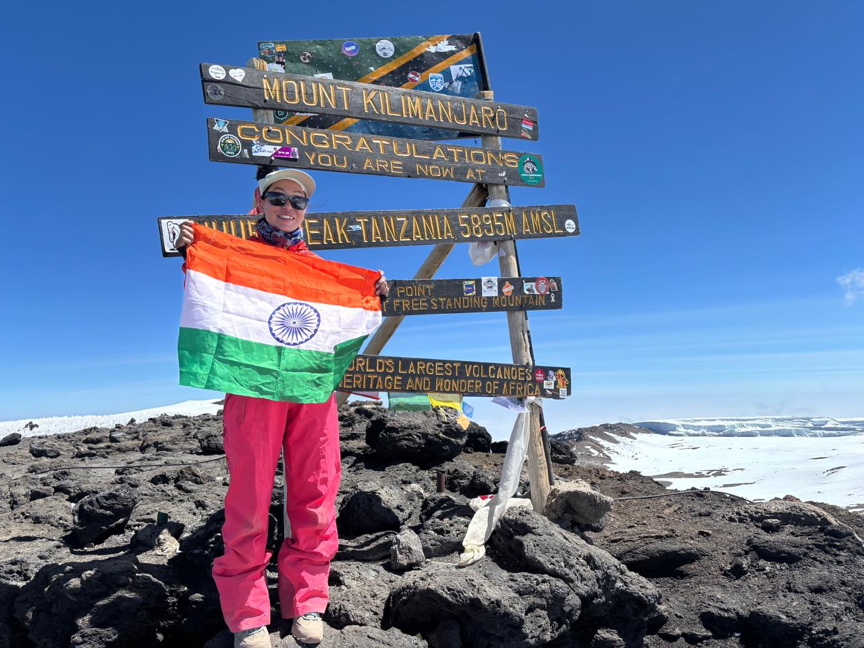
The Governor of Arunachal Pradesh, Lt. General KT Parnaik, PVSM, UYSM, YSM (Retd.), has congratulated Ms. Kabak Yano on successfully summiting Mount Kilimanjaro, the highest peak in Africa and one of the renowned Seven Summits of the world.
The Governor, who had flagged off Ms. Yano’s expedition on 28th July 2025, expressed immense pride in her achievement. He remarked that Ms. Yano, an accomplished Everest climber, has once again demonstrated the indomitable spirit, courage, and perseverance that define the people of Arunachal Pradesh.
The Governor said that Ms Yano’s feat is a source of inspiration for all, especially the youth of Arunachal Pradesh, reminding them that with grit and determination, no summit is beyond reach.
Ms. Yano reached the summit of Mount Kilimanjaro on 4th August 2025 at 10:27 AM (African Time). Towering at 5,895 meters (19,340 feet), the iconic snow-capped volcano in Tanzania is the tallest peak on the African continent. It is also the highest free-standing mountain in the world.

