GOVERNOR’S SECRETARIAT
ARUNACHAL PRADESH
ITANAGAR

Press Communiqué
Dated August 5, 2025
Chief Minister Pema Khandu Launches ‘Water Bill’ App for Online Payments, Pushes Digital Transformation in Public Services
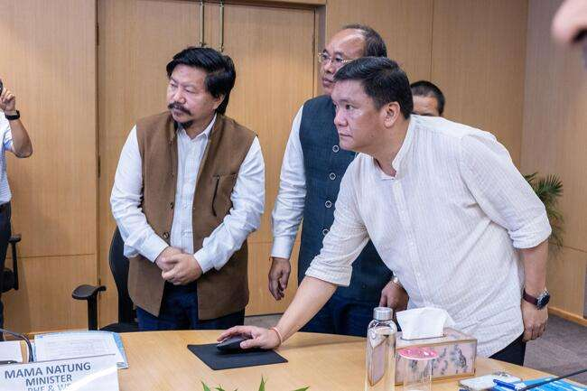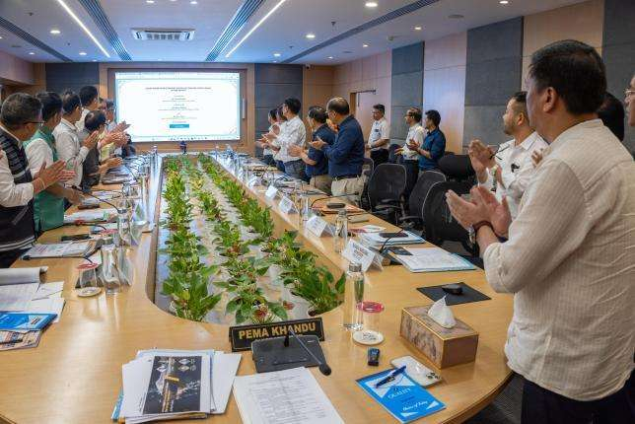
Chief Minister Pema Khandu today launched the ‘Water Bill’ app of the department of Public Health Engineering & Water Sanitation (PHE&WS) that would enable citizens to pay their water bills online without having to physically visit the offices for bill payment.
The app – as a pilot project – will be available for consumers in the Itanagar Capital Region (ICR) to begin with.
Lauding the department for the digital initiative, the Chief Minister termed it as - a step that brings essential public service closer to the people.
“For the people in Itanagar Capital Region, paying a water bill will no longer mean taking half a day off work or standing in a long queue. Now, it’s just a few taps on a phone, a few clicks on a screen,” he added.
Khandu urged the department not to keep the service confined to ICR but to take it to all the districts.
“But this shouldn’t be just about Itanagar. It has to be part of a larger vision to bring digital systems for water connections, billing, and grievance redressal to every District Headquarters in Arunachal Pradesh,” he said.
Digitalization of bill payments by citizens, Khandu observed, greatly enhances revenue collection and urged all revenue earning departments of the state government to follow suit.
“Digital revenue collection is transparent, happens in real time and there is no leakage. But the best part is accessibility and ease of payment by the consumers,” he said.
Meanwhile, the Chief Minister also took stock of the department’s ongoing projects, future endeavours and departmental issues.
While assuring the state government’s support with funds and manpower, Khandu suggested recruitment of trained people even for contingency posts in the department.
“Take in youths who have passed out from our ITIs. They are technically capable. All work departments should do the same. Recruit ITI pass-outs even if it is a contingency or MTS post. This way our youths would opt for the ITIs established across the state. They will get employment and you will get technicians,” he added.
PHE&WS minister Mama Natung, Advisor Pani Taram, Chief Secretary Manish Kumar Gupta and departmental officials were present during the launch.

