GOVERNOR’S SECRETARIAT
ARUNACHAL PRADESH
ITANAGAR

Press Communiqué
Dated August 4, 2025
CM Pema Khandu Launches Mission Karmayogi Training, Calls for Transformative Governance and Citizen-Centric Administration
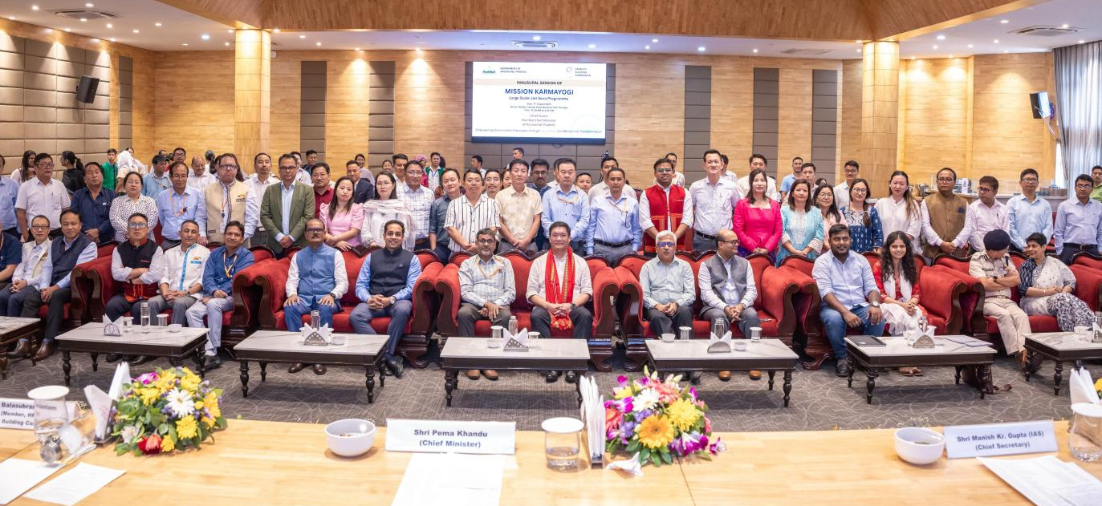
Chief Minister Pema Khandu on Monday emphasized the need for continuous capacity building of civil servants to align governance with the evolving aspirations of citizens in a rapidly changing world.
Speaking at the inaugural session of a five-day lead trainers’ workshop under Mission Karmayogi - India’s ambitious civil services reform initiative - Khandu said that a future-ready, citizen-centric, and responsive bureaucracy must be equipped with the right mix of attitude, knowledge, and skills to meet 21st-century governance challenges.
“Mission Karmayogi is not just another training programme. It is a movement. A transformative journey to reorient our government employees to go beyond the routine, to act with empathy, to serve with humility, and to solve with creativity,” the Chief Minister noted.
He further underlined that this five-day capacity-building initiative isn’t only about acquiring new skills.
“This 5-day capacity-building initiative isn’t only about acquiring new skills. It’s about shifting mindsets. It’s about doing things differently, and doing them with purpose. Because real change, the kind that lasts doesn’t start in policy files or memos. It starts within us. In how we show up. In how we treat the people who walk through the doors of a public office,” Khandu said.
The training workshop, jointly conducted for officials from Arunachal Pradesh and Tripura, is being organized by the Capacity Building Commission (CBC), Government of India, barely a month after Arunachal signed a memorandum of understanding with the Commission through its Administrative Training Institute.
While welcoming the initiative, Khandu made a strong pitch for culturally sensitive development, cautioning that neither tradition nor progress should come at the cost of the other.
“If development erodes our cultural values, that’s a tragedy. But if in the name of preserving culture, we reject development, that’s equally tragic,” the Chief Minister observed.
Khandu also stressed the need to improve the happiness index alongside governance reforms. “Development must make people happier. If governance improves but the happiness index declines, we’ve missed the point,” he said.
The Chief Minister reiterated the state government’s commitment to ensuring inclusive development, especially for the most underserved. He said Mission Karmayogi will further strengthen efforts to reach the “last person in the queue.”
To truly achieve the mission’s objectives, he advocated a shift from rule-based to role-based human resource management, modernization of training across all departments, digital upskilling, improved service delivery, and fostering a culture of transparency and performance.
Calling Mission Karmayogi the world’s largest capacity-building initiative, Khandu praised Prime Minister Narendra Modi for his visionary leadership in launching such a transformative reform.
Addressing the batch of lead trainers, he urged them to fully engage with the training process and return to their districts ready to guide the next level of master-trainers. He also encouraged a citizen-first mindset, asking them to reflect on key questions:
“How welcoming is your office? How responsive are you to public concerns? Are your staff respectful and accommodating? And how effectively are issues being resolved?”
The Chief Minister set a two-month timeline, till September, for the completion of Mission Karmayogi’s training modules across Arunachal Pradesh.
Manish Kumar Gupta, Chief Secretary, Dr R Balasubramanium, Member (HR) CBC, Shyama Prasad Roy, Joint Secretary, CBC and consultants from CBC were present on the occasion along with lead trainers of Arunachal Pradesh and Tripura.
