GOVERNOR’S SECRETARIAT
ARUNACHAL PRADESH
ITANAGAR

Press Communiqué
Dated August 4, 2025
District Level Science Exhibition Held Under Rashtriya Avishkar Abhiyan in Lohit
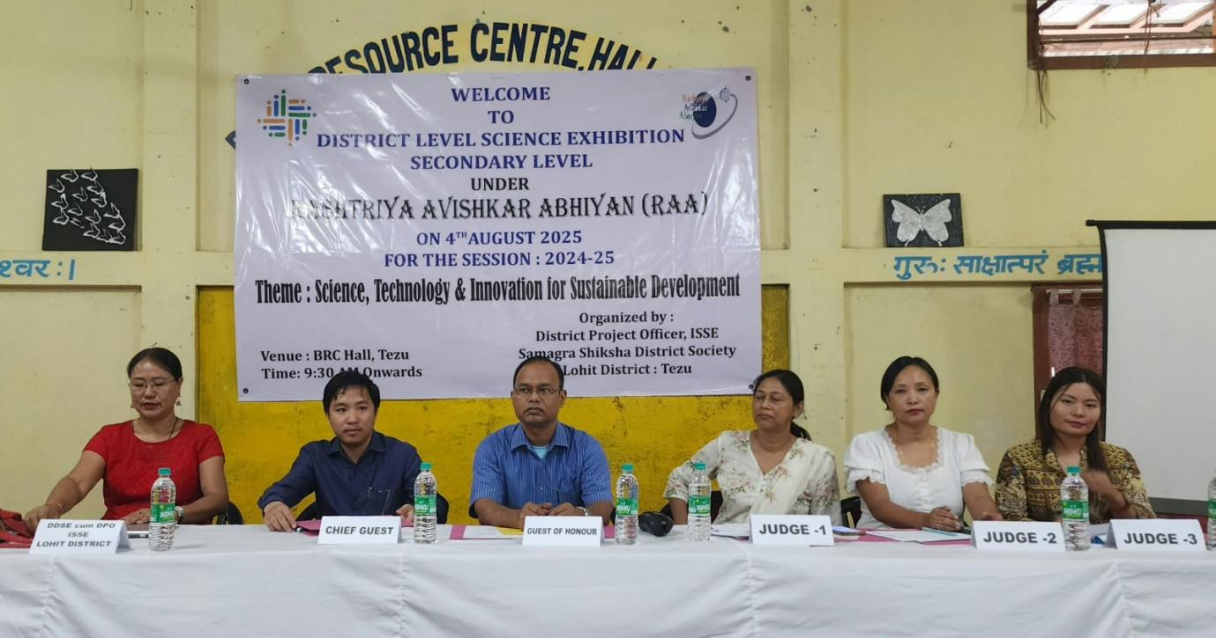
Lohit, August 4, 2025
A District Level Science Exhibition Competition for secondary-level students was successfully organized today under the Rashtriya Avishkar Abhiyan (RAA) by the District Project Officer (DPO), ISSE Samagra Shiksha, District Society Lohit. It was attended by Nyatum Doke DIPRO as Chief Guest and Om Prakash Principal KV Tezu as Guest of Honour. The event aimed to promote scientific thinking and innovation among school students and saw enthusiastic participation from nine government schools across the district.
Tumngam Nyodu, DDSE-cum-DPO ISSE, in her address, highlighted the core objectives of the Rashtriya Avishkar Abhiyan. She stated that the initiative is designed to nurture a scientific temper among students and encourage them to apply classroom knowledge to real-life challenges. She further emphasized the importance of hands-on learning, creativity, and curiosity in building the future scientific community of India. She urged teachers to act as facilitators and mentors, creating an environment where students feel confident to question, explore, and innovate.
Chief Guest Nyatum Doke DIPRO delivered an inspiring speech, reminding students that the event was not merely about displaying scientific models but about celebrating the spirit of curiosity, the power of innovation, and the future of the nation. He said, “Every project showcased here, whether big or small, simple or complex, represents the untapped potential of our young minds. It reflects your imagination, your thought process, and your willingness to engage with the world around you.”
He encouraged students to see their work as part of a larger national mission, stating, “What you are doing today is not just an academic exercise. It is the foundation of nation-building. The great scientists we admire—Dr. A.P.J. Abdul Kalam, Sir C.V. Raman, Marie Curie—did not start with grand laboratories. They began with curiosity, questions, and the courage to explore.” He further emphasized that science is about asking “why,” “what if,” and “how,” rather than rote memorization of facts and formulas. “Even a simple model for water filtration or a concept for renewable energy matters because of the thinking behind it. That is the essence of real science,” he said.
Guest of Honour, Om Prakash, Principal of Kendriya Vidyalaya Tezu, also spoke on the occasion, urging students to persevere and not be disheartened by failure. He stressed the importance of maintaining a scientific temper and a questioning mindset, and encouraged students to continue exploring and learning beyond the classroom.
The exhibition featured models and presentations across diverse themes such as Sustainable Development, renewable energy, health, and rainwater harvesting, reflecting the pressing environmental and societal concerns of today. The event witnessed enthusiastic engagement from students, teachers, and the wider academic community.
Among the participating schools, the top three entries were selected based on innovation, scientific relevance, and presentation. These students will now move forward to represent the district at the state-level science exhibition.
