GOVERNOR’S SECRETARIAT
ARUNACHAL PRADESH
ITANAGAR

Press Communiqué
Dated August 4, 2025
Ceremonial Programme On Commencement Of Classes With Hostel Facilities VKV Ramsing Held
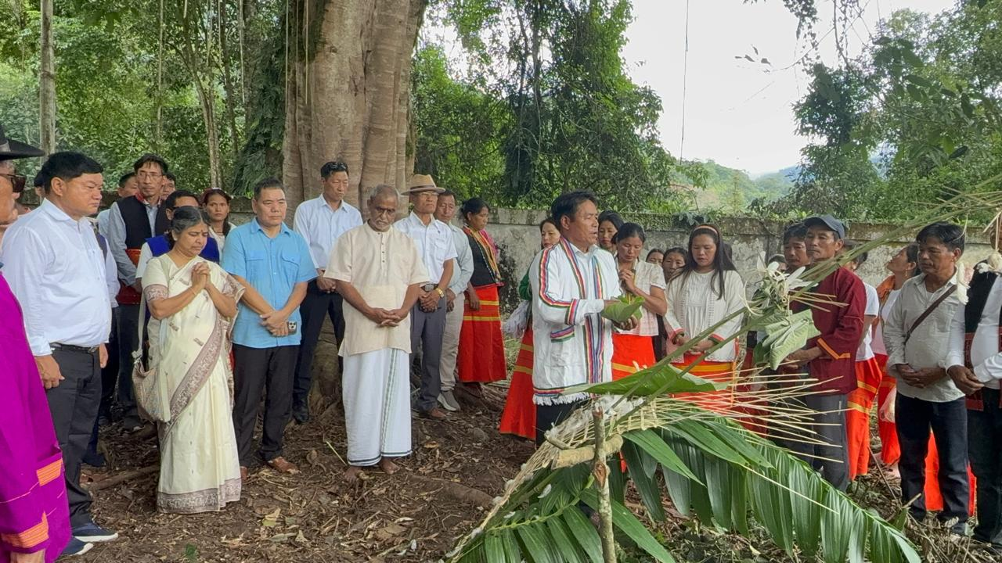
Ramsing, 4th August 2025: A grand ceremony marked the commencement of academic classes with hostel facilities at designated Vivekananda Kendra Vidyalaya (VKV), Ramsing (Pittung) today. The occasion was graced by Shri Hanumantha Rao Ji, All India Vice President, Vivekananda Kendra, Kanyakumari as the Chief Guest, and Ms. Sujatha Nayak Ji, Secretary, VKV Arunachal Pradesh Trust, Dibrugarh, as the Guest of Honour. The ceremony began with a traditional Bhumi Pujan, conducted by the Donyi Polo Yelam Kebang team, led by priest Takong Mingki, followed by a tree plantation drive within the school campus, organized by the Department of Forest and Environment, Yingkiong, symbolizing growth, sustainability, and a greener future for the coming generations.
Addressing the gathering, Shri Hanumantha Rao Ji highlighted the long-standing association between VKVs and Arunachal Pradesh, dating back to the establishment of the first school in 1977. He remarked that VKVs have grown into premier educational institutions, not only imparting academic knowledge but also instilling cultural values, patriotism, and a sense of responsibility among students. He praised the relentless efforts of the VKV Trust in the holistic development of children in the state and stated that studying in a VKV is a matter of pride. Shri Rao also lauded the Deputy Commissioner and his team, as well as local community leaders, for their unwavering dedication and efforts in making VKV Ramsing functional.
Guest of Honour Ms. Sujatha Didi, in her address, informed that VKV Ramsing is the 45th VKV established in Arunachal Pradesh, and marks the beginning of a new chapter in education for the region. She emphasized the crucial role of good teachers in society and their importance in fostering holistic education.
Hon’ble MLA and Advisor to the Hon’ble Chief Minister, GoAP, Shri Alo Libang, described the day as “historic and a dream come true” for the people of Upper Siang, especially for the residents of Ramsing. He expressed his heartfelt appreciation to all contributors, including the land donors from Rotgo Banggo and BRO contractors, for their support in turning this vision into reality. He recounted the initial challenges and his efforts to bring VKV to Upper Siang to enhance the district’s educational landscape.
Deputy Commissioner Shri Talo Jerang elaborated on the steps taken by the District Administration to make the school functional. He stated that although the infrastructure had been completed in 2017, it remained unused until a concerted effort was made over the past two months to operationalize it. Through collective mobilization of resources and support from HoDs, community leaders, and well-wishers, the school is now ready to begin operations. He emphasized that it is indeed a matter of celebration and jubilation for the people of Upper Siang and residents of Ramsing in particular, stating, “Getting a premier VKV school in our district is in itself a great achievement and a source of immense pride. We should all feel proud of this collective accomplishment.” He informed that boys from Classes III to V will begin classes at Ramsing, and by October or November, the entire school up to Class X will be shifted from its temporary location in Yingkiong to Ramsing. However, Classes Nursery to II will continue at Yingkiong for the time being. He also acknowledged the generous support from the local community, noting that 571 individuals contributed to the cause, and over 200 pieces of furniture were made from locally raised funds. Further, DC also directed the DDSE to ensure monthly inspections and extend full logistic support to VKV Ramsing.
Shri Lumgeng Litin, Zilla Parishad Chairperson (ZPC), also spoke on the occasion. He congratulated the entire team behind VKV Ramsing’s successful operationalization and emphasized the role of community participation in transforming the educational landscape of rural areas. He expressed hope that the school would emerge as a centre of excellence and inspire future generations.
Dr. R. Karkare, Principal of VKV Ramsing, expressed gratitude to the District Administration and assured that all efforts will be made to make VKV Ramsing one of the best-performing schools in the state. Shri Lobo Apang (Retd. Teacher) and committee member also addressed the gathering and shared the background and vision of VKV Ramsing.
Earlier, the Organizing Committee Chairman of the ceremony, Shri Dungge Apang, welcomed the distinguished guests and participants. Shri Kabir Apang, Retd. APCS Officer, delivered the vote of thanks and described the event as a milestone in the field of education. He extended his gratitude to the local legislator Alo Libang, Deputy Commissioner and his entire team and all individuals whose collective support made the school’s inauguration possible.
The programme was attended by a large gathering including all Heads of Departments (HoDs), PRI leaders, Gaon Burahs (GBs), public leaders, local residents, officials from the Border Roads Organisation (BRO), VKV staff, community leaders, and members of various Self Help Groups (SHGs).
Nestled in a picturesque valley near the Siang River and surrounded by lush greenery, VKV Ramsing is spread across a sprawling 8-acre campus and is well-connected by road, promising a serene and conducive environment for learning.
