GOVERNOR’S SECRETARIAT
ARUNACHAL PRADESH
ITANAGAR

Press Communiqué
Dated August 2, 2025

Horticulture Department Distributes Agricultural Inputs Under Vibrant Village Programme in Tawang

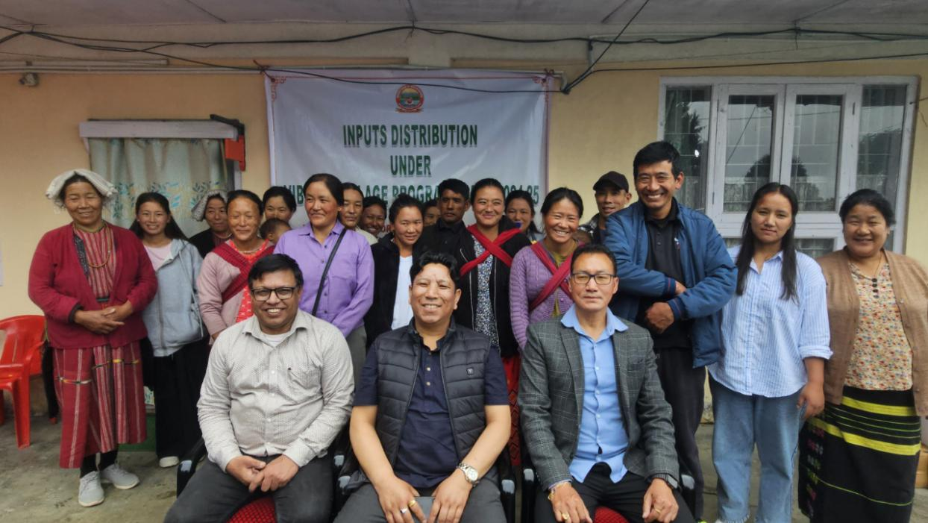
Tawang, 02/08/2025 : The Department of Horticulture, Tawang, today organized an Horticultural input distribution programme under the Vibrant Village Programme (VVP) for three villages under the Pamakhar Circle of Lungla Sub-Division. The event took place at the DHO Office, Tawang, and was attended by 24 beneficiaries from the identified villages.
Each beneficiary were given hybrid vegetable seeds Kit comprising of 12 different vegetables, organic Plant Protection chemical Kits, 25 kg of organic manure and one knapsack sprayer aimed at promoting vegtable cultivation in the border villages organic and sustainable farming practices in border areas.
The programme was graced by Assistant

Commissioner Tawang, Tenzin Jambey, along with District Horticulture Officer (DHO) Safior Rahman, Sub-Divisional Horticulture Officer (SDHO) Lungla, Koncho Gyatso, and other officials from the Horticulture Department.
In his address, AC Tenzin Jambey elaborated on the Vibrant Village Programme, which has replaced the erstwhile Border Area Development Programme (BADP). He emphasized that the VVP is a comprehensive government initiative implemented through various departments and agencies, including central paramilitary and security forces, to ensure sustainable livelihood and all-round development of border villages. He urged the villagers to adopt organic farming methods to promote health, sustainability, and long-term soil fertility.
DHO Safior Rahman provided practical guidance to the farmers on the appropriate use of organic inputs such as pesticides, manure, and fertilizers, highlighting their role in improving crop yield and managing plant diseases effectively.
SDHO Koncho Gyatso stressed the significance of organic farming in promoting eco-friendly agriculture. He informed that the beneficiary villages under the programme were identified by the central government across five blocks of Tawang. The selection of individual beneficiaries was done in coordination with local panchayats and Gaon Burahs. He further mentioned that the Jang Thingbu block has already been covered, and inputs will soon be distributed to the remaining identified beneficiaries.
SDHO Gyatso also extended his heartfelt gratitude to AC Tenzin Jambey and all stakeholders for their active participation and support in making the event a success.
