GOVERNOR’S SECRETARIAT
ARUNACHAL PRADESH
ITANAGAR

Press Communiqué
Dated August 2, 2025

Deputy CM Chowna Mein Sets Targets, Launches Akanksha Haat at Samaroh

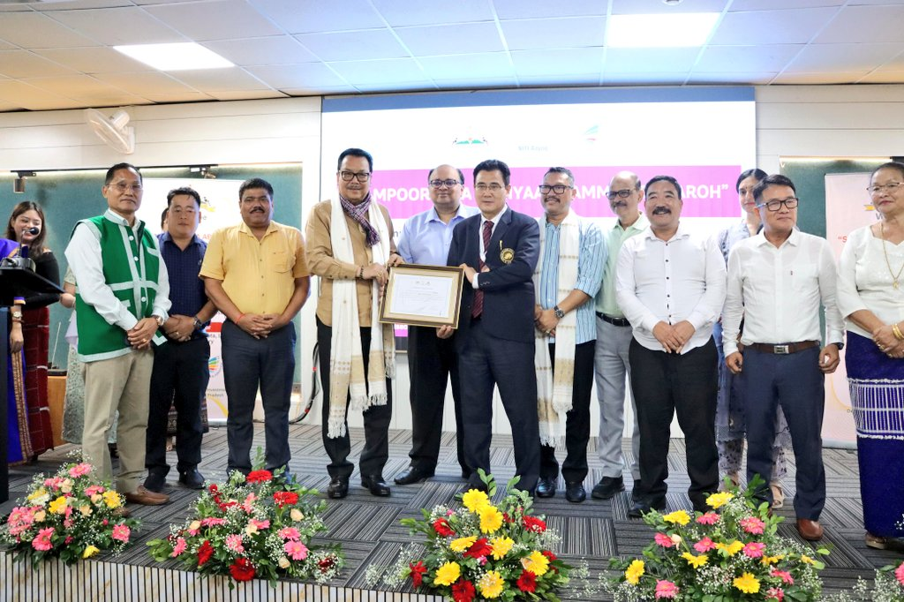
Itanagar, August 2: Deputy Chief Minister of Arunachal Pradesh, Chowna Mein, who is also the Minister In-Charge for Planning & Investment today attended the “Sampoornata Abhiyaan Samman Samaroh” held at the Dorjee Khandu State Convention Centre, Itanagar. The event was jointly organised by the Planning & Investment Department, Government of Arunachal Pradesh, and NITI Aayog to celebrate and recognise achievements made under the Aspirational District and Aspirational Block Programmes.

In his address, the Deputy CM called the Abhiyaan more than just a governance exercise. “It is a mission to ensure that every single citizen reaps the full benefits of every flagship government scheme. It is about converting aspirations into measurable, actionable outcomes,” he said.
The Deputy Chief Minister extended his heartfelt congratulations to all the awardees recognised under the Aspirational District and Aspirational Block Programmes for their outstanding contributions to grassroots development.
He lauded the outstanding performance of Namsai district, which has climbed from the 97th to the 12th position among the 112 Aspirational Districts in India. “This remarkable leap is a testament to the tireless efforts of the district administration, field officials, and the active participation of the local community,” he noted.
He congratulated the Deputy Commissioner of Namsai, the BDO of Chongkham, and other officials for their well-deserved recognition. Their leadership helped achieve 100% saturation in key performance indicators (KPIs) across several blocks, most notably Chongkham and Lekang.
DCM further said that this is not the final goal but the beginning of a greater journey. He issued a clear directive to all officers and stakeholders involved in the Aspirational District Programme of Namsai and the Aspirational Block Programmes of Chongkham (Namsai), Tali (Kra Daadi) and Pongchau (Longding) to ensure 100% saturation in remaining KPIs by December 2025.
“I will personally visit Pongchau Aspirational Block in Longding District and Tali Aspirational Block in Kra Daadi District during the coming winter to oversee and review progress,” he announced.
He also urged Senior Officers and Deputy Commissioners to intensify monitoring of all Central and State flagship programmes to ensure timely execution and quality outcomes.

“Monitoring must be regular, purposeful, and aligned with our goal of saturation. Every indicator from healthcare and nutrition to education, soil health, and electrification, must be pursued with accountability and urgency,” he said.
Describing the momentum as the rise of a governance culture called ‘Team Arunachal’, Mein acknowledged the silent efforts of Deputy Commissioners, DPOs, BDOs, field workers, data managers, and countless others.
While launching the ‘Akanksha Haat’, a week-long initiative to promote self-help groups (SHGs) and local enterprises, Mein described it as a celebration of grassroots innovation and community empowerment.
“This platform not only showcases local products and talents but also nurtures self-reliance and strengthens the rural economy,” he added.
Commissioner (Planning & Investment), Ankur Garg, expressed his gratitude to NITI Aayog for its continued guidance and for fostering a spirit of competition, collaboration, and performance among states. He noted that the Aspirational District and Block Programmes mark a transformative shift towards targeted, data-driven development, with a strong emphasis on the three Cs - Convergence, Competition, and Collaboration.
The event was also attended by MLA Namsai, Zingnu Namchoom, Secretary Planning & Investment R.K. Sharma, Secretary Rural Development & Panchayati Raj, Sonal Swaroop, San Gupta from NITI Aayog, and the Deputy Commissioners of Namsai and Longding, among others.
