GOVERNOR’S SECRETARIAT
ARUNACHAL PRADESH
ITANAGAR

Press Communiqué
Dated August 19, 2025

Arunachal Pradesh Celebrates 4th Edition of Entrepreneurship Development Programme
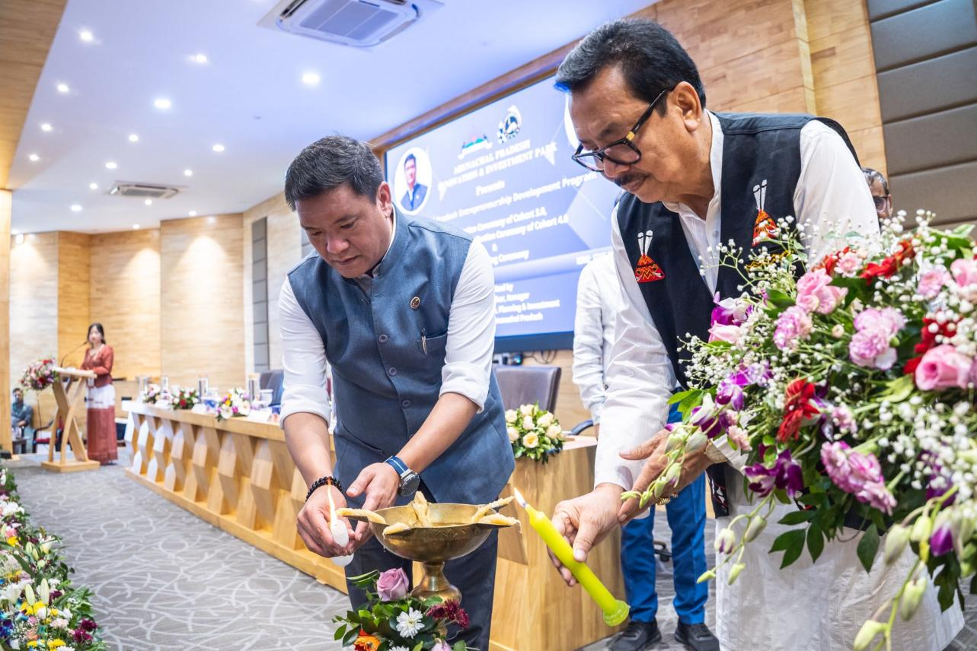
Itanagar, August 20, 2025 – Chief Minister Pema Khandu presided over the 4th Edition of the Arunachal Pradesh Entrepreneurship Development Programme (APEDP) featuring the graduation ceremony for Cohort 3, prize distribution for Cohort 4, and MoU signing ceremony.
The event showcased the remarkable progress of the Arunachal Pradesh Innovation and Investment Park (APIIP), which has evolved from vision to a thriving innovation ecosystem since its inception.

Key Achievements
Since APEDP's launch in 2020, the programme has:
- Supported 106 startups across various sectors
- Provided over Rs 4.5 crore in seed funding
- Created a robust entrepreneurial ecosystem in the state

Future Vision
Chief Minister Khandu announced plans for a world-class permanent campus for APIIP and the expansion of YES (Youth Empowerment Service) Arunachal to ensure comprehensive access to growth opportunities for the state's youth.
"It has been a joy to witness the growth of our startups and the journey of APIIP. What began as a vision is now a vibrant ecosystem of innovation," stated CM Khandu during the ceremony. The initiative continues to strengthen Arunachal Pradesh's position as an emerging hub for innovation and entrepreneurship in Northeast India.
