GOVERNOR’S SECRETARIAT
ARUNACHAL PRADESH
ITANAGAR

Press Communiqué
Dated August 15, 2025

CM Pema Khandu hoisted the Tricolour at IG Park to mark the 79th Independence Day, Itanagar
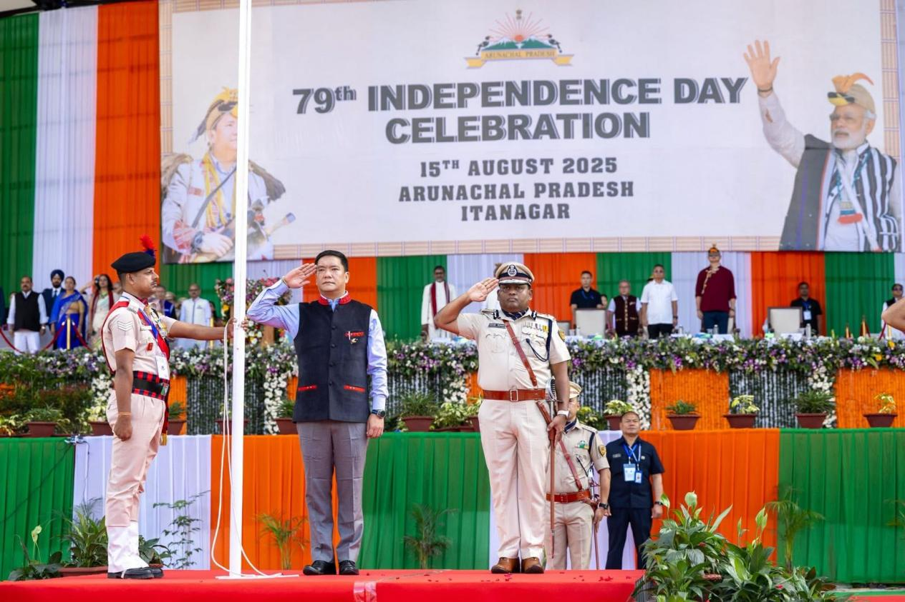
Itanagar, August 15, 2025 - Chief Minister Pema Khandu today hoisted the Tricolour at IG Park to commemorate India's 79th Independence Day, marking the occasion with impressive participation from marching contingents of the Central Armed Police Forces, State Police, XI Nagaland Armed Police, and students from across the state.
In his address to the gathering, the Chief Minister emphasized the importance of collective action in building a developed Arunachal Pradesh by 2047, aligning with the nation's vision of Viksit Bharat. "On this historic day, I appeal to everyone to work together for Viksit Arunachal @ 2047," stated Chief Minister Khandu, extending an invitation to all citizens to contribute their ideas and suggestions towards this transformative goal.

Five Pran for Viksit Arunachal
The Chief Minister outlined five fundamental pledges - the "5 Pran" - that every citizen should embrace for the state's comprehensive development:
1. Keep Arunachal Clean, Keep Arunachal Proud
Emphasizing environmental cleanliness and civic pride as foundational elements of progress.
2. Live Green, Respect Nature
Promoting sustainable living practices and environmental conservation in harmony with the state's rich biodiversity.
3. Buy Local, Build Local
Encouraging support for local businesses and industries to strengthen the state's economy and foster self-reliance.
4. Be Digitally Smart, Be Future-Ready
Advocating for digital literacy and technological advancement to prepare citizens for the challenges of tomorrow.
5. Be Alert, Support Law and Order
Calling for active citizenship in maintaining peace, security, and rule of law across the state.
The Independence Day celebration witnessed enthusiastic participation from various security forces and educational institutions, reflecting the unity and commitment of Arunachal Pradesh towards national development goals.
Chief Minister Khandu's vision for Viksit Arunachal @ 2047 represents a comprehensive approach to development that encompasses environmental sustainability, economic growth, technological advancement, and social harmony.
