GOVERNOR’S SECRETARIAT
ARUNACHAL PRADESH
ITANAGAR

Press Communiqué
Dated August 10, 2025

CJI Justice B.R. Gavai Inaugurates New Court Building of Itanagar Permanent Bench of Gauhati High Court
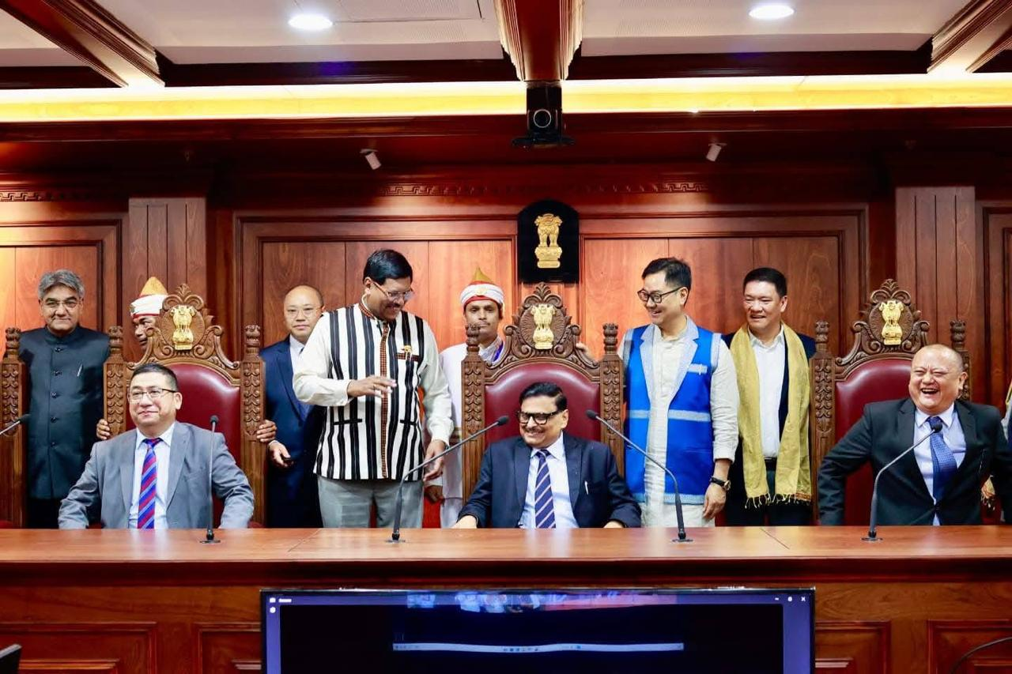
Naharlagun, Arunachal Pradesh The newly constructed Court Building of the Itanagar Permanent Bench of the Gauhati High Court at Naharlagun was inaugurated today by Hon’ble Chief Justice of India Justice B.R. Gavai in a grand ceremony attended by a host of dignitaries from the judiciary and government.

The inaugural event witnessed the presence of Hon’ble Chief Minister of Arunachal Pradesh Shri Pema Khandu, Hon’ble Judges of the Supreme Court of India — Justice Ujjal Bhuyan, Justice Sandeep Mehta, Justice N. Kotiswar Singh, and Justice Vijay Bishnoi — along with Hon’ble Deputy Chief Minister Shri Chowna Mein and Hon’ble Minister of State for Law and Justice Shri Arjun Ram Meghwal.

Also gracing the occasion were Chief Justice of the Gauhati High Court Justice Ashutosh Kumar, Justice Michael Zothankhuma (Judge Administrative Department, Gauhati High Court), Judges of the Gauhati High Court, Hon’ble Justice Hrishikesh Roy, Former Judge of the Supreme Court of India, and other eminent dignitaries.
