GOVERNOR’S SECRETARIAT
ARUNACHAL PRADESH
ITANAGAR

Press Communiqué
Dated August 2, 2025

565 SHG Members Attended the Annual General Body Meeting of Hiichi Bulla MPCS Ltd. in Ziro Valley

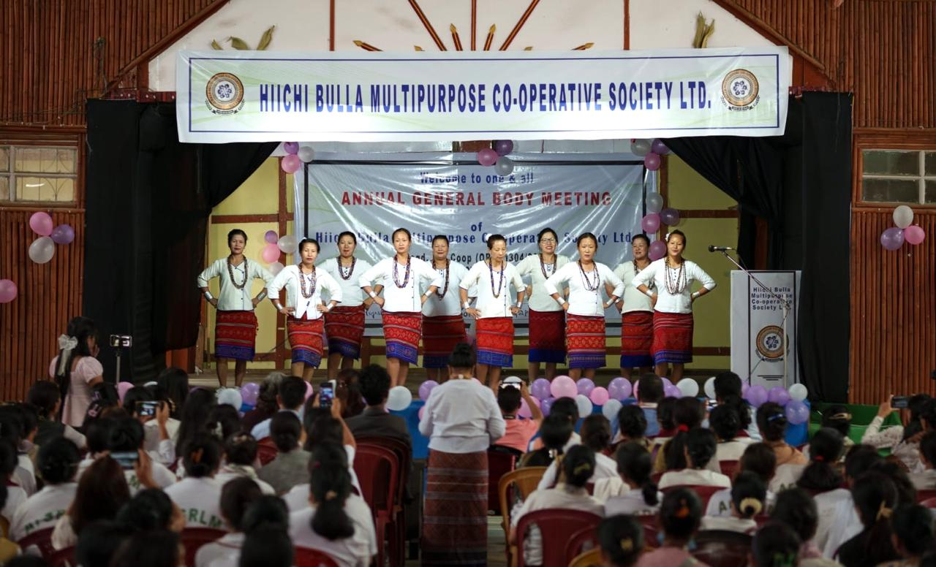

Abotani Hall, Ziro, August 2, 2025 : The Annual General Body Meeting (AGBM) of the Hiichi Bulla MPCS Ltd. was held with great enthusiasm and active participation at Abotani Hall, Ziro on August 2. The event was marked by the presence of over 565 SHG members, demonstrating its commitment to community development, financial inclusion, women empowerment and grassroot involvement in the cooperative’s activities.
In the welcome address, Smti Kime Yanyung, President of the Hiichi Bulla MPCS Ltd. gave a brief background of the organization’s journey so far. While presenting the Annual Report, the MPCS Manager showcased their achievements in livelihood, health & hygiene, and governance operations. The Business Development Planning Sub-Committee also presented their various initiatives. The SHG members also shared success stories and challenges faced, fostering a spirit of transparency, accountability, and collaboration.
After a thorough discussion, they adopted a financial policy, including a new loan policy for medical emergencies and also selected new office bearers.
Also, they attended the nationwide live-streaming program of the launch of 20th instalment of the PM-KISAN Scheme by the Hon’ble Prime Minister of India from Varanasi, Uttar Pradesh.
Shri Sanjiv Tirkey, PMIBCB ArSRLM lauded the efforts of the society in promoting sustainable livelihood opportunities. He further encouraged them to strive for excellence and growth and assured continued support from ArSRLM in scaling up their initiatives.
Miss Tage Rimpi, Block Mission Manager (BMM) ArSRLM, Ziro, under whose supervision the Hiichi Bulla MPCS Ltd. has been formed has reported that the said MPCS Ltd. was registered on January 9, 2024 and today it has over 945 SHG members.
Among others, DC Oli Perme, DAO Tasso Butung, NRP ArSRLM Alok Sahu, ArSRLM staffs from other districts also attended the program as guests.
The event concluded with vote of thanks to all participants, reaffirming the society’s commitment to strengthening the SHG movement and building self-reliant rural economy.
