GOVERNOR’S SECRETARIAT
ARUNACHAL PRADESH
ITANAGAR

Press Communiqué
Dated August 2, 2025

Deputy Chief Minister Chowna Mein Attends Itanagar Zonal Final of 'Battle of Minds 2.0'; Commends Rising Spirit of Academic Excellence Among Arunachal's Youth

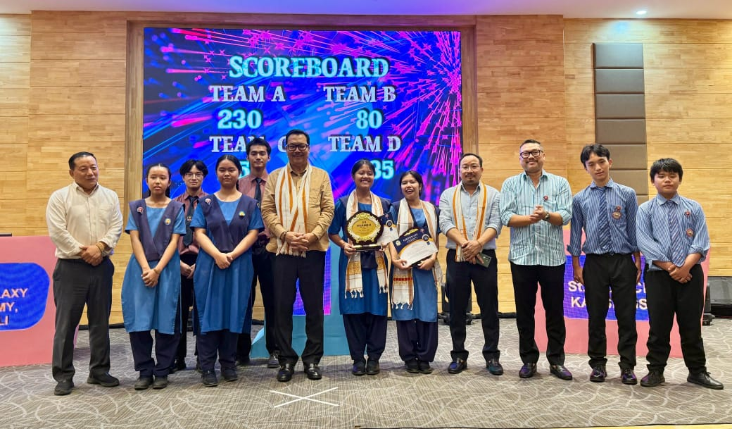

Itanagar, August 2, 2025: Deputy Chief Minister of Arunachal Pradesh, Chowna Mein, while attending the Itanagar Zonal Final of the Battle of Minds 2.0 Quiz Competition organised by the Department of Youth Affairs, Government of Arunachal Pradesh, held at the State Banquet Hall on Saturday evening commended the Department of Youth Affairs for curating such impactful programmes aimed at unlocking the full potential of Arunachal’s youth and reaffirmed the government’s commitment to creating more such vibrant platforms for learning and leadership.
Addressing the gathering, the Deputy CM expressed his delight at the overwhelming response to the initiative. “From just 53 teams in its inaugural edition to an impressive 343 school teams this year, the growth of Battle of Minds reflects the rising intellectual curiosity and competitive spirit among our students,” he said. The Deputy Chief Minister underscored the importance of such platforms in nurturing academic brilliance, leadership potential, and collaborative learning. “Empowering youth with knowledge, opportunity, and a clear vision is key to building a Shashakt Arunachal,” he added and further stated that we want to create a skill youth force for a ‘Viksit Arunachal’.
Congratulating all participants and winners, Mein noted, “Today’s quizzers are tomorrow’s leaders. I encourage each of you to dream big, stay disciplined, and pursue your goals with clarity and determination.”
The zonal finals witnessed high-spirited participation, with students competing across four engaging segments - General Knowledge, Know Your Region, Audio-Visual, and Rapid Fire. The quiz not only tested academic knowledge but also brought forth the presence of mind, confidence, and critical thinking abilities of the young participants.
He felicitated the winning team of the Itanagar zonal final, Team VKV Chimpu (Group D), for their stellar performance and commended all other participants for their enthusiasm and effort. He also extended best wishes to the winners from all six zones who will now move on to the state-level semi-finals and finals to be held in August and September.
Mein was joined by Minister, Sports & Youth Affairs, Kento Jini, Advisor to Minister Sports & Youth Affairs, Chau Zingnu Namchoom, Secretary Sports & Youth Affairs, Abu Tayeng, Director Sports, Tadar Appa, and Director, Youth Affairs, Ramesh Linggi, among others.
