GOVERNOR’S SECRETARIAT
ARUNACHAL PRADESH
ITANAGAR

Press Communiqué
Dated August 2, 2025

2nd Friendly Badminton Tourney Between RGU & TRIHMS Organised As A Part Of The Month Long Celebration Of 79Th Independence Day At Rgu

Team Rgu Edged Past Team Trihms
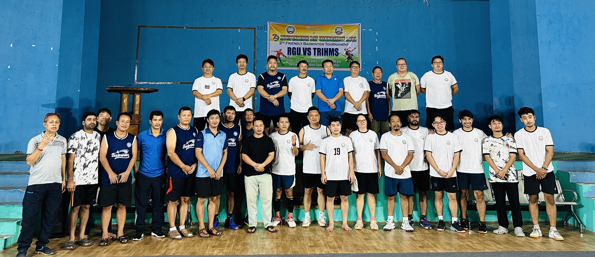
In the sequel to the first one organized in TRIHMS in last August, the badminton teams of Rajiv Gandhi University (RGU) and Tomo Riba Institute of Health & Medical Sciences (TRIHMS) came together again locking horns for the 2nd Badminton Friendly Tourney-2025, held as a part of the month long celebration of the country’s 79th Independence Day and to develop and strengthen bonhomie between the two organizations on the 2nd of August, 2025 at RGU’s Mini Indoor Sports Hall, the host team of RGU defeated the visiting team of TRIHMS by five matches against one. Both the teams were faculty members, academic administrators, officials, interns and students. A total of five men’s doubles teams and one mixed doubles team from each institution took part head to head.
All the six matches were witnessed by a huge gathering of spectators comprising of faculty members, officers, research scholars, students, and staff and badminton enthusiasts from the two institutes and game lovers from the nearby area. The Vice Chancellor (Acting) of RGU Prof. S.K. Nayak congratulated both the teams for playing zealously and reiterated that such coming together through sports should continue creating bonhomie, and a sense of friendliness and camaraderie, which can be a great way to foster positive relationships, promote teamwork, and encourage healthy competition. He further said that, TRIHMS as an affiliated institute offering MBBS degree under RGU is growing at its best and has got tremendous scope to grow further academically and in the field of medical research.
Earlier, while jointly inaugurating the 2nd friendly badminton tourney-2025 with the Registrar of RGU, the Director of TRIHMS Dr. Moji Jini in his speech encouraged all to play in the spirit of true sportsmanship and appreciated the initiatives which encourages collaborations, and further said that, as sports is an integral part of human life and conduct of such events where the two organizations could come together and be a part of the much needed bonhomie and togetherness. The Registrar of RGU Dr. N.T. Rikam who is an ardent player himself was in all praise for the organizers for creating an environment and exclusive ambience of sports befitting the idea of strengthening bonhomie between the two institutes, and he further advocated that, this way, everyone works together to achieve a common goal of staying fit and healthy and the shared cause are sure to strengthen the bond between the two institutions. The Joint Registrar of RGU and patron of the host committee of RGU-TRIHMS Badminton Tourney Dr. David Pertin felt that by creating regular opportunities for interaction and teamwork through sports, the two organizations can build a strong sense of community, leading to lasting friendships and professional networks as through such events the scope of celebrating the diversity within institutions, fostering teamwork and mutual respect, and most importantly to bridge the gap increases. He further informed that, six teams each participated and locked horns as per the rankings of the teams of the respective institutes, where in RGU won four matches out of the five men’s doubles category matches and in one mixed doubles category match, and clinched the winners’ trophy. He also informed that, RGU will be playing a series of badminton, futsal and football matches with the sister institutes like NERIST, TRIHMS, DNGC, and others in the run up to the month long 79th Independence Day celebrations. Amongst others, the Sub-Dean of TRIHMS Dr. Mika Umpo, Chairman of the Officers Club of RGU Prof. Gibji Nimasow, Chairman of TRIHMS Badminton Club Dr. Taling Mari, and Secretary of OCRGU Pitam Jomoh also spoke.

Thereafter, the tourney matches started with the pair of Nangram Toglik & Dr. Heisnam Shanjit Singh of RGU winning easily in two straight sets defeating the TRIHMS’ pair of Dr Kime Dani & Dr Pranshu Dwivedi with the score reading 21-11 & 21-12. In the second match also the RGU’s pair of Dr N.T. Rikam & Dr Hemantajit Gogoi gets past defeating the TRIHMS pair of Dr Naloh Mibang & Dr Kemba Padu in two straight sets with the score reading 21-14 & 24-22. The third match played between RGU’s Munna Lal Sharma & Pitam Jomoh and TRIHMS’ pair of Dr Rinchin Dorjee Megeji & Dr Miding Perme saw opening of accounts for TRIHMS with the score reading 21-16, 18-21 & 22-20 in favour of TRIHMS. In the fourth match, the RGU pair of Dr David Pertin & Hage Kojee edged past the TRIHMS’ pair of Dr Moji Jini & Dr Taling Mari in yet another thrilling three setters with the score reading 18-21, 21-15 & 21-19. In the solitary Mixed Doubles event, the team of Techi Kamtung & Osinam Eko from RGU had an easy sail over the team of Dr Mayank Negi & Dr Naomi Saring of TRIHMS with the score reading 21-15 & 21-8 giving RGU an unassailable lead of four matches in the tourney of six matches and sealed the victory for RGU. The sixth match played between RGU’s Prof. Gibji Nimasow & Pura Deilyang and the TRIHMS interns’ pair of Vijay Tad Murtem & Jumnu Gusar was an easy sailing for the veterans of RGU with the scores reading 21-12 and 21-8 in favour of RGU again. The tournament was participated by ten men’s doubles and two mixed doubles teams. The visiting team of RGU had the upper hand in the events and was declared winners by a margin of five matches to one and declared winners.

