GOVERNOR’S SECRETARIAT
ARUNACHAL PRADESH
ITANAGAR

Press Communiqué
Dated August 24, 2025

Mechukha Trout Quest 2025 achieves a remarkable milestone with 105 catches, establishing a new national standard on the Yargyap Chu River
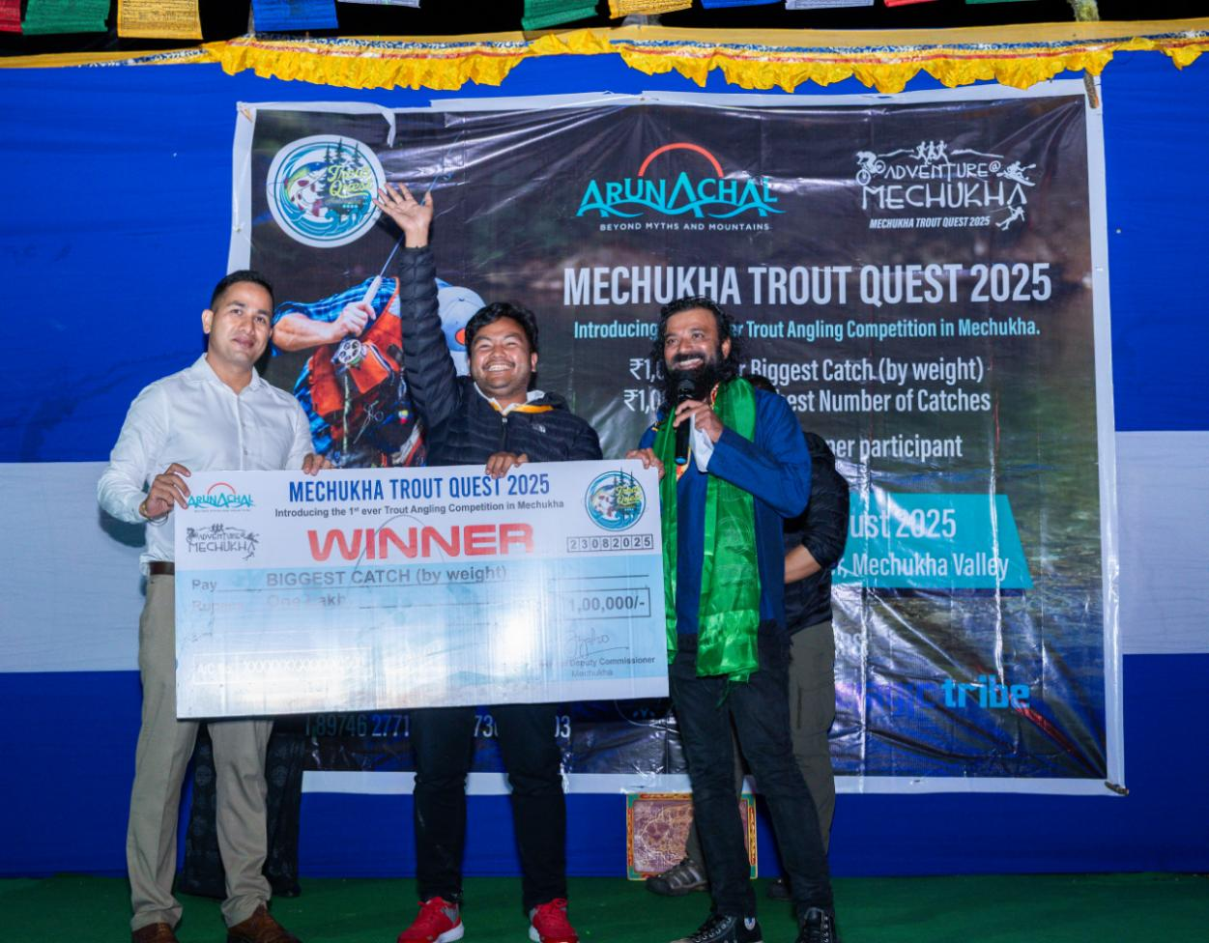
MECHUKHA, ARUNACHAL PRADESH – August 24, 2025 – The Mechukha Trout Quest, an esteemed angling competition organised by the Department of Tourism, Government of Arunachal Pradesh, wrapped up its 2025 edition on August 23rd, marking a significant milestone. The event achieved a remarkable milestone by establishing a new national record for the highest number of brown trout catches in a single-day competitive angling event. In an exciting competition, 23 anglers hailing from Arunachal Pradesh, Assam, and Meghalaya took to the waters of the Yargyap Chu river. Over the course of an intense 8-hour event, they successfully caught a remarkable total of 105 trout. This outstanding achievement highlights the flourishing trout population in Mechukha, thanks to the dedicated conservation efforts of the local community and skills of the anglers.
The competition dedicated itself to the principles of "catch and release," ensuring that all 105 trout catches were expertly handled and successfully returned to the river.
"This year's Mechukha Trout Quest has been a remarkable showcase of sportsmanship and a significant milestone for angling in India," stated Derek Dsouza, Angling Expert and Director of Pelagic Tribe. The remarkable achievement of 105 trout catches within a mere eight hours serves as a compelling testament to the vitality of our rivers and the effectiveness of our conservation initiatives.”
The event celebrated the achievement of two champions, each demonstrating outstanding performance in their respective categories. Shri Moji Riram emerged victorious in Category 1, showcasing the largest catch of the day—a stunning trout tipping the scales at 860 grammes. Shri Ngurang Nega emerged as the Category 2 winner, demonstrating remarkable talent with an impressive total of 26 catches. Shri Asiel L D Shira from Meghalaya closely trailed behind, achieving a total of 22 catches. The recipients received a trophy along with a cash prize of Rs. 1 Lakh each. Recognition and tokens of appreciation were presented to the anglers who secured the second to fifth positions, graciously supported by Pelagic Tribe and Outdoor Gears.
The Mechukha Trout Quest stands out as a remarkable event, embodying a celebration of the natural world, serving as a platform for eco-tourism, and championing sustainable practices. The achievements of 2025 will reinforce Mechukha's standing as a premier trout fishing location in India.
The anticipation grows as they prepare to welcome an increasing number of anglers and enthusiasts to Mechukha in the years ahead.
