GOVERNOR’S SECRETARIAT
ARUNACHAL PRADESH
ITANAGAR

Press Communiqué
Dated July 7, 2025

Dy CM Chowna Mein attends 3rd annual felicitation programme by ATKSSU in Namsai
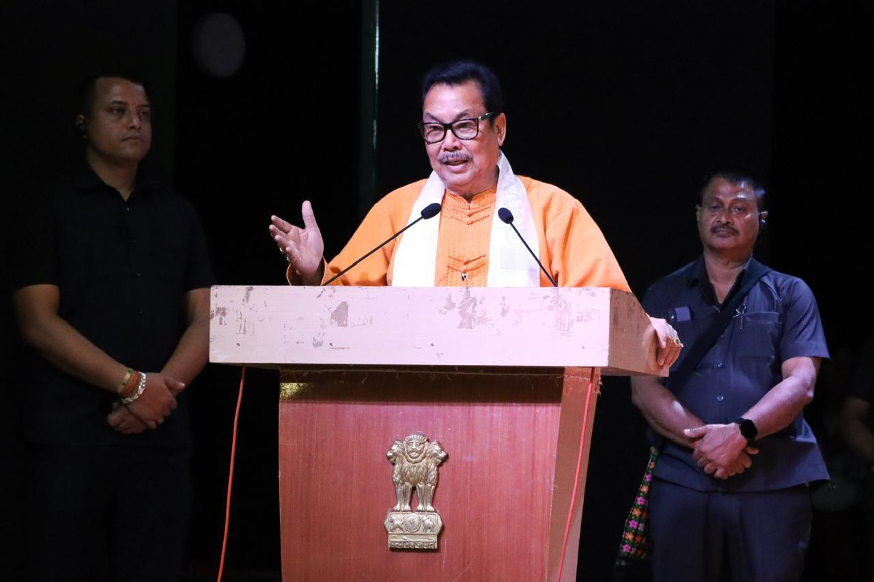
NAMSAI, July 7: Deputy Chief Minister Chowna Mein, today graced the 3rd Annual Felicitation Programme organized by the All Tai Khamti Singpho Students' Union (ATKSSU) at the Multi-Purpose Cultural Hall in Namsai. The event celebrated the academic, sporting, cultural, and social accomplishments of the Tai Khamti and Singpho youths.
On the occasion, young achievers from the Tai Khamti and Singpho communities in games and sports, gold medallists in academic, toppers in State and CBSE Board Exams, and those excelling in fields such as film and fashion were felicitated.
Addressing the young achievers, Mein said that their accomplishments are a source of pride not only for their families but for the entire community.
He encouraged the youth to continue striving for excellence and to be guided by sincerity and discipline in their endeavours. He said, "Government of Arunachal Pradesh remains steadfast in its commitment to transparent and merit-based recruitment through the APSSB. In this era of competitiveness, I urge youths to pursue their goals with unwavering dedication”.
The Dy CM also lauded the efforts of student body headed by its President Branglin Injo and General Secretary Chau Suphita Manjeykhun, for their efforts in promoting youth empowerment and community development.
The programme was also attended by ZPC Nang Urmila Mancheykhun, DC Namsai C.R. Khampa, SP Sange Thinley, ADC Chongkham K. Tikhak, ZPM Chau Jenia Namchoom, along with community leaders from TKSC, SDS, TKDS, and a vibrant gathering of youths.
The felicitation ceremony served as a platform not only to honor the achievers but also to reinforce a shared commitment towards nurturing talent and building a progressive and united community.

