GOVERNOR’S SECRETARIAT
ARUNACHAL PRADESH
ITANAGAR

Press Communiqué
Dated July 6, 2025

Governor participates in the 125th Birth Anniversary celebration of Dr. Syama Prasad Mookerjee
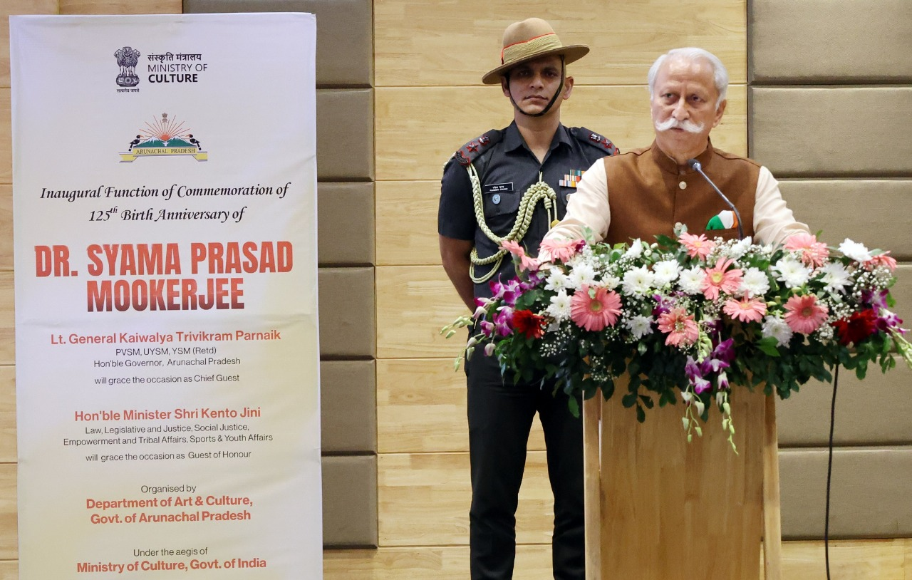
ITANAGER, July 06: The Governor of Arunachal Pradesh, Lt. General KT Parnaik, PVSM, UYSM, YSM (Retd.) participated in the inaugural commemoration of the 125th Birth Anniversary
Dr. Syama Prasad Mookerjee at Golden Jubilee State Banquet Hall, Niti Vihar, Itanagar on Sunday organized by the Department of Art and Culture, under the aegis of the Ministry of Culture, Govt. of India, the function commenced the two-year celebration.
Paying tribute to the valiant leader of national unity on the occasion, the Governor admired Dr. Mookerjee's life as a shining example of unwavering commitment to India's integrity, cultural pride, and democratic values. He emphasized that the occasion is more than just a remembrance. It is a powerful call, especially to the youth, to draw inspiration from Dr. Mookerjee's courage, conviction, and selfless service.
The Governor passionately addressed the youth of Arunachal Pradesh, declaring them the torchbearers of Dr. Mookerjee's vision. He affirmed that their strength is in their talent and capacity to dream big for their community, State and country.
Connecting the ideals and principle of Dr. Mookerjee with the progress and youth of Arunachal Pradesh, the Governor urged the youth of the State to embrace deep pride in their traditional heritage, art, culture, land, and languages, while simultaneously showing equal courage in excelling across science, sports, technology, innovation, and entrepreneurship. He expressed his hope that the celebration would ignite within everyone a renewed sense of purpose to contribute meaningfully towards realizing the dream of a strong, united, and self-reliant India.
The Governor said that when youth are given the opportunity to lead with purpose and serve with compassion, they not only become stronger individuals but also catalysts for positive change. He called for empowering them to raise their voices, take initiative, and lead with integrity, so that Arunachal Pradesh and India can move forward with the strength of committed youth.
The Governor said that Dr. Mookerjee was far more than a political figure. He was a visionary, an esteemed educationist, and a courageous nation-builder and driven by a profound belief in 'One India, Great India,' he founded the Bharatiya Jana Sangh in 1951, laying the ideological groundwork for national unity and integrity at a time when the country was still healing from partition.
The Governor recounted Dr. Mookerjee's unwavering opposition to Article 370 and his powerful call for "One Country, One Head, One Flag, One Constitution" in 1953, a stance that marked a pivotal moment in Indian political history. He noted that this very dream of equality, national integration, and constitutional unity was realized under the decisive leadership of Prime Minister Narendra Modi and Union Home Minister Amit Shah, with the abrogation of Article 370 and the full integration of Jammu and Kashmir into the Indian Union.
The Governor recalled Dr. Mookerjee's dedication to industrializing India, noting his crucial role as Minister for Industries and Supply where he established vital undertakings like the Chittaranjan Locomotive Factory, Sindri Fertilizer Corporation, and Hindustan Aircraft Factory. He said that Dr. Mookerjee strongly opposed to the partition of Bengal, driven by his conviction that India was culturally one, making him vehemently against any division based on religion.
Recalling the pivotal role of Dr. Mookerjee in the Constituent Assembly, the Governor said that he persistently advocated for minority rights and the preservation of regional languages to ensure a Constitution acceptable and applicable to all communities.
The Governor urged everyone to strive forward, holding steadfast to the eternal values of truth, courage, compassion, and justice. He emphasized the importance of taking immense pride in our unique identities, languages, cultures, and traditions, recognizing them as symbols of our rich heritage, as well as the very roots of our collective strength.
The Governor stressed that by empowering our local institutions, from village councils to cultural groups, with honesty and transparency, we build the very foundation for good governance and meaningful development, ensuring every voice is heard and truly transforms lives. He appealed to the people of Arunachal Pradesh for a renewed commitment to nation-building, and s a shared, inspiring dream: a developed India by 2047.
The celebration witnessed insightful addresses by the State Minister for Law, Justice, Sports & Youth Affairs, Kento Jini, Chief Secretary Manish Gupta, and Secretary for Art & Culture, Mamta Riba shared their reflections on the significance of the occasion.
Delivering the memorial lecture, Prof. Nabam Nakha Hina from the Department of Political Science, Rajiv Gandhi University, spoke eloquently on “The Life and Legacy of Dr. Syama Prasad Mookerjee and His Commitment to Nation Building,” shedding light on the visionary leader’s enduring contributions to India's unity and integrity. Complementing the discourse, Prof. Ashan Riddi from the Department of History, also of Rajiv Gandhi University, delivered a thought-provoking talk on “Dr. Syama Prasad Mookerjee: An Embodiment of Unyielding Belief in One Nation, One Constitution.”
The occasion was graced by the presence of Deputy Speaker of the State Legislative Assembly,Kardo Nyigyor and Local MLA Techi Kaso drew participation from people across all walks of life, especially students from various educational institutes reflecting the collective reverence for the legacy of Dr. Mookerjee.
Adding a vibrant and patriotic touch to the event, artists from the Songs and Drama Unit of the Directorate of Art & Culture enthralled the audience with stirring performances that celebrated national unity and cultural pride.

