GOVERNOR’S SECRETARIAT
ARUNACHAL PRADESH
ITANAGAR

Press Communiqué
Dated July 06, 2025

Dy CM joins 90th birthday celebration of His Holiness the 14th Dalai Lama in Tezu
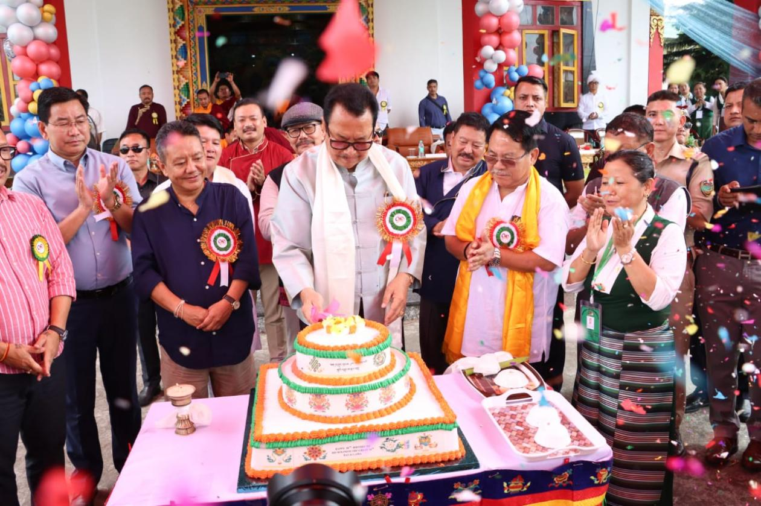
TEZU, July 06: Deputy Chief Minister of Arunachal Pradesh, Chowna Mein today joined hundreds of devotees, dignitaries, and members of Tibetan community at Dhargyeling Tibetan Settlement in Tezu to celebrate the 90th birthday of His Holiness, the 14th Dalai Lama. The celebration was marked by prayers, cultural performances, and heartfelt tributes at sacred Lhagon Jangchup Choeling Monastery, Tezu.

Deputy Chief Minister, along with Head Monk His Eminence Dzogchen Ganor Rinpoche, offered prayers for long life and good health of His Holiness.

In his speech, he described His Holiness as not only a spiritual leader for Tibetan people but also a beacon of peace and compassion for the entire world. “His life and message transcend borders, reminding us all of the power of kindness, forgiveness, and inner strength,” he said.

Mein said that His Holiness’ gracious announcement for continuation of the Institution of Dalai Lama is largely welcomed by the people of Himalayan Region including Arunachal Pradesh. “This historic decision reaffirmed the spiritual and cultural identity of Tibetan people for generations to come and strengthened the hopes of millions of Tibetans and well-wishers worldwide”, he said.

He further praised resilience and cultural pride of the Tibetan people residing across India. “I deeply admire how Tibetan community has preserved its language, attire, and spiritual traditions. Their strength in maintaining cultural identity is both moving and inspiring,” he noted. He recalled how their story is a reminder that no matter the circumstances, heritage can be carried forward with pride and dignity.

Reiterating the importance of preserving one’s own indigenous languages and scripts, Mein said, “When a language dies, a culture is lost,” urging communities to draw inspiration from Tibetan efforts in safeguarding their Bodhi script and ancient wisdom through generations.

Chowna also informed that a trekking event called as ‘Freedom Trail’ – along the route taken by His Holiness during his escape from Tibet to India—which passes through Arunachal Pradesh was organized by the Tawang District Administration, Monks, local people and ITBP personnel from March 31 to April 5 this year. He said that Govt is developing an adventure tourism circuit along this route and efforts are on to transform this historic path into a commemorative trekking route and to organize cultural festival in order to promote pilgrimage tourism and to honour this extraordinary journey.

He highlighted use of technology, such as artificial intelligence, in rediscovering and preserving indigenous texts, including versions of Ramayana & Mahabharata written in native Tai Khamti scripts.

The celebration was also attended by Ministers, Wangki Lowang and Pasang Dorjee Sona, along with MLAs Dr Mohesh Chai, Chau Zingnu Namchoom, Mutchu Mithi, IGP (Eastern Range), P N Khrimey, DCs and SPs Lohit &Namsai and HoDs among others.

