GOVERNOR’S SECRETARIAT
ARUNACHAL PRADESH
ITANAGAR

Press Communiqué
Dated July 02, 2025

Governor, Chief Minister participates in virtual meeting with NASDAQ Entrepreneurial Centre, California
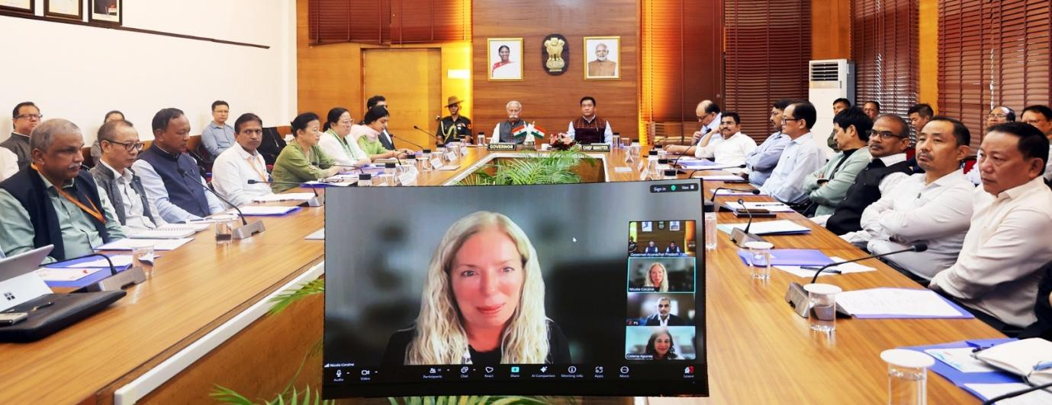
ITANAGER, July 02: The Governor of Arunachal Pradesh, Lt. General KT Parnaik, PVSM, UYSM, YSM (Retd.), along with the Chief Minister Pema Khandu participated in a virtual workshop organized by the State Department of Information Technology in collaboration with the NASDAQ Entrepreneurial Centre, California, at Raj Bhavan, Itanagar on 2nd July . The workshop, held to empower the youth, nurture the State’s start-up ecosystem, and foster entrepreneurship, marks a significant milestone in Arunachal Pradesh’s digital and economic journey. It also focused on ways to bring together global expertise and local aspirations on a single platform, with a shared commitment to innovation-led development.
In his address, the Governor lauded the initiative and emphasized the critical role of Artificial Intelligence (AI), geospatial intelligence, and satellite-based monitoring in driving the State’s development agenda. He highlighted the urgent need for seamless integration of modern technologies to track and evaluate the implementation of various flagship programs and infrastructure projects, especially given the State’s vast and geographically challenging terrain.
The Governor stressed that priority sectors like Health, Education, and Agri tech must be at the forefront of this technological transformation. He called for proactive involvement of the NASDAQ Entrepreneurial Centre and proposed the development of AI-driven tools specifically tailored to Arunachal Pradesh’s unique developmental needs, such as early warning systems for agriculture, telemedicine for remote areas, and smart education platforms for rural schools.
The Chief Minister, in his address, underscored the importance of such collaborations in realizing the vision of Viksit Bharat, as envisioned by Prime Minister Narendra Modi. He highlighted key government initiatives, including the Arunachal Pradesh State Industrial and Investment Policy 2020, designed to create a conducive environment for entrepreneurs and investors in the State.
The Chief Minister said that the youth of the State are talented, innovative, and full of potential, but what they need is encouragement, a nurturing ecosystem, and access to global platforms. He urged the NASDAQ Entrepreneurial Centre to engage in deeper dialogue with the State Government and explore structured avenues of cooperation that will benefit our start-ups, MSMEs, and aspiring entrepreneurs.
Nicola Corzine, CEO & Executive Director, Nasdaq Entrepreneurial Centre, along with Celena Aponte, VP Strategy & Development, and Prasoon Sharma, Advisory Board Member, briefed about the Entrepreneurial Centre and the scope of cooperation. Senior officers, including Commissioners and Secretaries of various departments of the State Government, including State Chief Secretary Manish Gupta, participated in the online programme.
The workshop concluded with a strong consensus among stakeholders to move forward with renewed energy and collaboration while harnessing the power of technology, innovation, and youth potential to shape a vibrant and future-ready Arunachal Pradesh.

