GOVERNOR’S SECRETARIAT
ARUNACHAL PRADESH
ITANAGAR

Press Communiqué
Dated July 01, 2025

District Level Monitoring Committee reviews progress of works and welfare schemes in Tawang
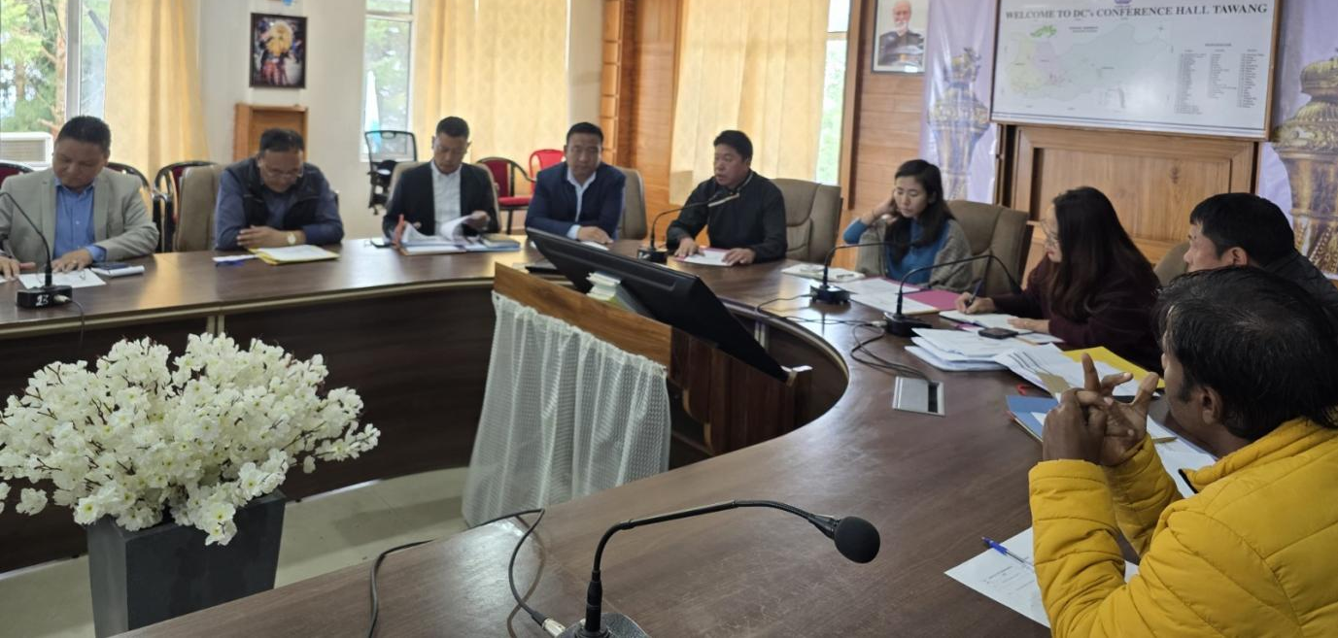
TAWANG July 01: A two-day District Level Monitoring Committee (DLMC) meeting was convened on June 30 and July 1, at the Deputy Commissioner’s Office, Tawang, to review the progress of ongoing developmental works and welfare schemes in the district.
The meeting was chaired by Deputy Commissioner Namgyal Angmo, IAS, and were attended by Zila Parishad Chairperson (ZPC), Leki Gombu, ADC Lungla, Tashi Dhondup, ADC Jang Sub-Division, Hakraso Kri, along with Heads of various work-implementing departments and allied agencies.
In her address, DC stressed the importance of timely completion of works

and urged departments to work in close coordination to address bottlenecks. She emphasized the need for proper utilisation of the limited working season in the region without compromising on the quality and standards of execution. The DC called upon all departments to set realistic timelines and ensure adherence to project schedules.
ZPC Tawang, Leki Gombu, highlighted the need to convene a meeting with all banks operating in the district to streamline the timely disbursement of loans to eligible beneficiaries. He also requested proactive support from the district administration and implementing agencies to facilitate access to welfare schemes and loan provisions at the grassroots level, ensuring that benefits reach the intended recipients effectively.
Over the course of two days, the progress of various centrally sponsored schemes, state-funded programmes, and Prime Minister and Chief Minister flagship initiatives was

reviewed thoroughly. Departments presented detailed status reports and power point presentations showcasing achievements, challenges, and the way forward.
The meeting provided a platform for inter-departmental coordination, sharing of best practices, and redressed of issues related to project implementation.
The DLMC reiterated its commitment to transparent and efficient governance, ensuring the fruits of development reach every citizen in the district.

