GOVERNOR’S SECRETARIAT
ARUNACHAL PRADESH
ITANAGAR

Press Communiqué
Dated July 29, 2025

ARUNACHAL ELECTRONIC AND DIGITAL MEDIA ASSOCIATION CELEBRATES 13TH FOUNDATION DAY WITH THIRD EDITION OF AEDMA CONCLAVE
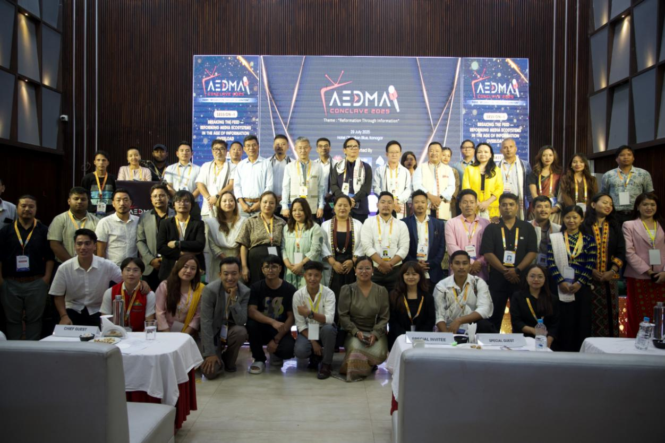
ITANAGAR, July 29, 2025: The Arunachal Electronic and Digital Media Association (AEDMA) today celebrated its 13th Foundation Day with the successful conduct of the third edition of the AEDMA Conclave at a city hotel here. The conclave, themed 'Reformation through Information', brought together media professionals, government officials, and industry experts to deliberate on contemporary challenges and opportunities in the media landscape.
The conclave featured two comprehensive technical sessions addressing critical aspects of modern media operations. The first session, titled 'Breaking the Feed: Reforming the Media Ecosystem in the Age of Information Overload', was moderated by Theim Lhouvum and featured distinguished speakers including Prof. Kh Kabhi, Head of Department, Mass Communication, Rajiv Gandhi University, and Dodum Yangfo, President, Arunachal Press Club.
The second session focused on 'Corporate Affairs and Taxation in Media', moderated by JT Tagam, with presentations by entrepreneur Doni Riba and chartered accountant Ramesh Chandra Roy. Both sessions emphasized the urgent need for structural and organizational advancement in the media sector, while underlining the critical importance of state government support in fostering a sustainable media ecosystem.
Honourable Minister for Information & Public Relations, Nyato Dukam, graced the occasion as the chief guest. In his address, the Minister urged the media fraternity to assume a more responsible and proactive role in disseminating government programmes and policies to the public. He assured continued governmental support for the growth and development of the media industry in Arunachal Pradesh.
The event witnessed significant participation from senior IPR Department officials including Secretary Nyali Ete, Director Gijum Tali, Deputy Director DIPR Denga Bengia, and various District Information and Public Relations Officers from across the state.
AEDMA President JT Tagam, representing the digital media fraternity, expressed gratitude to the IPR Department for the implementation of the long-pending Electronic Media Advertisement Policy, 2020, and acknowledged the state government's progressive initiatives in supporting media development.
The conclave was attended by prominent media organization leaders including APUWJ President Amar Sangno and APMWS President Takam Sonia, along with numerous media professionals, students, and scholars from across the region.
The event was supported by the IPR Department, Government of Arunachal Pradesh, the Itanagar branch of Indian Bank, and Eesh, marking another significant milestone in AEDMA's 13-year journey of promoting electronic and digital media in the state.
This conclave reinforces AEDMA's commitment to fostering professional excellence and industry growth while addressing contemporary challenges facing the media sector in the digital age.

