GOVERNOR’S SECRETARIAT
ARUNACHAL PRADESH
ITANAGAR

Press Communiqué
Dated July 29, 2025

Successful Earthquake Preparedness Drill Conducted in Tawang
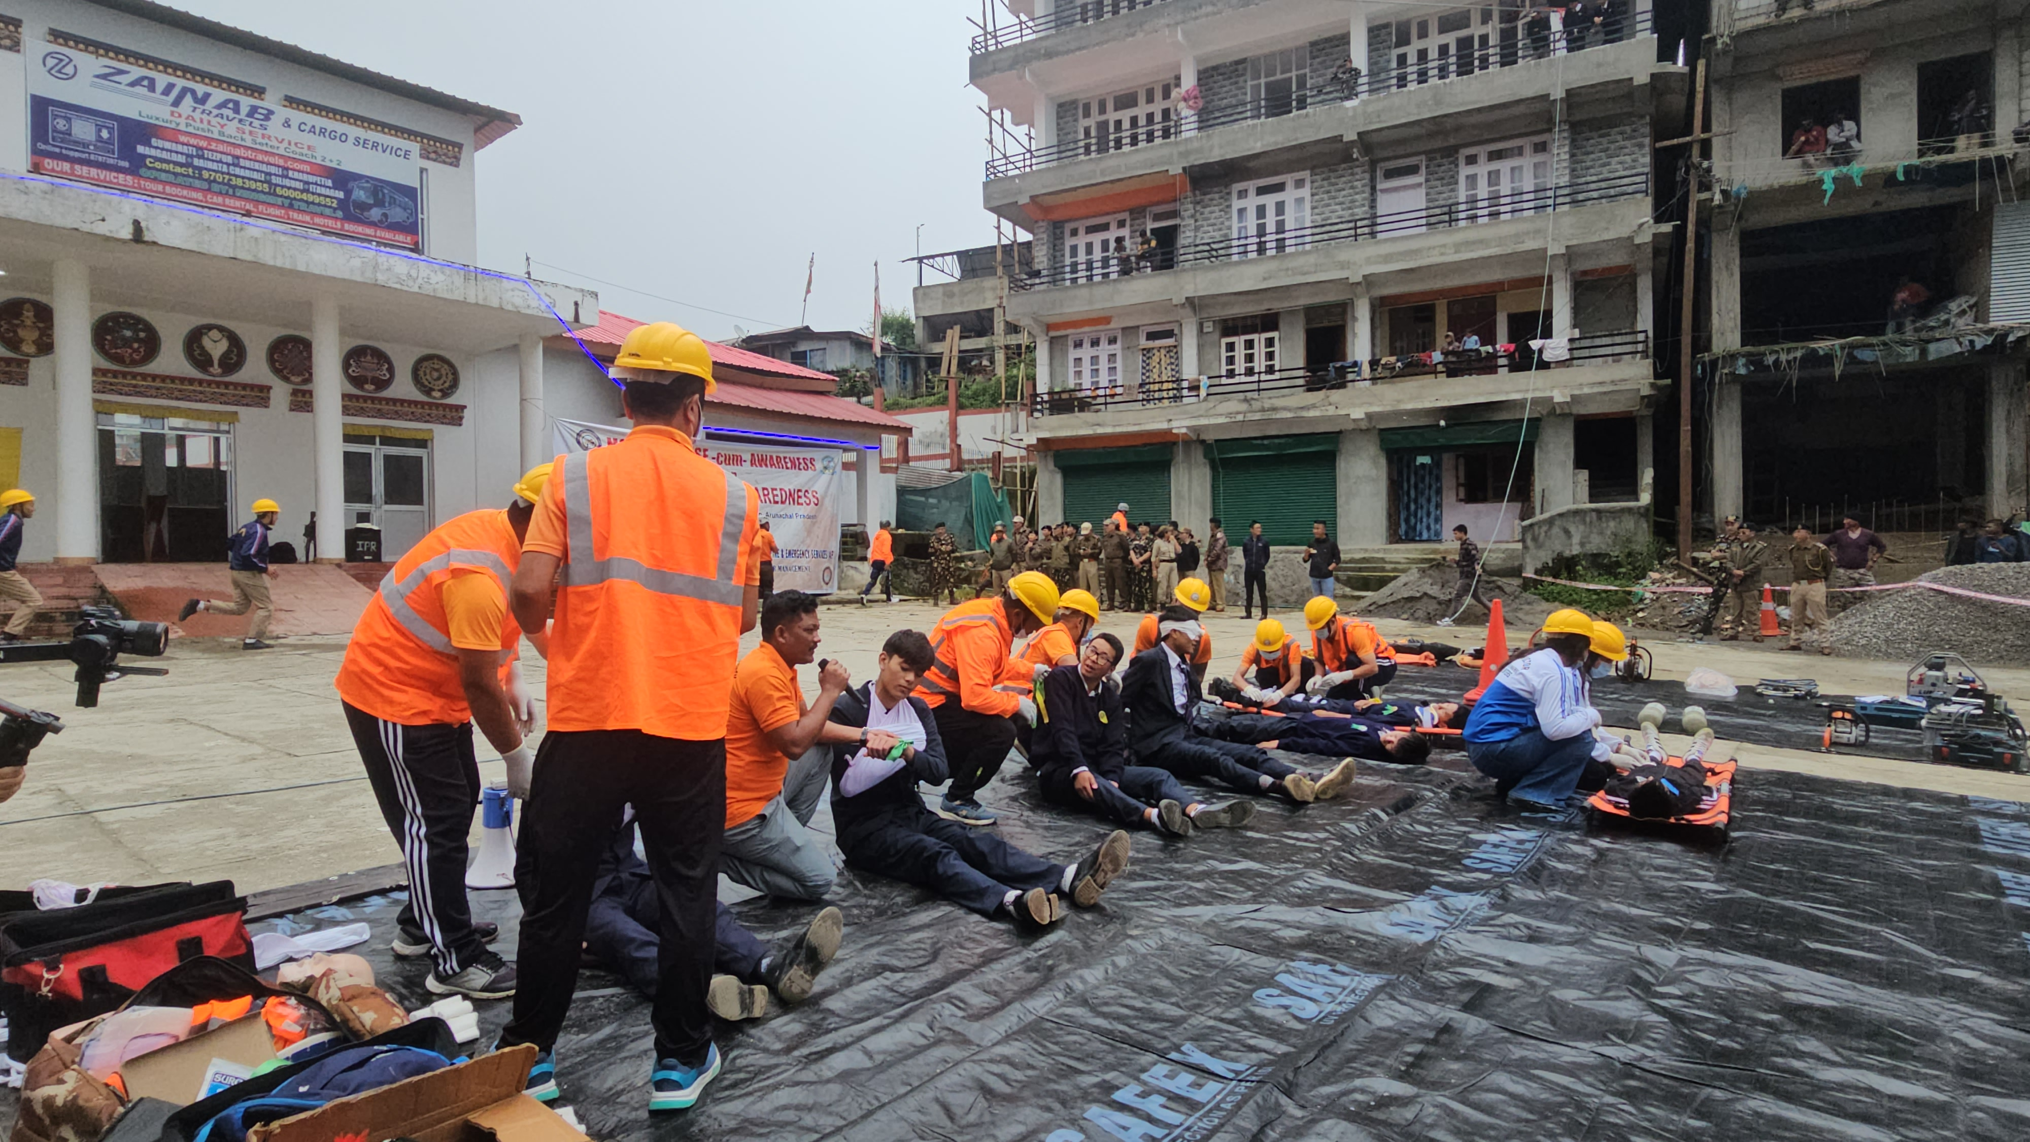
Mock Exercise cum Awareness Programme Raises Community Readiness
Tawang | July 29, 2025
A comprehensive Mock Exercise cum Awareness Programme on earthquake preparedness was successfully conducted today near the Walk-Through Market, Tawang. The event was jointly organized by the State Disaster Response Force (SDRF) and Fire & Emergency Services Itanagar, under the aegis of the Department of Disaster Management, Government of Arunachal Pradesh.

Key Participants
The programme witnessed enthusiastic participation from key officials and stakeholders, including:
- Deputy Commissioner Tawang: Namgyal Angmo, IAS
- Superintendent of Police: Dr. D.W. Thongon
- SP SDRF & Fire Services: John Pada
- Heads of Offices
- Bazar Welfare Committee
- NCC, NSS, SSB personnel
- Students and members of the general public

Official Statements

Deputy Commissioner's Address
In her address, DC Namgyal Angmo emphasized the critical importance of disaster preparedness, noting that Arunachal Pradesh lies in Seismic Zone V, one of the most earthquake-prone areas in the country.
"There is no warning system for earthquakes – they strike suddenly and can cause immense destruction. However, preparedness can significantly reduce the damage and loss of life," she stated, urging the public to attentively observe the mock drill and internalize the safety protocols demonstrated.

Superintendent of Police's Remarks
SP Tawang Dr. D.W. Thongon echoed the sentiment, encouraging all attendees to memorize the emergency response techniques and safety measures demonstrated during the exercise.
"Learning these techniques today could help save lives tomorrow," he remarked.

SDRF Officer's Insights
Welcoming participants to the event, SP cum Nodal Officer SDRF & Fire Services, John Pada, shared insights into the role of SDRF during emergencies and stressed the importance of community response in the initial moments of a disaster.
"While trained forces like SDRF are vital, the first and most critical response often comes from the people themselves. This is why awareness and preparedness at the grassroots level is essential," he said.
He also extended gratitude to the SSB, NCC, NSS volunteers, and Bazar Welfare Committees for their active involvement in the programme.

Programme Highlights

Mock Exercise Demonstrations
Following the formal programme, a live mock exercise was carried out by SDRF personnel, demonstrating:
- Key rescue operations
- Evacuation drills
- Fire safety techniques
Fire & Emergency Services, Tawang, showcased the proper use of extinguishers and emergency response methods.

Community Participation
Volunteers from SSB, NCC, and NSS of Higher Secondary School Tawang and Town Secondary School Tawang played a crucial role in the enactments, exemplifying community participation in disaster response.

Safety Infrastructure Enhancement
In a noteworthy gesture to boost local safety infrastructure, three fire extinguishers each were distributed to the three Bazar Welfare Committees by Fire & Emergency Services, Itanagar, to enhance local emergency response capabilities.

Future Initiatives
The event concluded with District Disaster Management Officer (DDMO), Tawang, Genden Tsomu, announcing that a Comprehensive Safety Audit will be conducted by the District Disaster Management Authority (DDMA) in the district soon. She also thanked all participants and agencies for their commitment to disaster readiness.
