GOVERNOR’S SECRETARIAT
ARUNACHAL PRADESH
ITANAGAR

Press Communiqué
Dated July 24, 2025

Governor Inaugurates Two-Day Capacity Building Training Programme for PWD Engineers
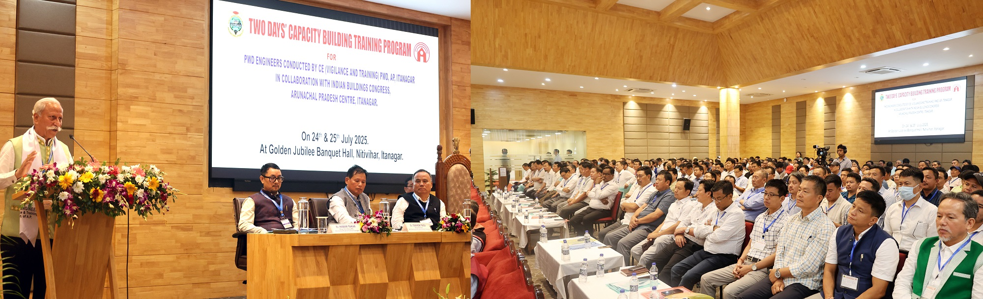

- Engineers are the backbone of the state’s developmental story: Governor
Engineers are the ones who turn policy into progress, translating ideas into physical infrastructure that serves the people: Governor
- The efforts of the engineers must be based on the latest expertise to raise the standard bar, use of software applications, and prioritize green technologies, energy efficiency, and climate-resilient infrastructure: Governor
- Governor calls upon engineers and officials alike to uphold the highest standards of accountability, ensure complete transparency in financial dealings, and treat public resources with the same diligence and care as their own
- Governor suggests reviewing and reforming the culture of sub-letting by ensuring that contracts are executed by those with the qualifications, capacity, and the will to deliver with integrity and excellence
- Governor voices serious concerns over issues affecting infrastructure quality in the State

The Governor of Arunachal Pradesh, Lt. General KT Parnaik, PVSM, UYSM, YSM (Retd.), inaugurated the two-day Capacity Building Training Programme for engineers of the State Public Works Department (PWD), at Itanagar on 24th July 2025.
In his address, the Governor stated that engineers are the backbone of the state’s developmental story, while citing the critical role they play in shaping the state's infrastructure and future. He said that the engineers are the ones who turn policy into progress, translating ideas into physical infrastructure that serves the people.
Stressing the importance of technical up-skilling and ethical conduct for sustenance and future readiness, the Governor called upon engineers to embrace innovation, sustainability, and above all, integrity in their work. He emphasized on accountability and individual uprightness, while advising that every project an engineer takes up, its design, quality, budget, timeline, and societal impact must stand for his or her trust and reliability. He also advised them never to compromise on quality.
The Governor said that their effort must be based on the latest expertise to raise the standard bar, use of software applications, and prioritize green technologies, energy efficiency, and climate-resilient infrastructure. He urged the engineers to actively embrace and integrate modern technological tools such as Artificial Intelligence (AI), GIS mapping, and smart monitoring systems into every stage of project planning and execution.
Highlighting that the infrastructure sector is undergoing rapid digital transformation, the Governor emphasized that these technologies are no longer optional but essential for improving efficiency, accuracy, and transparency in public works. AI can help optimize design and resource allocation, GIS mapping allows for better spatial planning and real-time tracking, while smart monitoring tools ensure timely progress, quality control, and accountability. By adopting such innovations, the Governor noted, engineers can significantly enhance the precision and reliability of their work, reduce delays, curb corruption, and instill public confidence in the system.
Highlighting the State Government’s firm stance against malpractices, as reflected in the recent passage of the ‘Zero Tolerance for Leakage and Corruption’ resolution in the State Legislative Assembly, the Governor underscored the critical importance of financial prudence in all developmental works. He called upon engineers and officials alike to uphold the highest standards of accountability, ensure complete transparency in financial dealings, and treat public resources with the same diligence and care as their own.
The Governor also voiced serious concerns over issues affecting infrastructure quality in the State. He highlighted the prevalent and problematic practice of sub-letting project works, stating that while it may bring short-term economic benefits to some individuals, it has severely compromised quality, accountability, and public trust. He suggested reviewing and reforming the culture of sub-letting by ensuring that contracts are executed by those with the qualifications, capacity, and the will to deliver with integrity and excellence.
The Governor commended the State PWD and the Indian Building Congress, Arunachal Pradesh Centre, for their initiative in organizing the programme. He said that the training programme is an investment in the future of our State and strengthens the technical foundation of our engineering workforce, equipping them to meet emerging challenges in infrastructure development with competence and character.
The State PWD and the Indian Building Congress, Arunachal Pradesh Centre, jointly organize the two-day training programme. The programme aims to equip PWD engineers with the latest knowledge and practices in engineering, planning, execution, and ethical governance in infrastructure development. It is attended by engineers from across the State and features expert lectures, case studies, and interactive sessions.
Principal Secretary, Public Works Department, Shri Kaling Tayeng, Chairman, Indian Buildings Congress, Arunachal Pradesh Centre, Dr. Toli Basar, Chief Engineer, (Vigilance & Training), PWD, Er. Rimmar Taso and Executive Engineer, PWD, Er. Nabam Takar shared their views on the significance of the occasion.
The two-day training programme is jointly organized by the Vigilance and Training Wing of the PWD and the Indian Building Congress, Arunachal Pradesh Centre. The programme aims to equip PWD engineers with the latest knowledge and practices in engineering, planning, execution, and ethical governance in infrastructure development. It is attended by engineers from across the State and features expert lectures, case studies, and interactive sessions.
