GOVERNOR’S SECRETARIAT
ARUNACHAL PRADESH
ITANAGAR

Press Communiqué
Dated July 23, 2025

Four-Day Awareness Programme on Solid Waste Management and Ban on Single-Use Plastic Begins in Tawang
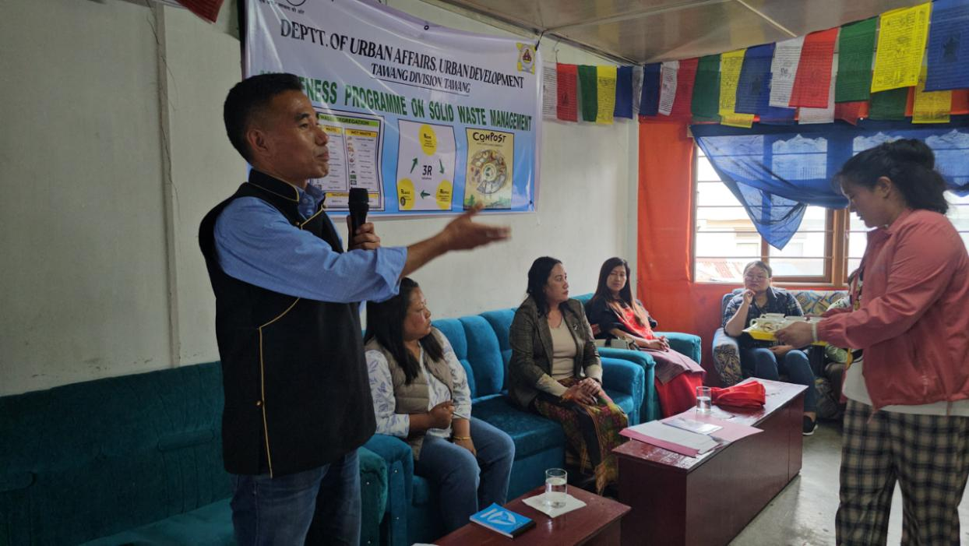

Tawang, July 23, 2025 : A four-day awareness programme on Solid Waste Management and the ban on single-use plastic carry bags commenced this afternoon at the Old Market Community Hall, Tawang. The event, organized by the Department of Urban Development (UD), Tawang, in collaboration with the District Administration, Women Welfare Association (WWA), Market Welfare Committee, and Clean Tawang Task Force, seeks to promote sustainable waste management practices and reduce plastic pollution in the region.
Inaugural Session Highlights : The programme began with a welcome address by Executive Engineer Phurpa Lamu, who emphasized the importance of the 3Rs – Reduce, Reuse, and Recycle. She also informed attendees about upcoming sanitation charges to be levied on shops and hotels based on their categories, urging stakeholders to adopt responsible waste disposal practices.
Assistant Commissioner-cum-Town Magistrate Sangey Norbu appealed to the public to minimize plastic usage for the sake of future generations. He highlighted that 2025 is being celebrated as the "Year of Compassion" in honor of His Holiness the Dalai Lama’s 90th birthday, urging citizens to align their actions with compassionate and eco-friendly behavior. He stressed the need for behavioral change in environmental protection and called upon business owners, especially those from outside the region, to treat Tawang as their second home and act in its best interest.
The AC also warned of penalties for improper waste segregation by shop owners and emphasized the dignity of sanitation workers, urging the community to dispose of waste respectfully.
Community Participation and Initiatives : Yangkey Lhamo, an active member of WWA Tawang, shared insights into the association’s long-standing efforts in plastic segregation and waste management. Drawing inspiration from the innovative practices of Jhamtse Gatsal School, Lungla, she encouraged the market community to hand over properly segregated plastic waste to the WWA. She also acknowledged the contributions of Shyo Village, Mandrelling, and Changbu residents for their cooperation in waste management efforts.
Campaign Outreach: The awareness drive will cover all four major markets and the Tawang Monastery, concluding on July 25, 2025. The initiative aims to foster a cleaner, greener Tawang through community participation and sustainable practices.
