GOVERNOR’S SECRETARIAT
ARUNACHAL PRADESH
ITANAGAR

Press Communiqué
Dated July 22, 2025

ASSAM RIFLES ORGANISES MEDICAL CAMP AT CHASA VILLAGE

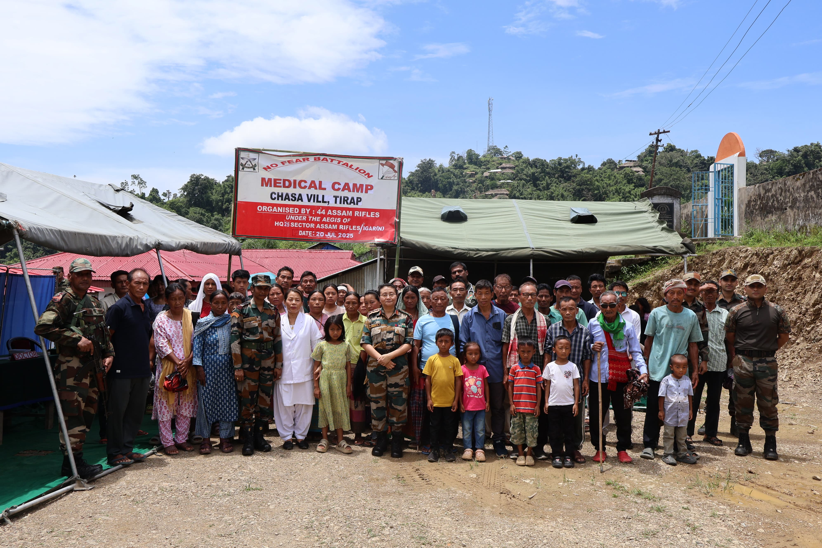

Assam Rifles conducted a Medical Camp at Chasa Village, Tirap district, Arunachal Pradesh with the aim of extending essential healthcare services to the local population. The camp saw an overwhelming response, with a total of 146 villagers benefiting from the initiative, including 41 males, 70 females, and 35 children. Medical consultations, check-ups, and free medicines were provided by a dedicated team of medical professionals.

The villagers expressed heartfelt gratitude for the noble efforts of Assam Rifles and highlighted the positive impact such outreach activities have on the community. The event served as a testament to the enduring bond between Assam Rifles and the people of the region, truly reflecting the spirit of Friends of the Northeast.
