GOVERNOR’S SECRETARIAT
ARUNACHAL PRADESH
ITANAGAR

Press Communiqué
Dated July 21, 2025

CM Pema Khandu Reviews Border Infrastructure Progress with BRO Chief; Frontier Highway Project Assessed

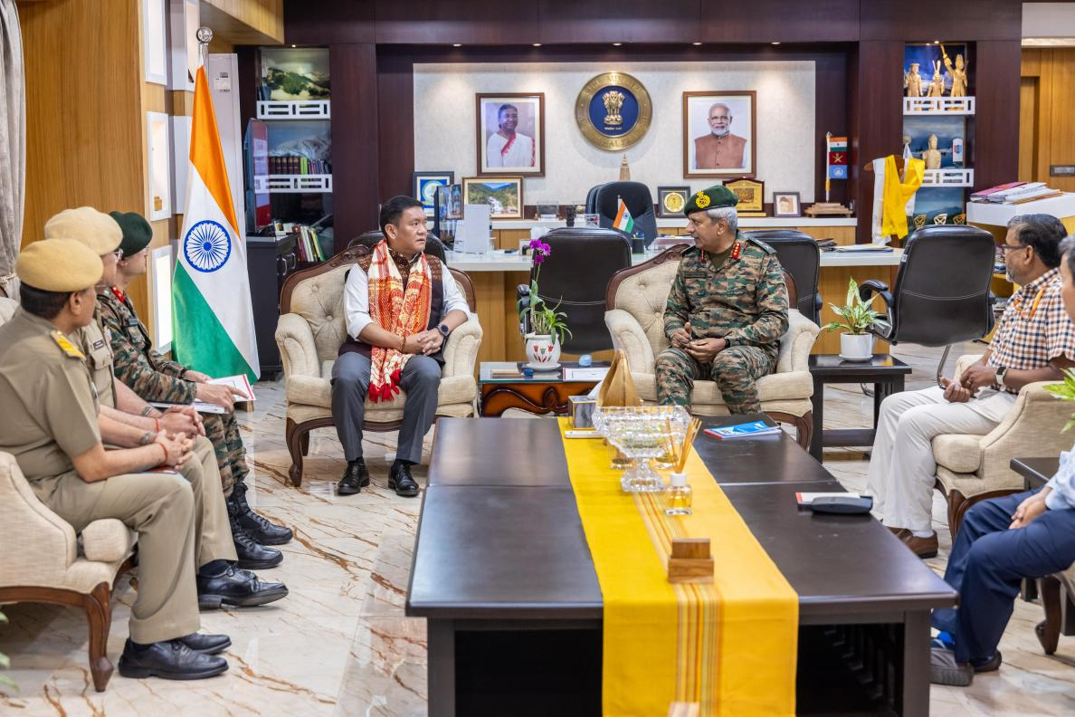

Arunachal Pradesh Chief Minister, Pema Khandu with Chief Secretary Manish Kumar Gupta convened a high-level meeting today with Director General (DGBR), Border Roads Organizations, Lt Gen Raghu Srinivasan, PVSM, VSM, to assess the progress of infrastructure initiatives being undertaken by BRO across the state.
The DGBR provided a comprehensive overview of BRO’s ongoing and upcoming infrastructure development efforts, with a focus on enhancing road connectivity in remote and strategically significant areas of Arunachal Pradesh. He highlighted BRO’s dual commitment to socio-economic advancement and national security by improving operational mobility for the armed forces.
Discussions covered the execution of critical road networks, bridges, and associated support infrastructure aimed at meeting both civilian and defence requirements.
The Chief Minister commended BRO’s relentless dedication and reiterated the State Government’s full support for ensuring timely and efficient implementation of these vital projects.
Following the meeting in Itanagar, the DGBR visited Ziro to review progress on the Frontier Highway Project. This flagship initiative is designed to significantly improve all-weather connectivity along the international border, catalyse regional development, and enhance national security through improved logistical capabilities and troop mobility.
Lt Gen Raghu Srinivasan reaffirmed BRO’s guiding principle - “Shramena Sarvam Sadhyam” = and expressed appreciation for the consistent support from the people and administration of Arunachal Pradesh. He emphasised that such collaboration remains pivotal to the successful delivery of these transformative infrastructure projects.

