GOVERNOR’S SECRETARIAT
ARUNACHAL PRADESH
ITANAGAR

Press Communiqué
Dated June 4, 2025
RGU organizes Yoga Quiz Competition
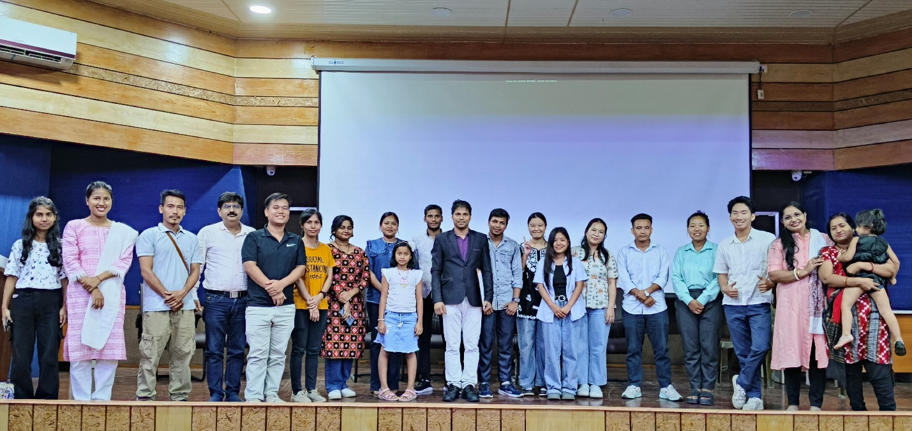

RONO HILLS, Jun 4:
Rajiv Gandhi University {RGU} Rono Hills ,Doimukh as a part of the 100 days countdown into International Day of Yoga to be celebrated on June 21st 2025 organized a Yoga Quiz competition today under the leadership of honorable vice-chancellor Prof. S. K. Nayak to spread awareness about health, hygiene and mental fitness among University fraternity. There were seven teams participated in the quiz competition but two teams are eliminated in the preliminary round. For the remaining five teams there were five rounds of yoga quiz was held. Questions were asked related to yoga Asanas, Pranayam, Yoga postures and general awareness. Team No. 1. Mamata Sonowal & Kali Boje got 1st, Team 2: Lobsang Lhamu & Chandrakanta Malik got 2nd and Team 3: Marry Ngulum & Mumni Tayeng got 3rd positions respectively. The certificates and prizes will be given to the winning candidates on international Day of yoga, 21st June 2025. Dr. Narender Singh and Dr. Varsha Pattnaik acted as scorer in this event. Dr. Sushant Kumar Nayak, Assistant Professor, Department of Education hosted the event as Quiz Master. Dr. A. Yu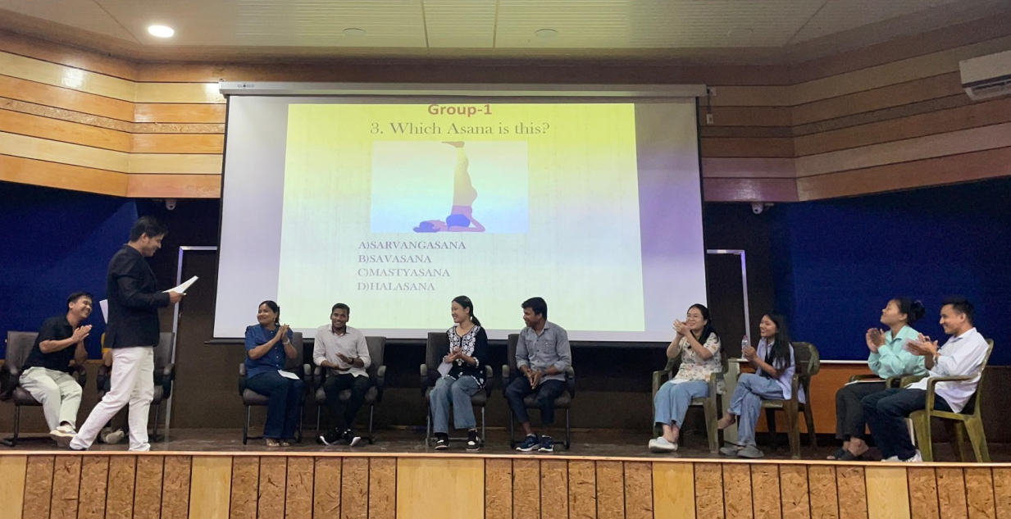vraj, Assistant Director Physical Education coordinated the overall programme. Refreshment was given to the participants.

