GOVERNOR’S SECRETARIAT
ARUNACHAL PRADESH
ITANAGAR

Press Communiqué
Dated June 23, 2025

56 Infantry Division GOC calls on the Governor
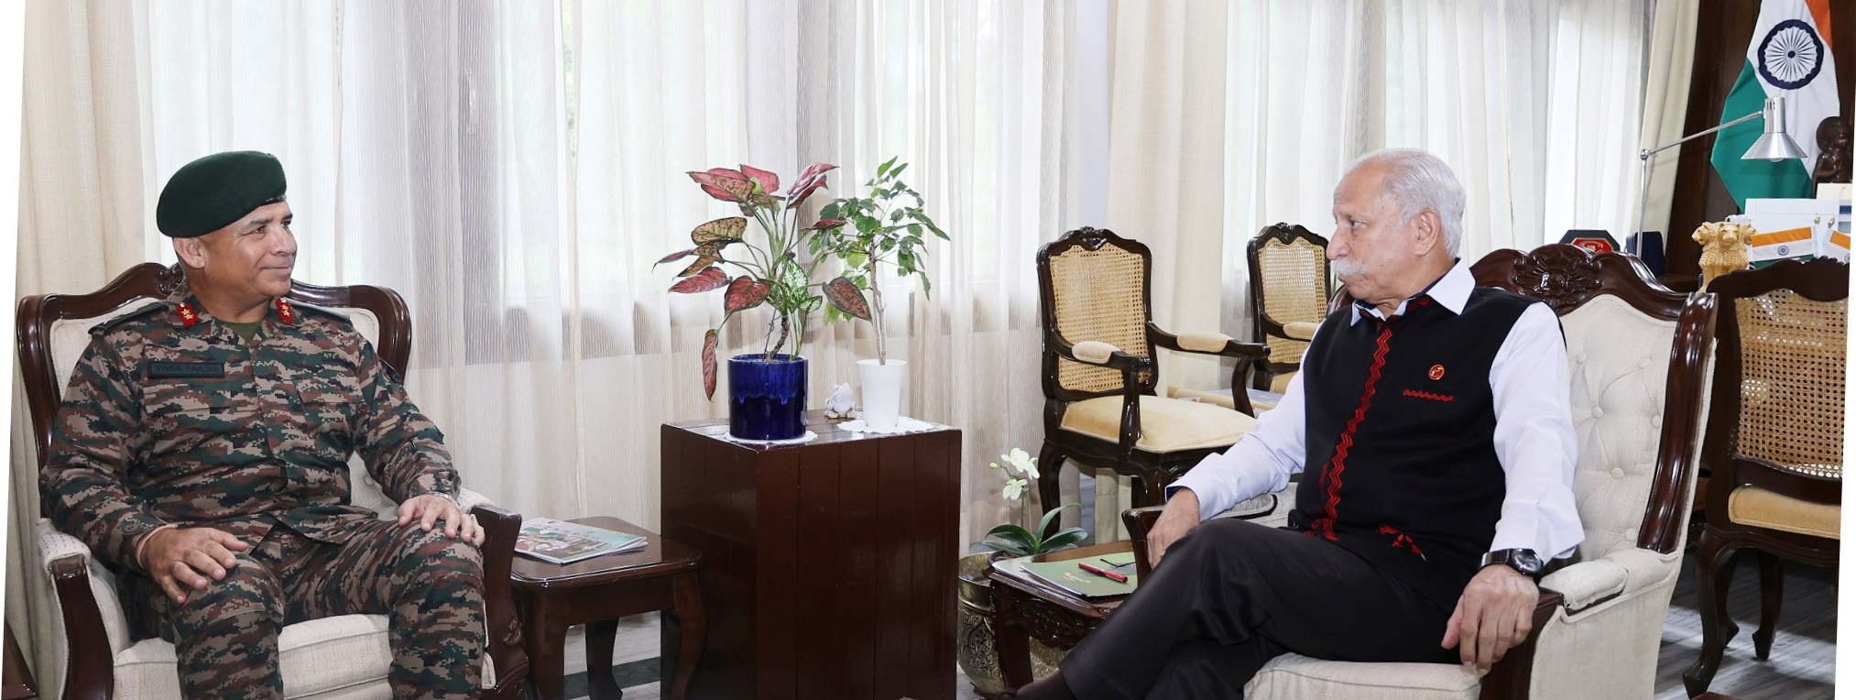

- Governor commends the Indian Army’s dedication and discipline in safeguarding Arunachal’s borders and maintaining peace in sensitive areas

- Governor underlines the transformative potential of schemes like the Vibrant Villages Programme when supported by both military and civil agencies

- Governor urges the Army to take a proactive role in guiding and mentoring the youth of Arunachal Pradesh by engaging with schools, organizing motivational talks, and creating awareness about career opportunities in the armed forces

The General Officer Commanding, 56 Infantry Division, Major General Vivek Bakshi, called on the Governor of Arunachal Pradesh, Lt. General KT Parnaik, PVSM, UYSM, YSM (Retd.), at Raj Bhavan, Itanagar on 23rd June 2025. They discussed the security situation and strategic environment along the LAC, strengthening civil-military cooperation, and joint efforts in disaster preparedness, welfare initiatives for Ex-Servicemen and Veer Naris, and community outreach.
The Governor commended the Indian Army’s dedication and discipline in safeguarding Arunachal’s borders and maintaining peace in sensitive areas. He expressed confidence in the Army's preparedness along the LAC and its pivotal role in maintaining territorial integrity.
Emphasizing stronger coordination between the Army and civil administration, the Governor highlighted successful joint initiatives like road construction, disaster response, and civic action programs. He underlined the transformative potential of schemes like the Vibrant Villages Programme when supported by both military and civil agencies.
The Governor, who has been participating in Ex-Servicemen rallies in different parts of the State, also discussed welfare measures for ex-servicemen and Veer Naris with the GOC. He suggested more job fairs, medical camps, and pension outreach in remote districts.
The Governor urged the Army to take a proactive role in guiding and mentoring the youth of Arunachal Pradesh by engaging with schools, organizing motivational talks, and creating awareness about career opportunities in the armed forces. He said that such outreach would not only inspire patriotism and discipline but also open new pathways for the youth, especially in remote and border areas.
The General Officer Commanding, 56 Infantry Division assured the Governor continued support and collaboration with the State Government to further the shared goals of security, development, and public welfare.

