GOVERNOR’S SECRETARIAT
ARUNACHAL PRADESH
ITANAGAR

Press Communiqué
Dated June 23, 2025

Governor inaugurates HIM SAMWAD 2025
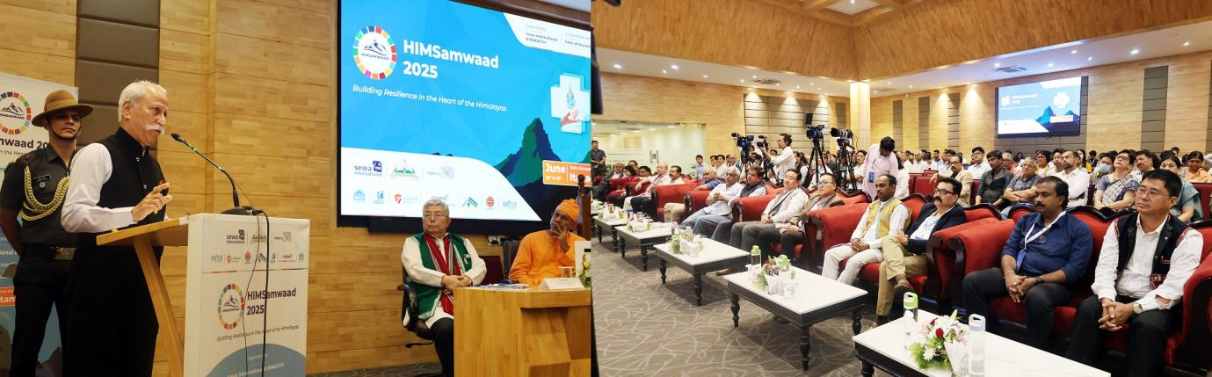
The Governor of Arunachal Pradesh, Lt. General KT Parnaik, PVSM,UYSM,YSM (Retd.) inaugurated ‘HIM Samwaad 2025’, a three-day national dialogue focused on the Himalayan region’s most pressing social, environmental, and policy issues, at the Golden Jubilee Banquet Hall, Niti Vihar, Itanagar on 23rd June 2025.
In his inaugural address, the Governor emphasized that the path forward lies in meaningful collaboration between governments, academic institutions, civil society, and most importantly, local communities. He urged all stakeholders to build capacity, stay rooted in indigenous wisdom, and embrace innovation for sustainable development.
The Governor said that HIM SAMWAAD 2025 is an important platform for dialogue, and a launch pad for concrete action to build resilient systems, ensure clean water, strengthen public health, and secure a sustainable future for the Himalayan region.
Appreciating the efforts of Sewa International, RIWATCH, the State government, and environment-conscious NGOs, the Governor underlined the critical focus of this year’s SAMWAAD on Health and Water, two deeply interconnected pillars of mountain life. He said that clean water in the fragile Himalayan ecosystem is not just about daily needs, but central to health, resilience, and survival. Climate change, glacial retreat, and poor practices are putting immense stress on traditional water sources, directly affecting lives and livelihoods. He said HIM SAMWAAD offers a timely opportunity to bring together experts, policymakers, and grassroots voices to craft community-led solutions in water conservation, hygiene, and healthcare. This integrated focus aligns with Sustainable Development Goals: SDG 3 (Good Health) and SDG 6 (Clean Water), both essential for long-term well-being across the Himalayas.
Citing a major milestone, the Governor shared that Arunachal Pradesh has achieved 100% saturation under ‘Har Ghar Jal’, becoming the first Northeastern state and the 10th in India to do so. But he stressed that household tap connections are just the beginning. The next step is ensuring clean water access in every health facility, from rural clinics to major hospitals.
Highlighting the role of indigenous wisdom, the Governor noted that traditional healing, water conservation, and community practices offer timeless, sustainable solutions. He praised the State Biodiversity Action Plan as a model that bridges traditional knowledge with scientific planning and community participation.
The Governor spoke warmly of the people of Arunachal Pradesh, calling them the heart and soul of the state. Their rich diversity, deep-rooted traditions, and close relationship with nature offer powerful lessons in sustainable living. He emphasized that this cultural strength must guide development efforts. He also outlined the transformative journey Arunachal is on with expanding roads, green energy, and a growing tourism sector, guided by sustainability. The Pakke Declaration, ban on single-use plastics, Sewa Aapke Dwar, and innovations like the Anti-Drug App and GIS-based Terrain Mapping are key initiatives reflecting this balanced approach under the leadership of Chief Minister Shri Pema Khandu.
The Governor flagged the unique challenges in border areas. With many Vibrant Villages located just 20–40 km from international borders, he stressed the need for strategic, inclusive development, one that balances national interest, local participation, and ecological sensitivity. He also called for collaborative cooperation in managing shared water resources through diplomacy, transparency, and mutual respect. A joint initiative with the Army and paramilitary forces is being developed to secure these regions.
Looking ahead, the Governor emphasized the importance of awareness, research, and documentation. He advocated for preserving and promoting indigenous knowledge in health, water management, and agriculture. Oral traditions must be recorded to protect ancestral wisdom for future generations. In this context, he highlighted the establishment of a Tribal Research Centre at RGU and another upcoming one at APU Pasighat, as key steps forward.
Shri. Shyam Parande, General Secretary and Global Coordinator, Sewa International, Swami Vedasarananda, Secretary Maharaj, Ramakrishna Mission Hospital, Itanagar, Prof. Anil Kaul, Acting Vice Chancellor, Indian Institute of Public Health, Hyderabad, Dr. Emi Rumi, President, Indigenous Faith and Cultural Society of Arunachal Pradesh, Shri. Vijay Swami, Executive Director, RIWATCH, special invitees, delegates from all over the country and participants from all Himalayan States are participating in the programme.

