GOVERNOR’S SECRETARIAT
ARUNACHAL PRADESH
ITANAGAR

Press Communiqué
Dated June 22, 2025

DDMA Anjaw and 12 BN NDRF Conduct Three-Day Awareness Programme on Disaster Management
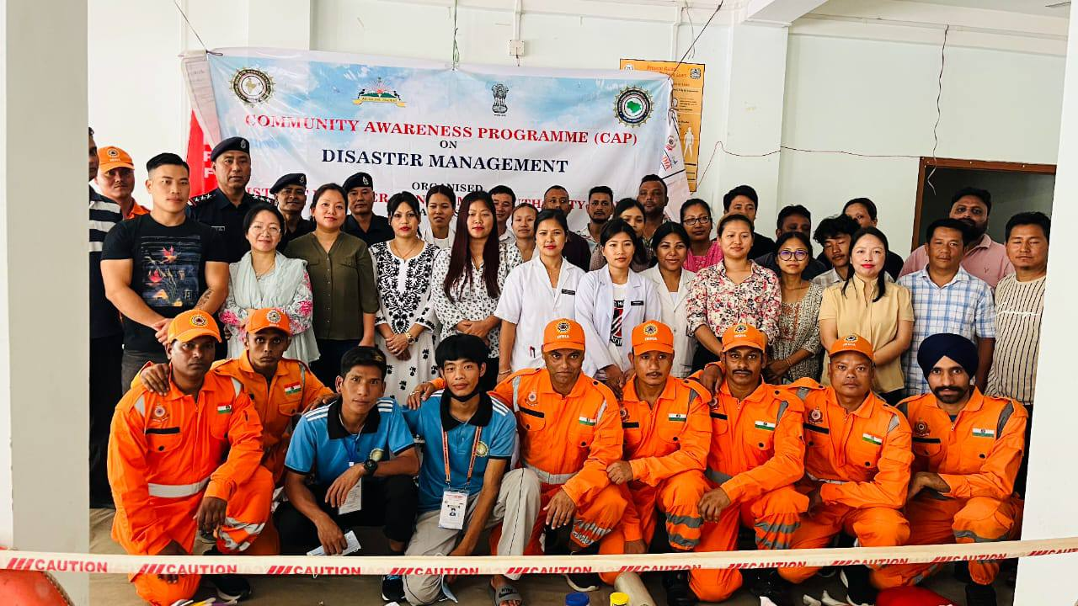

Hayuliang, June 22, 2025: The District Disaster Management Authority (DDMA), Anjaw, in collaboration with the 12th Battalion of the National Disaster Response Force (NDRF), successfully conducted a three-day Awareness Programme on Disaster Management from June 19 to 21, 2025. The programme aimed to promote community awareness and school safety in the face of natural calamities.
The awareness drive was held at three different venues across the district:
1. Kalikho Pul Memorial District Hospital, Hayuliang (June 19)
2. Anjaw Vidyapeeth School, Khupa (June 20)
3. Government Higher Secondary School, Hayuliang (June 21)

The initiative was designed to educate both the general public and school communities about critical aspects of disaster preparedness and response. The School Safety Awareness Programme particularly focused on equipping students and teachers with essential life-saving skills, including basic first-aid, search and rescue techniques, and vital Dos and DON'Ts during natural disasters such as earthquakes, floods, landslides, and fire outbreaks.
In parallel, the Community Awareness Programme (CAP) targeted broader disaster management strategies. Participants received training on disaster preparedness, mitigation measures, and effective response actions to be taken before, during, and after disasters.
Officials from DDMA and NDRF emphasized the importance of building a culture of preparedness and resilience within the community. The sessions were interactive, practical, and widely appreciated by the participants.
The three-day event concluded on a high note, with enthusiastic participation from students, teachers, healthcare workers, and local residents. DDMA Anjaw reaffirmed its commitment to continuing such initiatives for a safer and more disaster-resilient district.
