GOVERNOR’S SECRETARIAT
ARUNACHAL PRADESH
ITANAGAR

Press Communiqué
Dated June 21, 2025

Minister Dasanglu Pul Assures NH-113 Restoration After Trekking to Landslide Site
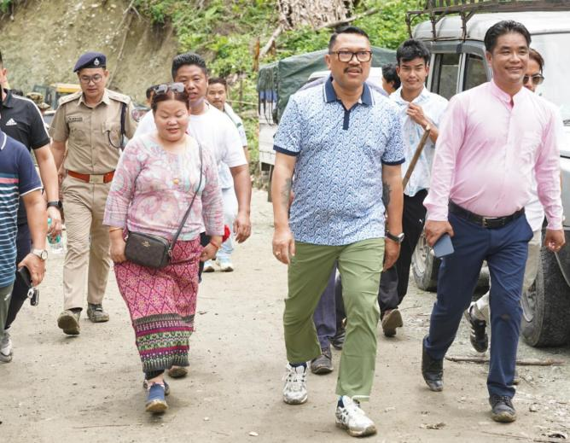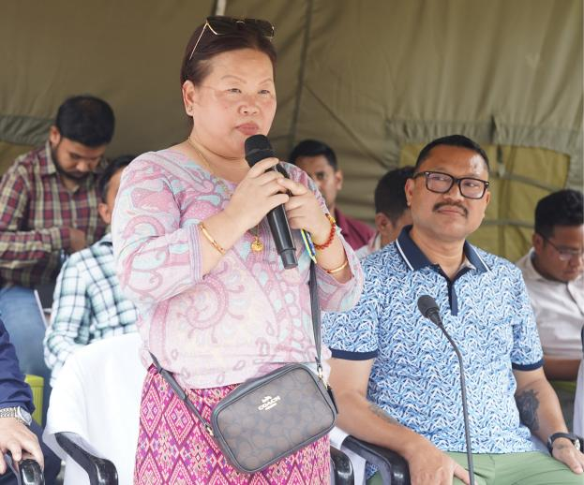

ITANAGAR: Arunachal Pradesh Women and Child Development minister Dasanglu Pul on Saturday undertook a strenuous trek through rugged terrain to reach Monpani (KM 78+000) along the Tidding–Arrowa section of National Highway-113, which has remained blocked for over a week due to massive landslides triggered by heavy rainfall.
The strategic highway, vital for connecting border areas along the Indo-China and Indo-Myanmar frontiers, has been cut off for more than eight consecutive days, severely affecting the movement of essential supplies to forward locations such as Kibithoo and Chaglagam.
Addressing residents at the site, Pul assured that temporary access would be restored by 4 pm on Sunday, with short-term repair work commencing the next day. She further announced the construction of a permanent bypass road, expected to be completed within two years.
“Our government is committed to ensuring uninterrupted connectivity to all corners of Arunachal, especially in border districts like Anjaw,” Pul said, thanking locals for their patience and resilience.
The landslide-hit stretch, falling within the critical Arrowa–Khupa–Hayuliang corridor, has suffered extensive damage, including surface cracks and slope failures due to continuous monsoon downpours.
Given the region’s strategic importance, the state and central governments have prioritised the restoration of connectivity. The NHIDCL has been directed to expedite both temporary relief measures and the long-term solution.
Pul was accompanied by Namsai MLA Zingnu Namchoom, Anjaw Zilla Parishad Chairperson Soblem Pul, Deputy Commissioner Millo Kojin, Superintendent of Police Rike Kamsi, NHIDCL General Manager Arindam Handique and officials from Bhartia Infra Projects Ltd.
