GOVERNOR’S SECRETARIAT
ARUNACHAL PRADESH
ITANAGAR

Press Communiqué
Dated June 20th, 2025

Advisor Dr. Mohesh Chai visits ITI Balinong, reaffirms commitment to strengthening skill development in
Arunachal Pradesh
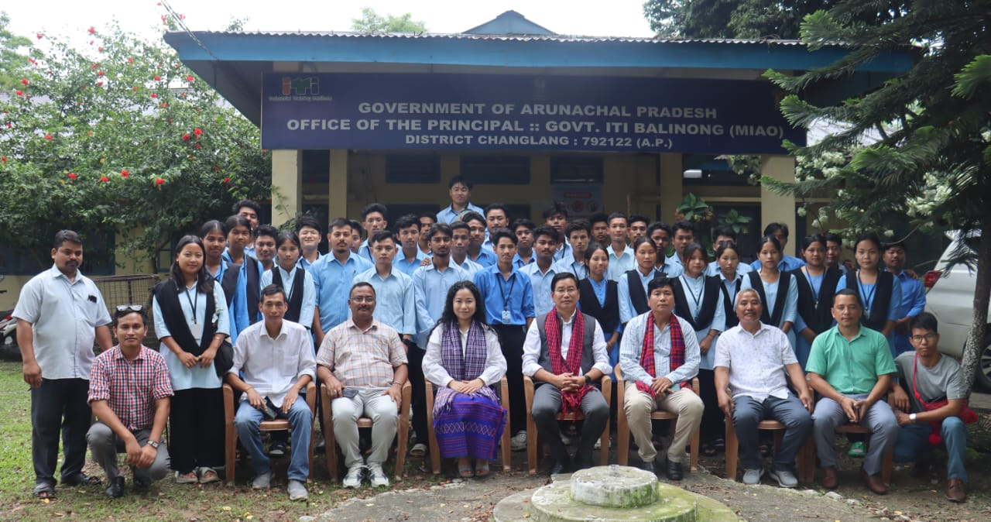

ITANAGER, June 20: As part of the Government of Arunachal Pradesh’s sustained efforts while demonstrating its continuous initiatives to uplift technical education and strengthen institutional resilience,Dr. Mohesh Chai, Advisor to the Minister of Skill Development & Entrepreneurship, visited Industrial Training Institute (ITI) Balinongin Changlang district. He was accompanied by Secretary Bullo Mamu and Director Sibo Passing, SDE and conducted an on-ground assessment of the institute’s ongoing efforts and challenges.
As part of its steadfast commitment to expanding access to quality vocational education, aimed to assess the current infrastructure, academic engagement, and functioning of the ITI. A comprehensive review was undertaken, including an on-site inspection of training workshops, classrooms, and hostel facilities, followed by meaningful in-depth engaging interactions with the trainee students and vocational instructors to understand the effectiveness of training modules and employment linkage opportunities.
The delegation gained valuable insights into the institute’s ongoing functioning, efforts and challenges. They also assessed the extent of the recent flood damage caused by the over flowing Buri Dihing River which severely affected Institute infrastructure. The Boys’ Hostel,had to be vacated, and additional infrastructure including three Type II quarters, the Bachelor Barracks, and the water tankhas been completely washed away.The emphasis for need for immediate and long-term infrastructure resilience planning to ensure continuity in technical education and safeguard the well-being of staff and students alike.
Dr. Chai emphasized strengthening academic & employment linkages and stressed the importance of aligning skill development courses with local industry needs and enhancing placement support for trainees. He advised to give more motivation to the trainees so that they don't depend upon government job only. They should be mould as a job giver not a job seeker. He encouraged faculty to instill entrepreneurial thinking in trainees and highlighted the importance of tracking post-training employment outcomes through a robust trainee database system
Secretary, SDE addressed the instructional staff, reinforcing the focus on curriculum modernization, digital literacy, and institution-industry linkages. She emphasized the need for strategic tie-ups and sustained engagement with regional employers to strengthen industry alignment and improve placement outcomes for graduating trainees.
Director, SDE conducted a detailed review of the enrolment patterns, trade-wise instructor deployment, and ongoing requirements for upgraded workshop equipment, especially in trades that cater to high-demand sectors.
Aligned with the Department of Skill Development & Entrepreneurship’s vision for inclusive, industry-oriented skill ecosystems, the visit highlighted the need for resilient infrastructure planning to safeguard and enhance the skill-building facilities toimprove the learning environment and equipping trainees not only with technical expertise but also with the mindset to become job creators, innovators, and contributors to the region’s socio-economic development.

