GOVERNOR’S SECRETARIAT
ARUNACHAL PRADESH
ITANAGAR

Press Communiqué
Dated June 20, 2025

APBB conducts training and capacity building programme for Biodiversity Management Committee
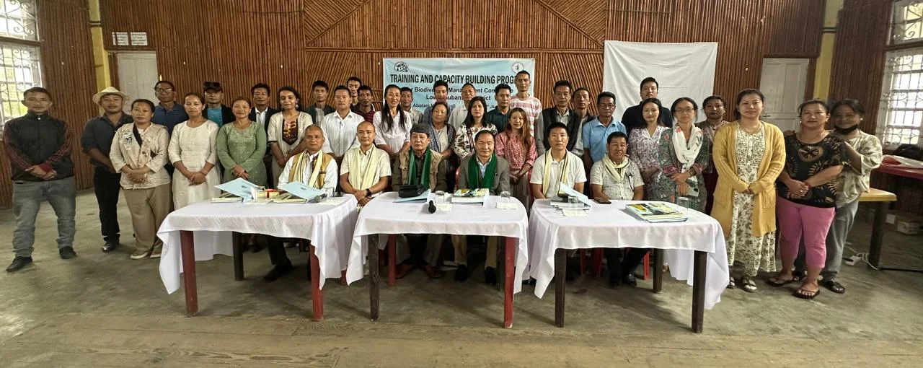

ZIRO, JUNE 20: The Arunachal Pradesh Biodiversity Board (APBB) successfully organized a Training and Capacity Building Programme for the Biodiversity Management Committee (BMC) Lower Subansiri at Ziro. The event was aimed to enhance the knowledge and skills of local stakeholders in managing and conserving the region’s rich biodiversity.
The programme was attended by BMC members, Gaon Buras, Staff of the State Biodiversity Board, Officers from all line departments, technical experts including K.S. Rab, Scientist Incharge of the Zoology Division at SFRI, and local stakeholders from the village community. The event commenced with a warm welcome from Dr. Bamin Yakang, Research Officer of the State Biodiversity Board, who emphasized the importance of collective efforts in conserving Arunachal Pradesh’s diverse ecosystems. H. B. Abo IFS, Member Secretary, highlighted the significance of grassroots participation, community engagement, and aligning conservation efforts with the Sustainable Development Goals (SDGs) to achieve the objectives outlined in the State Biodiversity Strategy and Action Plan 2025-2035.
Dr. Bamin Yakang, Research Officer of State Biodiversity Board conducted an insightful session on the Biological Diversity Act, 2002, and BD (Amendment) Act, 2023. She further highlighted the importance of updating the People's Biodiversity Register, access and benefit sharing and the responsibilities of BMCs, Panchayats, and local stakeholders for effective Biodiversity management.
Millo Tara, Horticulture Development Officer addressed local farmers and community members, emphasizing sustainable cultivation practices, conservation of native flora, organic farming, water conservation techniques like drip irrigation, and the preservation of medicinal and timber species.
Koj Hormin ,Agriculture Department Officer highlighted the rising issue of wild black grasshopper infestations, linked to climatic changes, and stressed the importance of ecological balance, pest management, and government schemes such as ATMA Krishi Yojana to combat these challenges.
Lyagi Lasa, Division Fishery Department Officer presented a comprehensive approach to strengthening local fish production, reducing dependence on external sources, and promoting sustainable fishing practices. He underscored the importance of preserving ecosystems like paddy fields to prevent soil erosion, water pollution, and habitat destruction, thereby boosting local economy and food security.
K.S. Rab Scientist Incharge of the Zoology Division at SFRI, mentioned recent data records on Arunachal Pradesh’s extraordinary biodiversity, detailing over 200 mammal species, 115 reptiles, 65 amphibians, 850-900 butterfly species, over 6,000 arthropods, and 260 fish species. He emphasized the need to protect these ecosystems from threats and capitalising the natural resources for livelihood generation.
Ashwini Krishna, consultant Biodiversity Board, Native folks Pvt Ltd., discussed the State Biodiversity Strategy and Action Plan (SBSAP), ongoing projects proposal under the ten-year plan, emphasizing integrated conservation efforts by incorporating indigenous knowledge and traditional livelihoods into conservation strategies.
The programme also facilitated discussions between local bodies and departmental officers to strengthen coordination and reinforce collective responsibility toward biodiversity conservation and sustainable development.
The event concluded with a vote of thanks by Guchi Nigma, JRF and staff of the Arunachal Pradesh Biodiversity Board.

