GOVERNOR’S SECRETARIAT
ARUNACHAL PRADESH
ITANAGAR

Press Communiqué
Dated June 19th, 2025

Speaker Calls On The Governor
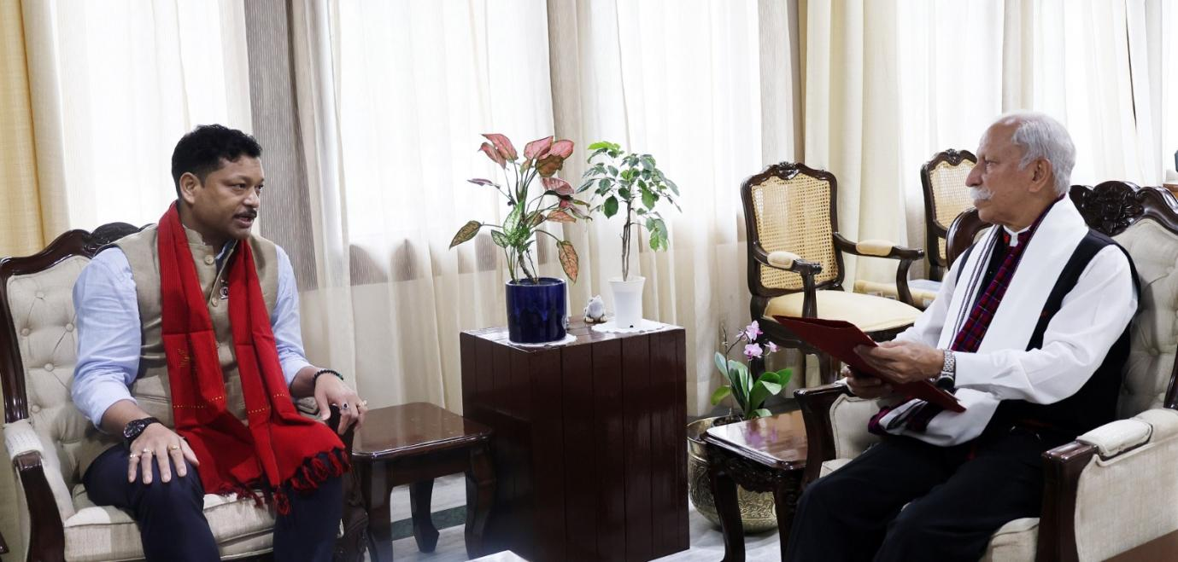

ITANAGER, June 19: The Speaker of the State Legislative Assembly, Tesam Pongte, called on the Governor of Arunachal Pradesh, Lt. General KT Parnaik, PVSM, UYSM, YSM (Retd.), at Raj Bhavan on 19th June 2025. They discussed the evolving role of the State Legislature and its contributions to the State’s development and governance.
The Governor commended the Speaker for his farsighted leadership and innovative initiatives aimed at modernizing legislative processes. He particularly praised the integration of Artificial Intelligence tools and the transition to a fully paperless system, describing it as a transformative step that positions the Arunachal Pradesh Legislative Assembly among the most forward-looking in the country.
The Governor said the Assembly, with its historical significance and modern outlook, has truly become a destination of pride in the State Capital. He also applauded the Assembly Secretariat for its thoughtful planning and the creative transformation of the complex, which blends functionality with aesthetic appeal.
Highlighting the crucial role of the Legislature in shaping the State’s future, the Governor shared his insights on how the institution can further strengthen its impact on public welfare and inclusive development.
The Speaker apprised the Governor of the preparations for the Golden Jubilee celebrations of the Arunachal Pradesh Legislative Assembly and extended a cordial invitation to him to grace the inaugural ceremony.
Tadar Meena, Secretary of the Legislative Assembly, was also present during the meeting.

